# Theme: .SCH

Student’s name: **Myrzabay Nurberdi**

Teacher’s name: **Mamiyeva Jamal**

**Aktau 2022**

**Title**

***Definition 1***

**Description of the organization 1**

**Methods currently used 2**

**Origin of the data 2**

**The appearance of the book 3**

**Contents of the book 4**

**Tasks of the book and grammatical spot 6**

**Investigation 7**

**Conclusion from the interview 9**

***Analysis 10***

**Flow chart 11**

**Data Flow Diagram 13**

**Problem with the current method: 14**

**Good and bad features 14**

**Data 14**

**Alternative approaches 15**

Usage of English helping tools 15

Project in Python 15

Duolingo 16

**Requirements 17**

User requirements: 17

Software requirements 19

Hardware requirements: 19

***Design 20***

**Goal of the system 20**

**Objectives of the system 20**

**Entity relationship diagram 21**

**Proposed record and data structure 22**

**Data Dictionary 22**

Users 22

Save1.json 22

saveworld1.json 23

Player 23

Levels 23

Enemy 23

Test 24

SaveSchool1Progress.json 24

**Prototype 25**

Main Page of the website 25

Sign in (Login) page of the website 26

Sign up (Registration) page of the website 27

Download page of the website 27

Leaderboard of the website 28

Main interface of the game 28

Testing form of the game 29

**Data input form 30**

Login Form 30

Registration Form 31

Login form of the game 32

Tasks of the game 33

**Data output form 34**

Users table 34

Score table 34

Website login form output 35

Website registration form output: 36

Game login form output 37

Game content output 38

**Menu and Module Design 39**

**Data flow diagram of the new system 40**

**Flow chart for the new system (Game) 42**

**Flow chart for the new system (Website) 48**

**Intended benefits 50**

**Limits of the scope of the solution 51**

***Development 52***

Preparation of necessary software 52

Building the base of the game 54

Building the base of the website 54

Creating local server and database on PHPMyAdmin 54

Connecting game with database 54

***Programming 55***

**GDScript Programming language: 55**

Login form of the game 55

Main Menu of the game 57

Dialog in the First Cutscene of the game 59

Main form of the First Cutscene of the game 63

Dialog of the Second Cutscene of the game: 64

First level of the game 66

Camera limit of the Player 68

Code of the Player 69

Code of the Player’s gun 72

Code of the gun’s bullet 73

Code of the Enemy 75

Code of the test form 79

Game progress saving form 83

Game progress loading form 86

Sending game score to the php file via POST method: 89

**PHP with HTML, CSS, and JavaScript 90**

Main Page of the website 90

Download Page of the website 97

Leaderboard Page of the website 98

Login form of the website 99

Registration form of the website 100

PHP for login and registration handling of the website: 101

Logout from session in the website 103

Logging in to the game 104

Receiving score from the game 105

***Testing 106***

**Test strategy 106**

**Test plan 106**

Test 1 109

Test 2 110

Test 3 111

Test 4 112

Test 5 113

Test 6 114

Test 7 116

Test 8 117

Test 9 119

Test 10 121

***Installation 123***

**Installation plan 123**

**Staff training plan 123**

**System implementation plan 123**

**Evidence of user’s testing 124**

***Documentation 126***

**Data dictionary of the Website 126**

Login (Sign In) form 126

Registration (Sign Up) form 126

**Data dictionary of the Game 127**

Login (Sign In) form 128

Main Menu form 128

DialogBox forms 128

Teaching computer forms 129

Pause form 130

Save form 130

Load form 130

**Section References 131**

**Possible Adaptive Maintenance 132**

***User documentation 133***

**User guide 133**

1. Hosting local website 133

**2.** **Opening and switching between tabs on the website** 136

**3.** **Logging in (Signing in) to the website** 136

4. Registering to the website 137

5. Downloading the game from website 138

6. Logging in to the game 139

7. Starting new game 140

8. **Game control** 140

9. phpMyAdmin guide 141

10. Back-up routine 142

11. Glossary 142

**Index 143**

***Evaluation 144***

**Evaluation of success 144**

Discussion of Degree of Success 144

Objectives of the system 144

**Evaluation of objectives 145**

My client’s response 146

Analysis of the client’s response 147

**Degree of success 148**

***Sources of information 149***

# Definition

## Description of the organization

One of the main sources of the education in Kazakhstan are state schools that are funded by the country, so the education is fully free except the school outfit, school accessories and sometimes books. Overall, schools contain an 11- year education which covers all the basics in science, P.E etc. by giving a chance for further education in colleges or universities. Also, the 11-school-year program is divided into 3 which are beginner school, middle school and high school. School year starts from September and ends in May and consists of 4 terms in the school year. In general, children start attending these schools from 6-7. In 2021, one of the branches of state schools was opened in Aktau, Kazakhstan and is in Shygys-1 micro district.

With the changes that were made in the school program, many children must learn languages (which are Kazakh, Russian and English) from young ages and from 1st grade. Before that, school programs were not overloaded in such a way. Due to that, many children are facing some difficulties from learning them or coping with them as their progress did not seem to be really different from the previous school program. Kazakh and Russian languages are not such a problem as they are our official languages and they meet both languages in ordinary life every day, so they don’t have much problem with them. However, there's a different situation with the process of learning English.

My client is Sailau Dana Dastankyzy, who attended this school in 2021 and is continuing her education from 3rd grade. She likes to draw, play outside and is interested in reading texts. Also, she can play the Kazakhstani national instrument called “Dombra”. Due to Covid-19 she had to study online for half of the school time in these 3 years. One of her ambitions was to learn English in order to go abroad as she is interested in other cultures and places. However, she hasn’t succeeded much in learning English and needs some help.

## Methods currently used

In order to learn the English language, the school has provided special English books called “Smiles” Pupil’s Book and Activity Book for 3rd graders in Kazakhstan in order to learn basic English. In this book, children meet interesting visual tasks that are based on teaching the basics of the English language from beginning. Also, the book is fully written in English. The contents of the book are next:

* Contents about animals, times of the day and regular time, building etc.;
* Necessary everyday vocabulary;
* Grammar content referred as study spot;
* Audio practicing exercises;

The problem with the book is that the data is only provided in English. Also, there is no understandable explanation for the grammar and some tasks related to grammar were likely created for learning the structure by learning sentences. However, they do demonstrate information how these grammatical structures are used but do not go into details. Due to my client’s class learning only words, these grammatical explanations are complicated for my client. In terms of audio practice, books include a CD disc in their back cover.

## Origin of the data

Basic knowledge of the English language is mainly obtained from a book, from a teacher, for example, assignments for juxtaposition, comparison, filling. As well as video and audio links for learning English.

## The appearance of the book

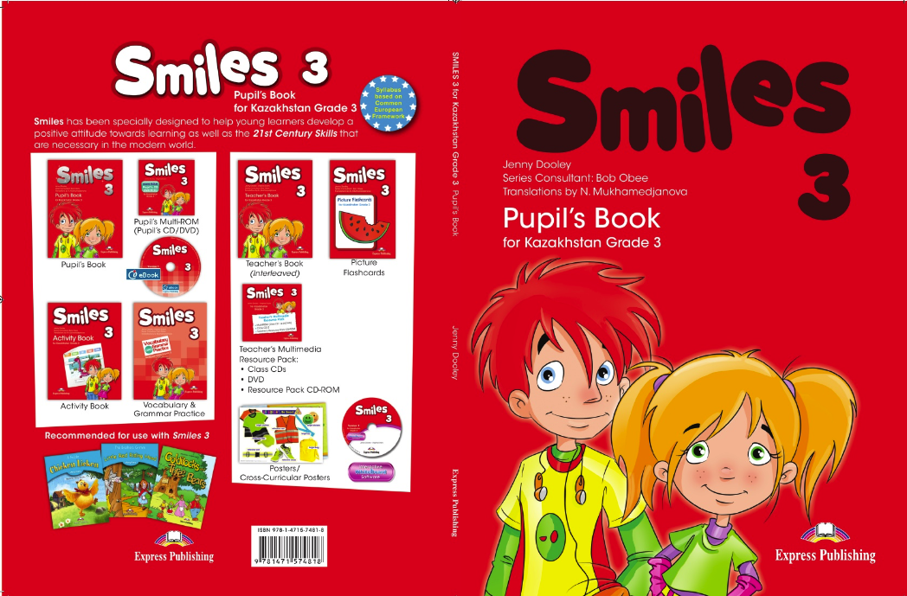

*Figure 1: Cover of the book*

## Contents of the book

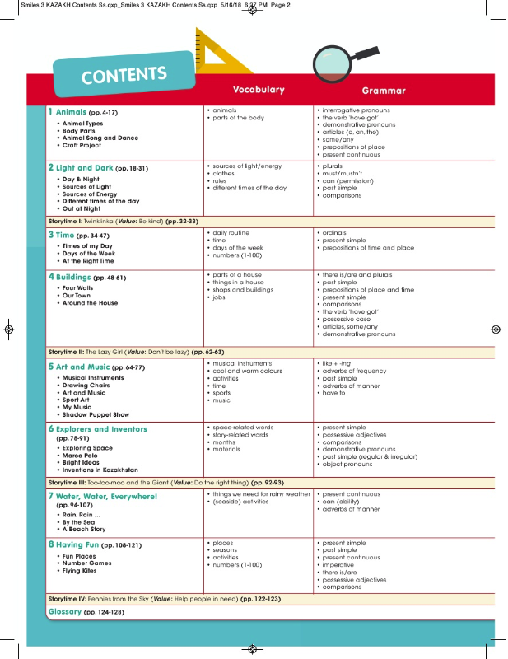

*Figure 2: Contents of the book (1-page)*

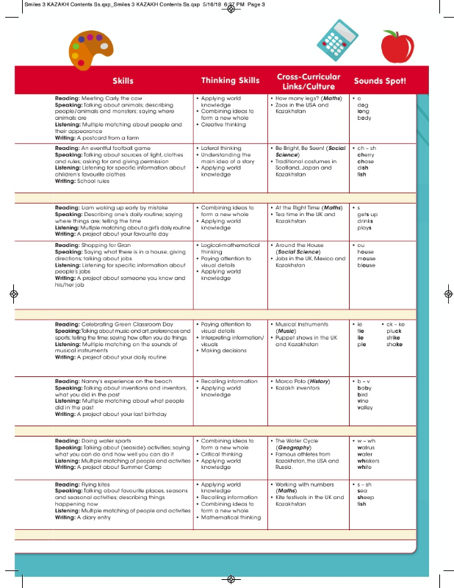

*Figure 3: Contents of the book (2-page)*

## Tasks of the book and grammatical spot

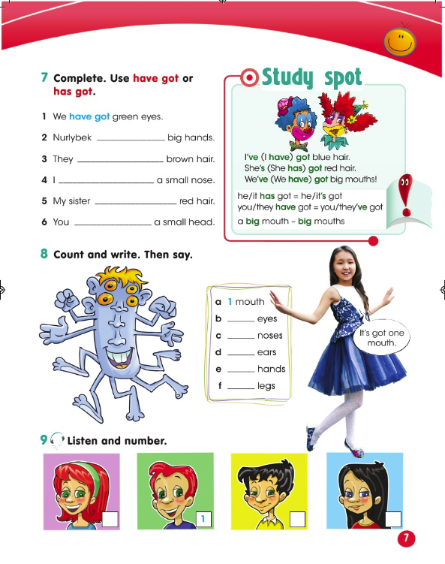

*Figure 4: One of the pages of the book*

## Investigation

In order to gain data about the process of the current system, analyze it for pros and cons, I decided to provide an interview with the client. Interview is going to be about the process of teaching English in state schools and especially, it will be related to the books that my client uses.

As the source of the knowledge used in the current system will be analyzed too, this can give me a proposed plan for completing my projects so my client can get access to the wide range of study materials that were not mentioned or understandably uncovered in the books. By this, I can make a solution which can fulfill the needs and requirements of my client.

An interview is given below which consists of a common dialogue-style talking with my client (M – me, S – my client):

M: Hello! I’d like to ask some questions about how you study English in school and in real life too. As I was helping you with the homework that was given from English, you seemed to use a book called “Smiles” that was published for Kazakh schools.

S: Yes, that’s true

M: However, this book is fully written in English. Do you think that it’s totally understandable for you?

S: Actually, no. I only know the basic words from English. So, I don’t understand all the words from these books. That’s why I need some help with my homework.

M: Have you tried using google translate?

S: Yes, but I don’t have constant access to the internet. Also, it’s hard to use a keyboard for typing all the words.

M: As you said once, in your school you’re still learning basic everyday words, aren't you?

S: Yes. Our teacher teaches them and we practice writing and spelling them.

M: Can you tell me more about the lessons in your school that teaches English?

S: Our lessons for English are held 45 minutes per lesson. At the start, the teacher checks homework, sometimes leaves feedback and marks us in the school journal. After, we open our notebooks and start the lesson. Teacher teaches us new words. We write them down and then, we all practice spelling these words. Usually, order by order or by chore. After that, she gives us homework for the next lesson which I write down, and we leave the classroom. Usually, she gives only one homework task from the book, and I complete this task at home.

M: Ok, do you think that this book is interesting due its visual images?

S: Totally, they are really interesting to watch!

M: Do you think that you can learn English with this book effectively?

S: I think yes. But mostly for learning basic words. Other contents tend to be hard to understand. From a creative point of view, this book is good though. But I’d like to learn in Kazakh language also as it’d be more understandable for me.

M: I guess, you might not make progress in English just reading a book. We might find a solution to this problem. What about going to English tutors?

S: I don’t know. Because I have other courses that I need to attend. So, I don’t have much time for that.

M: Hmm, then, what are your hobbies or what do you like?

S: I like playing games. It can be outdoor games or computer games.

M: You might learn English from apps like Duolingo. They have good courses where you can learn English.

S: Yeah, I heard about that app. But this app has many limitations, and you have to wait. Also, it is written in Russian, so it will be hard to understand.

M: In that case, what do you think about learning English while playing a game?

S: Is that possible? Can you help me with that?

M: Yeah, I can help you with the process of learning English. I think the creation of the game can help you with learning English as it will provide both entertainment and educational content.

S: Wow, that’d be awesome!

M: What would you like to see from a game?

S: Hmm, I think, it’d be cool if there were a quiz and an interesting plot where I can play as one character. Also, it would be interesting if game contained interesting visuals, plot and content for learning English which is written in Kazakh as I like the visuals from the book and like playing games.

M: Ohh, that means the game will be a RPG based game.

S: What is it?

M: Role play gaming. It’s a type of game genre where you play as one character on some world and mostly their work is based on getting rid of bad enemies) So, do you think that it would encourage you to learn English?

S: Yes! It will be cool if I can control character and complete various types of quizzes there! Also, it would be cool so the game could be saved and had scores.

M: Good. So, I’ll make a game for you. However, there you will be learning English, so, wait for the tests. Otherwise, you might get sucked into the game.

S: Ok, I think it will be good for me to practice more! Oh, another thing. I’d like to compare the results that I get from the game with others.

M: Comparing scores... You mean leaderboard?

S: I guess so. I want to see how much score others will get.

M: Ok, I think it can be done by the help of a website. But I can’t promise that for you...

S: It’s ok.

M: Ok, thanks for the interview!

## Conclusion from the interview

From the interview, we can see that the current method (English Book for Kazakhstani students) is not actually bad. However, the book is only written in English which is not understandable for 3rd graders who don’t learn the English language by themselves. They can understand the words that they learnt in school; however, these words are basic and aren’t much helpful for understanding the book. Nevertheless, the book contains entertaining visuals, pictures that can attract the attention of children.

Going to English courses/tutors or learning English from other apps such as Duolingo is not very effective. She doesn’t want to go to the tutor and apps have many limitations that will cut the time for learning English.

As I suggested, my client approved the idea of making a game. She said that the game should include interesting pictures, a character to control, quizzes and so on. Which means, the game should look like a role-playing game that will teach English. Also, the game should contain a plot which will give an interesting time-passing for my client as her request.

# Analysis

Analyzing the problem, my client and I concluded that I’ll create a game. However, the problem was in what dimension the game will be created. Will it be a 3D or 2D game? If it's a 3D game, should it be a first-person or third-person game? What kind of educational content should the game include in itself? So, the answer, which I thought would be a wise decision, was the creation of a top-down 2D game. It’s a game that looks like a third-person 3D game. But the game is only developed on a 2-dimensional surface. It will just give an illusion that the game is 3D. Why not 3D? Because it'd be harder to accomplish with my low level of knowledge about game development. So, I decided to start with a beginner-friendly method of game creation.

Another problem was, where should I start my own game development? Firstly, I wanted to use “Pygame” which will be discussed later. However, I decided by looking at the game engines as these tools have a ready user interface and functions that can help to create a game without many struggles. I wanted to start with Unity3D, but I heard that it costs money to use it, so I stuck to another new game engine called Godot. This game engine has a more simplified user interface, has many nodes that can be used to create game interfaces, has a good community that can help at any time and their own documentation.

## Flow chart

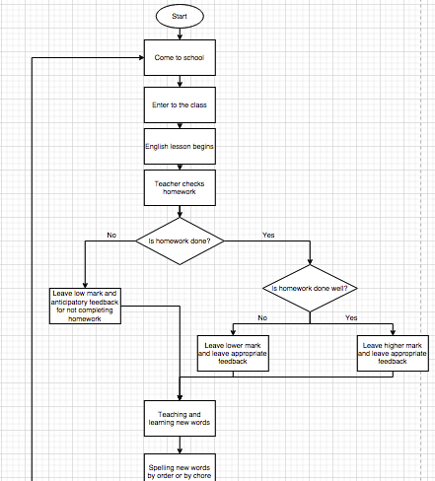

*Figure 5: Flow chart (1-part)*

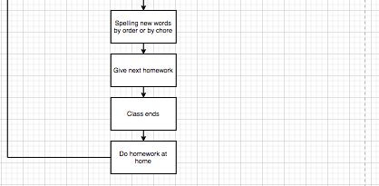

*Figure 6: Flow chart (2-part)*

## Data Flow Diagram

Firstly, the teacher prepares and gives a homework assignment for my client (Dana). Then, the client completes the homework and writes all the necessary answers to her notebook. Then, in the next lesson, my client shows her homework to the teacher. Teacher checks the homework and gives appropriate feedback about the homework. Also, the teacher puts marks on journal.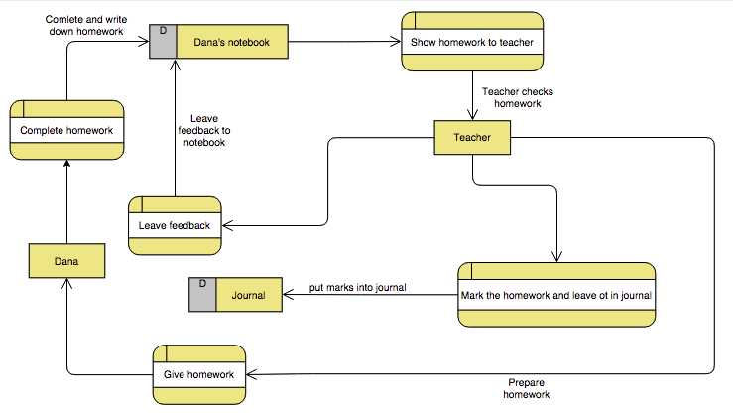

*Figure 7: Data flow diagram of the client's system (old system)*

## Problem with the current method:

From the analysis and interview part, I can conclude that the main problem of the method is that it’s hard and inconvenient to use and understand. Not all the content of the book is understandable for my client as they only learn basic words at school. Even the meaning of the given tasks appears to be complex for my client. Moreover, the teacher uses the book as the only assignment tool when this book contains other helpful grammatical contents. So, it is not likely that 3rd graders will get to know better about the grammar of English.

## Good and bad features

The current system has both advantages and disadvantages. If we start from the pros, the system is well designed and can gain the attention of the students due its creative approach to the material by adding interesting materials and images. Also, if the student is hard-working one, then the student can learn English by himself/herself which may increase their learning skills. In terms of cons, this method is hard to understand for children as there are no instructions in the Kazakh. So, children find it hard to understand all the data. Also, CD disc tends to be another downside as not all computers nowadays have a CD reading feature. However, by the help of this system, students can improve their searching, analyzing and learning skills as they will have to search information not only from books, but also from other resources.

## Data

Vocabulary words

Given homework

Answers for the tasks

Feedback from teacher

Mark from teacher

**Inputs:**

Vocabulary words – string

Given homework – string

Answers for the tasks - string

**Outputs:**

Feedback from teacher – string

Mark from teacher – numeric

## Alternative approaches

### Usage of English helping tools

What I mean by this is that there are a bunch of apps that can help with the translation of any language. Also, they are advanced systems, so their services are designed with a good interface. However, from the interview, I understood that this method is inconvenient for my client as she doesn’t have constant access to the Internet and it’s hard typing lots of words on the keyboard.

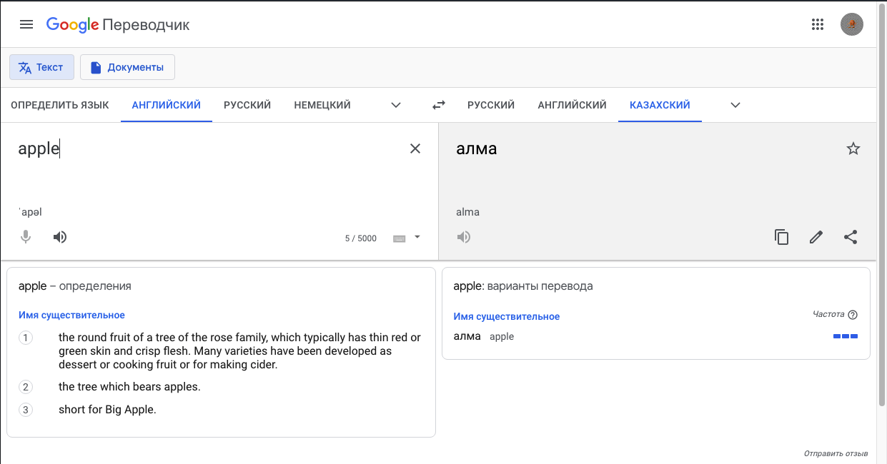

*Figure 8: Google translate*

### Project in Python

Project by the usage of Python could be another solution as it can be used for creating games. Especially, library called “Pygame” is especially designed for game development. However, it doesn’t have a convenient user interface and it will be hard to handle some of the logic of the game. So, I decided to pick an easier way of game creation.



*Figure 9: Logo of the pygame library*

### Duolingo

Duolingo is another app that is supposed to teach a variety of languages for users. This app is strong and has step-to-step tutorials that contain necessary data about English. It has daily tasks that user should complete, and it can analyze when an user wants to learn English by setting up the user's own schedule. This app has a good user interface. However, this app’s content doesn’t contain Kazakh language and it has time limitations. For example, you can’t take and complete all the tasks and quizzes at one time. So, this app does not fully meet the requirements of my client.

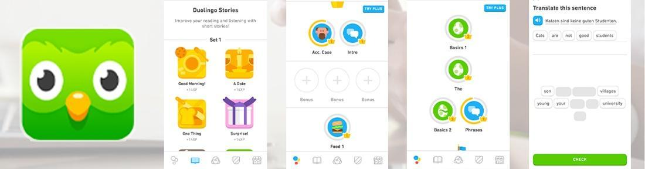

*Figure 10: Contents of the Duolingo app*

## Requirements

### User requirements:

These are the requirements for the new system which have been agreed with the client:

1. System should be created as a game;
2. System must have an educational content which will teach English;
3. System should include testing so the user can check his/her progress;
4. System should include good user interface;
5. Main user interface should be written in Kazakh;
6. Game should be Role-Play based;
7. System should include control over the character;
8. Game should have a plot;
9. Game should contain saving and loading system in order to save the progress of the game;
10. Development of the website which will save the record of high scores that was obtained from the game;
11. Every user should have an ability to create their own user account;
12. Website must have a link where users can download the game.

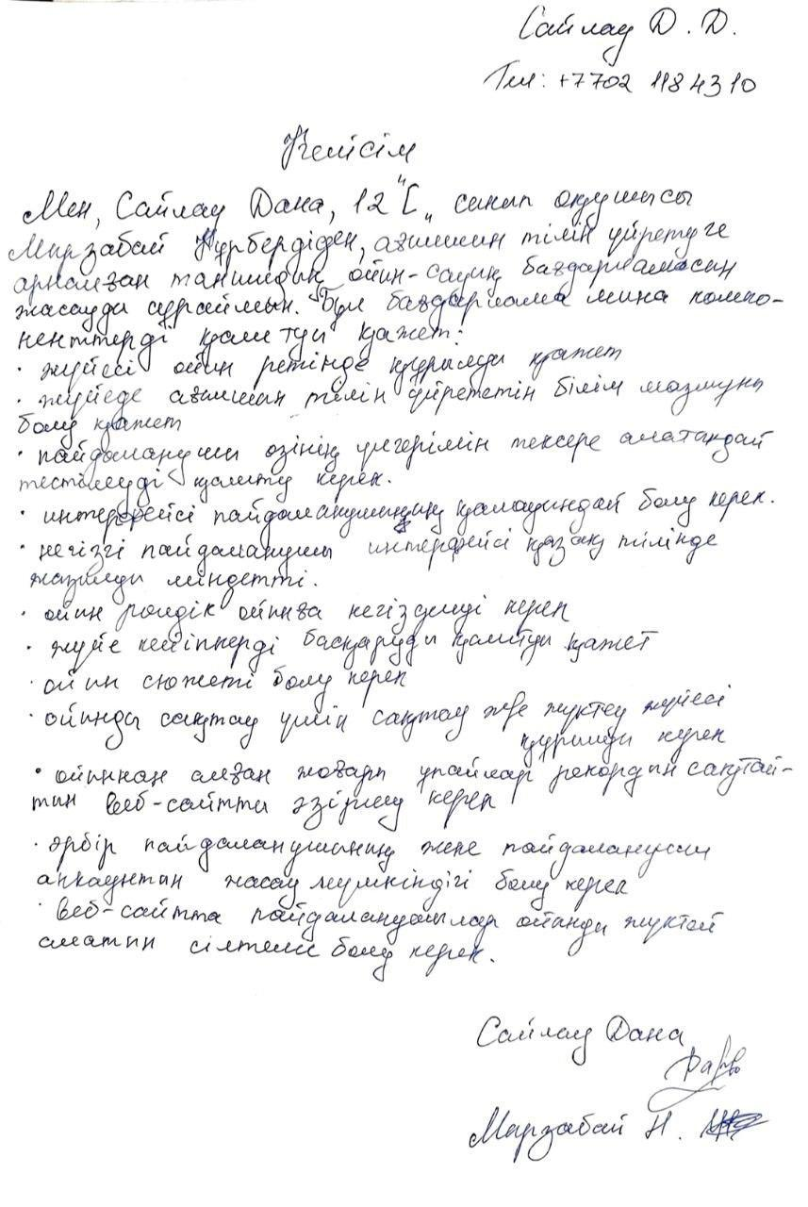

*Figure 11: Agreement of the user with her proposed user requirements*

### Software requirements

| **Software required** | **Reason** |
| --- | --- |
| Windows or Mac operating system | Due to the fact that the game can be exported to any platform, I decided to make this game for both Windows and Mac users as it would give flexibility for my sister. Also, in the future, it will be comfortable just to share games so it can be opened at any place. Also, the engine that I use can be used in any OS |
| Any web-browser that have access to the Internet | It is needed for testing the website |
| Godot | An open-source engine that is used for the creation of the game |
| Visual Code | Used for creating the website |

### Hardware requirements:

| **Name hardware** | **Device** | **Functions** |
| --- | --- | --- |
| Input device | Qwerty keyboard | To control the player and the menu of the system |
| Input device | Laser mouse | To control the player’s gun and interact with user interface |
| Output device | 1280x800 px monitor | Convenient for displaying all the data of game engine and game itself |
| Storage | RAM 8gb | I use a browser and game engine at the same time. So, they consume a good amount of ram in the laptop. So, I need good ram for working smoothly |

# Design

## Goal of the system

Goal of the system is to create an educational-entertaining system for my client where she can learn English while playing a game. This will provide both entertaining and a good learning source about English for my client.

## Objectives of the system

The following objectives are related to the requirements that were given by my client. With these objectives, my client can see what I am going to accomplish and my progress in game development. Also, I can sort out what kind of objectives were completed and use them for arranging my work correctly and give a brief planned structure of my further work. Moreover, these objectives might include my own personal preferences. These are the objectives:

1. System must be created as an entertaining educational application;
2. System must contain testing system so client can check her progress;
3. System must have user control over the contents of the game;
4. System must count the scoring of the user that was obtained in the game;
5. Interface must be understandable and entertaining for user;
6. System must be able to save all the necessary data;
7. System must include website development in order to keep the track of scores and give an access to the downloading link of the game;
8. Website must have a registration system for all users.

## Entity relationship diagram

In the process of website and game development or their design, I had to deal with a huge amount of data which needed to be saved. In the website, data from registration is saved in table Users. In game, there is data of the levels, player, enemy, and test when the game is being loaded. In order to save the data of Player and Enemy, I had to create new json files called Save1.json and Save2.json. When data is needed, these json files send data to Player node with many-to-one relationship as only one Player gets information about it and Enemy node with many-to-many relationship as there are many enemies which can be added to the level one by one. In order to save the current location of the Player, I had to first load the needed scene which is saved in json files called saveworld1.json and saveworld2.json where the name of world is stored and connected to the real level by one-to-one connection as only one level can be loaded. Then, the data of Player and Enemy is added to the level. In the test, data about the test's progress is saved in json files called SaveSchool1Progress.json and SaveSchool2Progress.json. They can be sent to the nodes related to the test and these nodes relate to the current level. They relate to many-to-many relationships as there are many tests that can be added to several levels. Also, the score of the Player can be sent to the website database by one-to-one relationship.

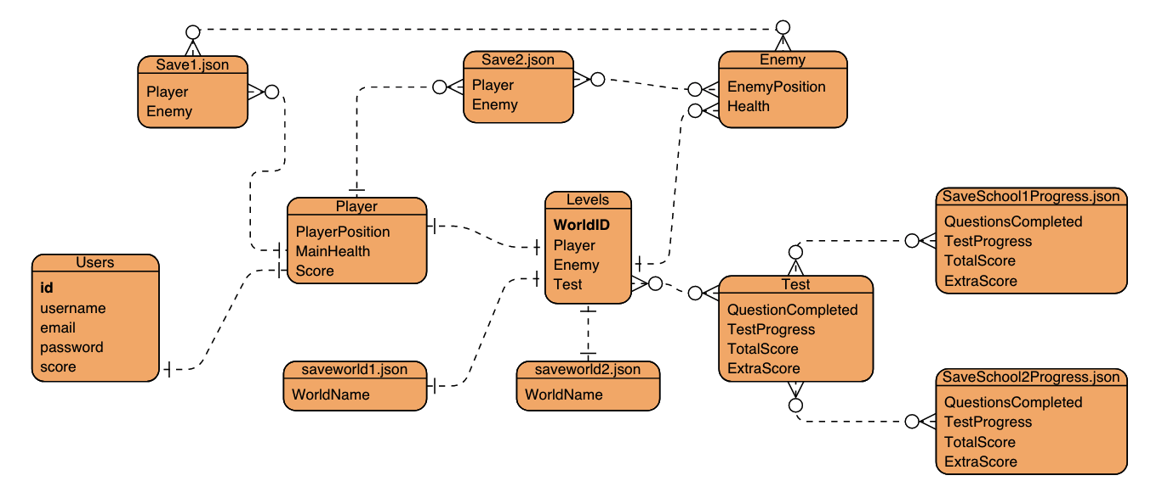

*Figure 12: Entity Relationship Diagram of the new system*

## Proposed record and data structure

The tables will be used in the system for saving the user data. Also, there are json files that save the game progress made by user which is represented as a code and changes with accordance to the game progress.

## Data Dictionary

### Users

| **Field** | **Type** | **Length** | **Validations** | **Description** | **Example** |
| --- | --- | --- | --- | --- | --- |
| id | int | 11 | Type check | Unique identifier of the user | 0 |
| username | string | 100 | Presence check | Name of the user that is chosen by user | KPTS |
| email | string | 100 | Format check | Email of the user | aaa@gmail.com |
| password | string | 100 | Presence check | Password of the user | Password123 |
| score | int | 10 | Type check | Score of the user that was scored in the game | 200 |

### Save1.json

| **/root/World1/World1/Player**  **(Description: Location, health, and score of the player in the level**  **Type: int**  **Length: N/A)** | **/root/World1/World1/Player { }**   | mainhealth | 10 | | --- | --- | | Pos | **pos { }**   | x | 516.590454 | | --- | --- | | y | 493.781921 | | | Score | 0 | |
| --- | --- | --- | --- | --- | --- | --- | --- | --- | --- | --- | --- |
| **/root/World1/World1/Enemy**  **(Description: Location, health, and score of the enemy in the level**  **Type: int**  **Length: N/A)** | **/root/World1/World1/Enemy { }**   | Health | 10 | | --- | --- | | Pos | **pos { }**   | x | 186.852753 | | --- | --- | | y | -28.664164 | | |

Save2.json file has similar data types

### saveworld1.json

| **Field** | **Type** | **Length** | **Validations** | **Description** | **Example** |
| --- | --- | --- | --- | --- | --- |
| “world” | String | N/A | Format check | Saves and load the location of the current level | res://World.tscn |

(saveworld2.json has similar data types)

### Player

| **Field** | **Type** | **Length** | **Validations** | **Description** | **Example** |
| --- | --- | --- | --- | --- | --- |
| PlayerPosition | vector | N/A | Format check | The main position of the Player in a map | "x":14496.5,  "y": -9800 |
| MainHealth | int | 10 | Range check | Health points of the player | 10 |
| Score | int | N/A | Type check | Score of the user | 450 |

### Levels

| **Field** | **Type** | **Length** | **Validations** | **Description** | **Example** |
| --- | --- | --- | --- | --- | --- |
| WorldID | int | N/A | Format check | The name of the level. Same as in saveworld1.json file | res://World.tscn |

### Enemy

| **Field** | **Type** | **Length** | **Validations** | **Description** | **Example** |
| --- | --- | --- | --- | --- | --- |
| EnemyPosition | int | N/A | Format check | The main position of the enemy in the map | "x":100,  "y": -90 |
| Health | int | N/A | Type check | Health of the enemy | 15 |

### Test

| **Field** | **Type** | **Length** | **Validations** | **Description** | **Example** |
| --- | --- | --- | --- | --- | --- |
| QuestionsCompleted | bool | N/A | Format check | To save the data of checked or not checked questions in the Test form as true or false | true |
| TestCompleted | bool | N/A | Format check | To indicate whether the test was completed or not | false |
| TotalScore | int | N/A | Type check | Total score that was obtained after submitting Test form | 450 |
| ExtraScore | int | N/A | Type check | To save temporary score of the player while completing test form | 120 |

### SaveSchool1Progress.json

| **Field** | **Type** | **Length** | **Validations** | **Description** | **Example** |
| --- | --- | --- | --- | --- | --- |
| QuestionsCompleted | bool | N/A | Format check | To save the data of checked or not checked questions as true or false from the Test form of the specific level | true |
| TestCompleted | bool | N/A | Format check | To indicate whether the test was completed or not in the specific level | false |
| TotalScore | int | N/A | Type check | Total score that was obtained after submitting Test form | 450 |
| ExtraScore | int | N/A | Type check | To save temporary score of the player while completing test form | 120 |

SaveSchool2Progress.json and SaveSchool3Progress.json has similar data types.

## Prototype

The main prototype of the website and game is provided below. My client and I made the prototypes, and these prototypes were agreed by the client.

### Main Page of the website

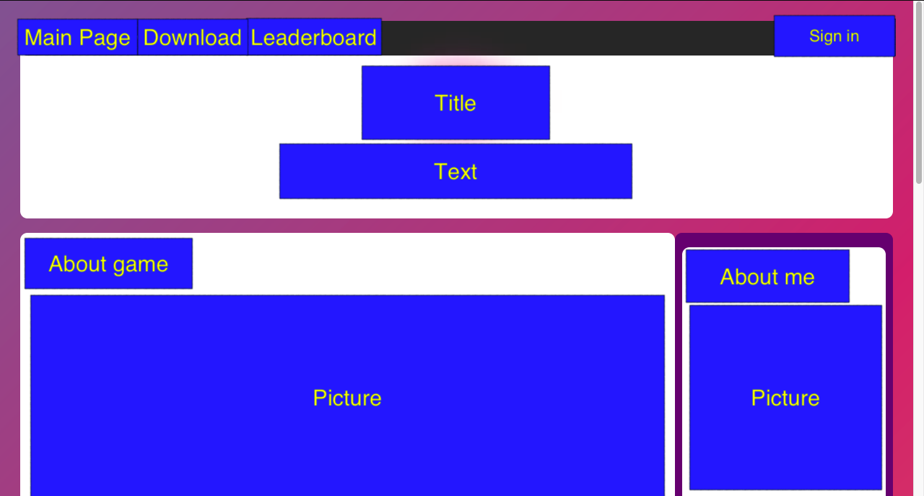

*Figure 13: Prototype of the Main Page of the website*

Main page of the website consists of navigation bar, which contain Main Page, Download, Sign in, and Leaderboard link, and necessary text information and pictures.

### Sign in (Login) page of the website

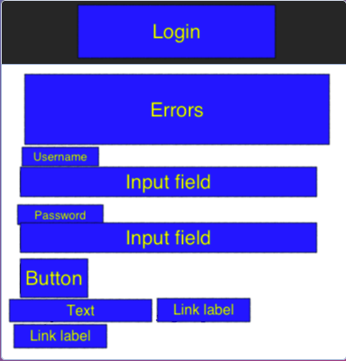

*Figure 14: Prototype of the Login form of the website*

Login form of the website will consist of Error area, Input fields, Text information, and necessary buttons and link labels.

### Sign up (Registration) page of the website

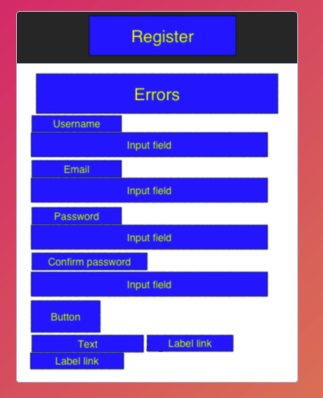

*Figure 15: Prototype of the Registration form of the website*

Registration page of the website has similar structure as the login form, but with additional Input fields.

### Download page of the website

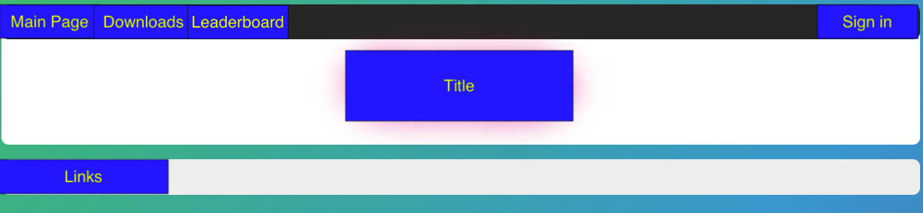

*Figure 16: Prototype of the Download page of the website*

Download page of the website will contain Navigation bar, text information and link to the game where it can be downloaded by the user.

### Leaderboard of the website

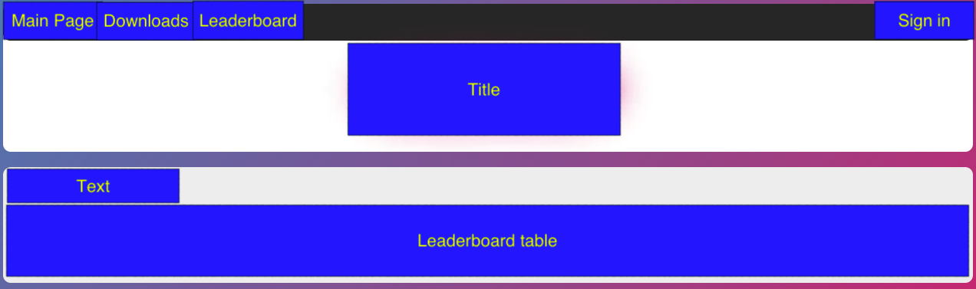

*Figure 17: Prototype of the Leaderboard page of the website*

Leaderboard page of the website will contain Navigation bar, text information, and the table with users’ scores from the game.

### Main interface of the game

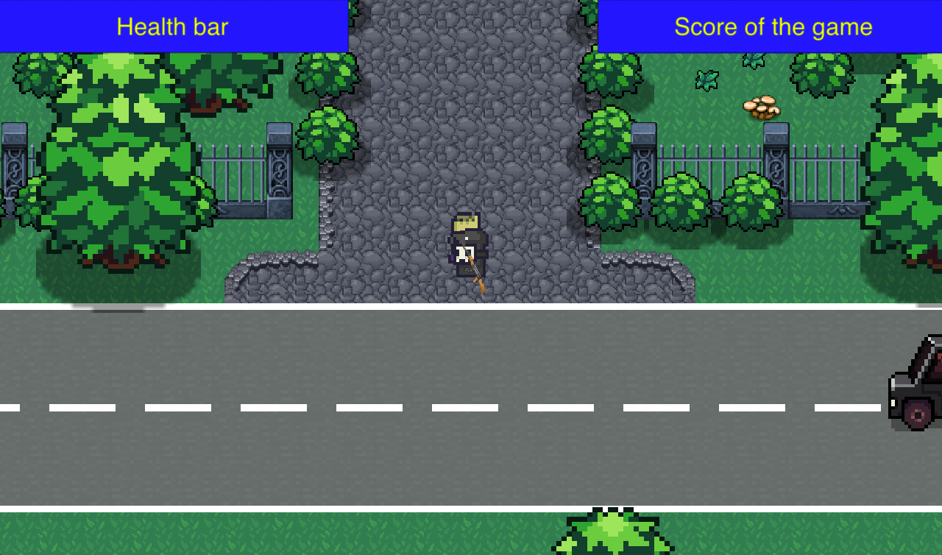

*Figure 18: Main gaming interface of the game*

The main interface of the game will contain Health bar of the player, Score of the player, and main gaming environment.

### Testing form of the game

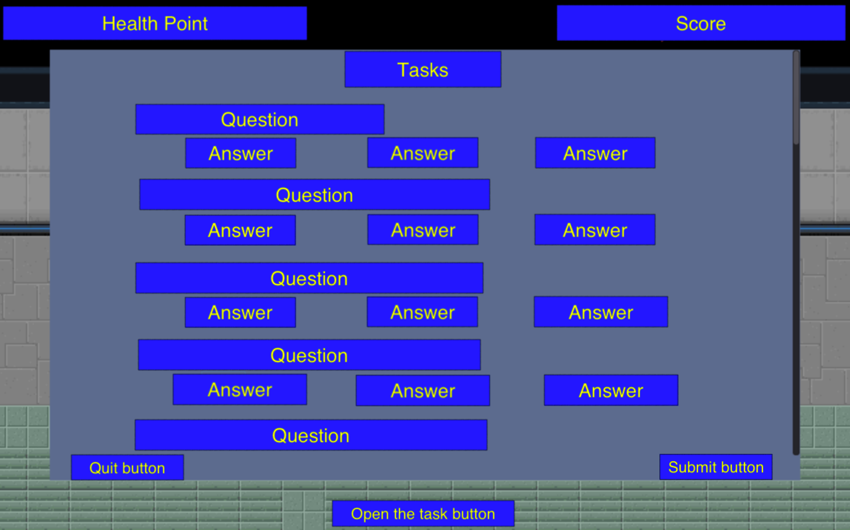

*Figure 19: Prototype of the testing interface in the game*

The main testing forms of the game will contain text information, questions, and possible multiple-choice answers for them. Also, buttons for controlling over the form such as quitting and submitting the test.

## Data input form

In order to be able to insert necessary data, the system must contain data input form for the user. It should contain labels that indicate the purpose of each input field where the data by user can be inserted. Also, there must be buttons for convenient control over the form where user can just click and save the data eg.

### Login Form

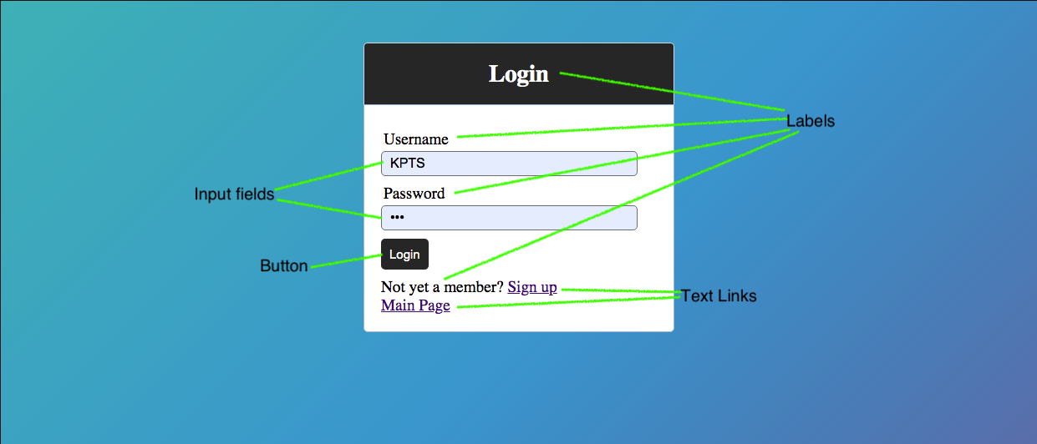

*Figure 20: Login form of the website*

This form above is used for logging in to the website. Labels are represented for better understanding the functions of form. Input fields are needed for filling up the username and password of the user. Login button sends data and checks if there’s such a user and checks if the data is correct and after validating the user, the user can open the webpage by his username. Also, there are extra text links if a user wants to enter a webpage without logging in or if the user wants to create a new account.

### Registration Form

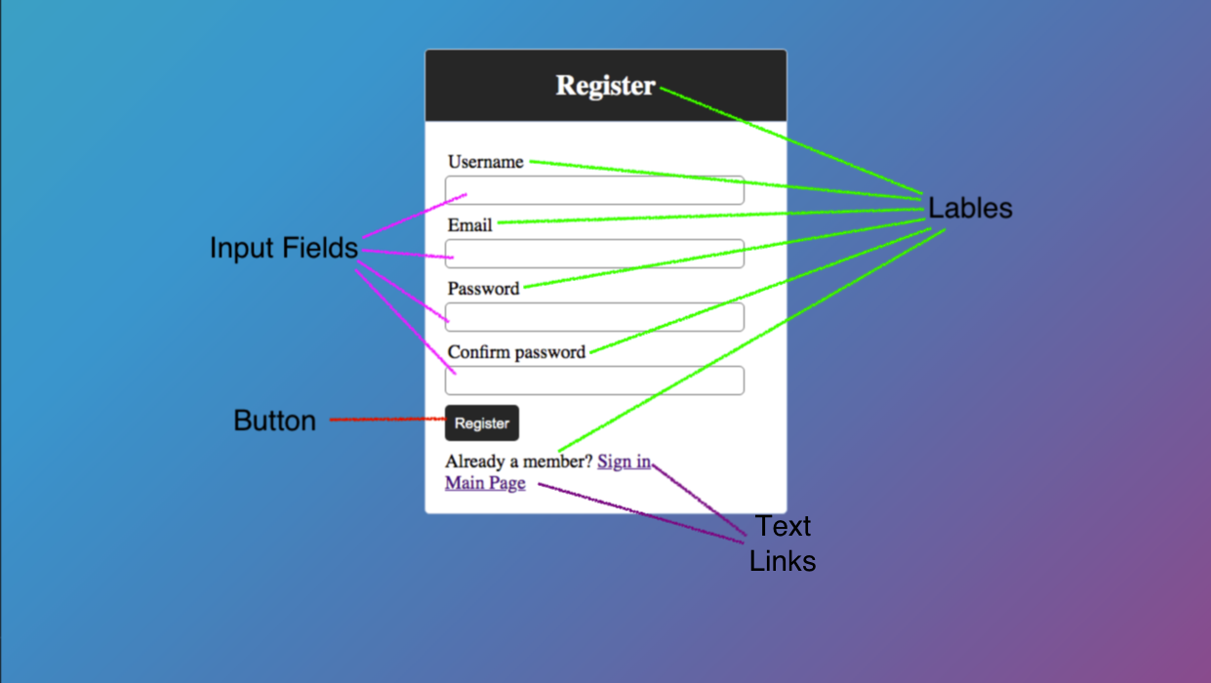

*Figure 21: Registration form of the website*

This form is used for registering new users to the website. Input fields collect username, user email, password and asks to repeat the password to make sure the user remembers her password. After pressing the “Register” button, the system checks if fields are filled up correctly and writes data to the database. With the help of text links, users can go back to Login form or main webpage.

### Login form of the game

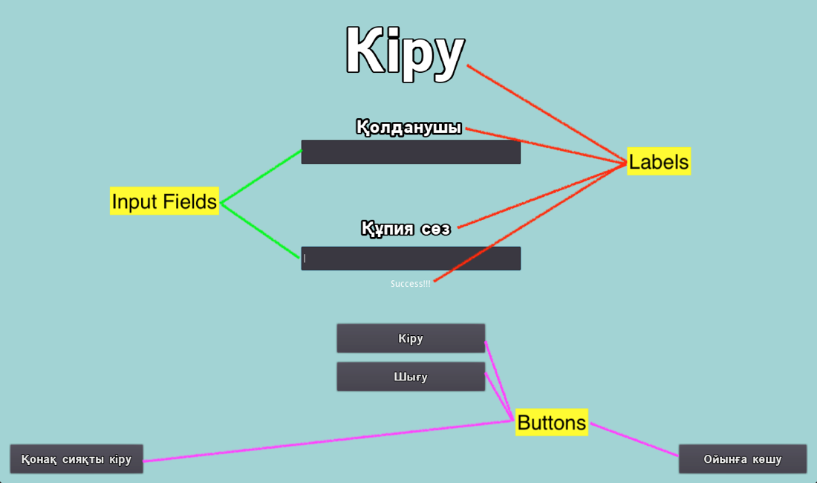

*Figure 22: Main login form of the game*

Login form of the game is very similar to the website's logging system. However, there are extra buttons such as “Шығу” which quits the form, “Қонақ сияқты кіру” which enters to the game as a guest, and “Ойынға кіру” that allows to enter to the game when logging in was successful.

### Tasks of the game

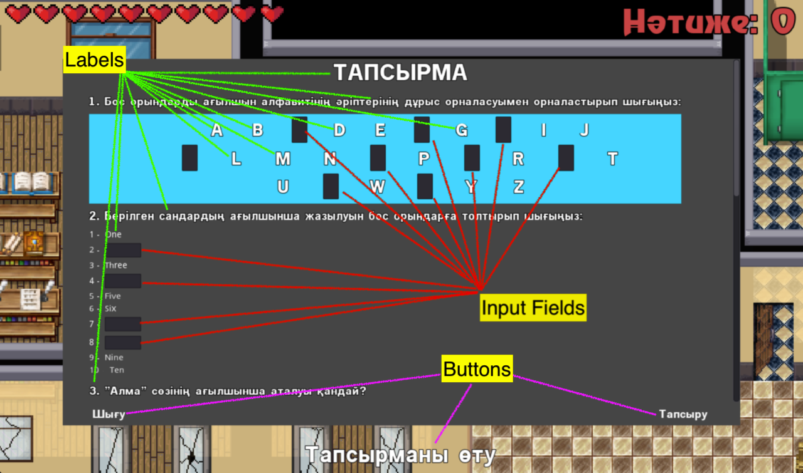

*Figure 23: Form with the tasks in the game*



*Figure 24: Another type of tasks in the form with tasks*

Given form represents the tasks in the game that the user must face in order to get access to another level. Commonly, labels represent the questions/some contents of the answers where the user input is not asked. Due to there being a lot of labels, I had to miss some of them as it’d make it inconvenient to see the content of the form. In terms of input fields, these input fields require answers from the user for the question. Also, there are radio buttons that play the same role which is answering the questions by picking the right answer. All the following tests have similar design and functionality, so there is no need of showing them all.

## Data output form

Data in the new system can be represented by various methods. In accordance with the requirements of the client, several data output forms were created in both game and website and illustrate specific data related to the website and game or both. Also, data from the site will be stored in XAMPP MySQL database, whereas the game progress will be saved in json files.

### Users table

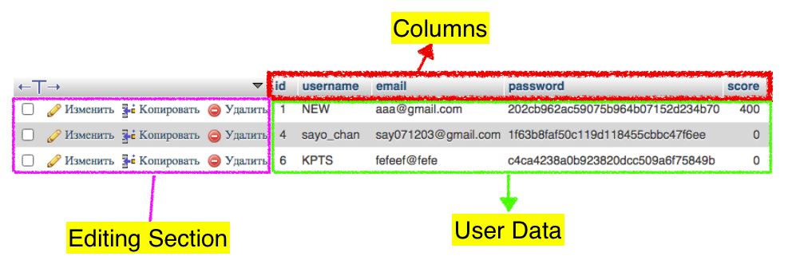

*Figure 25: Table in the database that contains information about the users*

In this given table, data about users are saved and located in the virtual database of XAMPP called MySQL. This data is obtained from registration form on the website and can be used by the help of php for other procedures. This table includes “id”, “username”, “email”, “password”, and “score” columns and each column has respective information or user data. Also, this table can be edited by the editing section.

### Score table

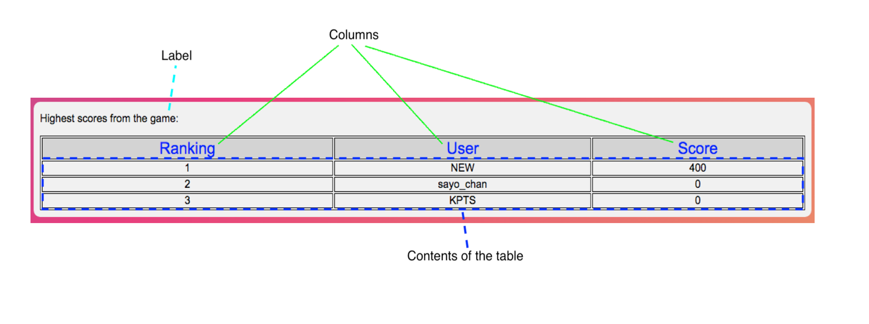

*Figure 26: Table with the scores*

Table above is created in order to display the results of users that they got from the game. It only shows the ranking of the user according to the highest scores of the users on the website, their nickname and score.

### Website login form output

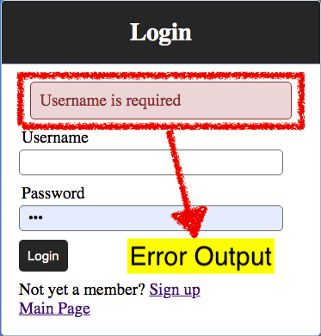

*Figure 27: Output of the errors in the website's login form*

In the login form of the website, error output was designed for displaying logging problems. This can help users to understand the problem that occurred during logging in. This error output is designed so it will check the users from MySQL database or will check the Input fields. This error may show that the user's username or password are incorrect or that the data is required if the input lines were left blank.

### Website registration form output:

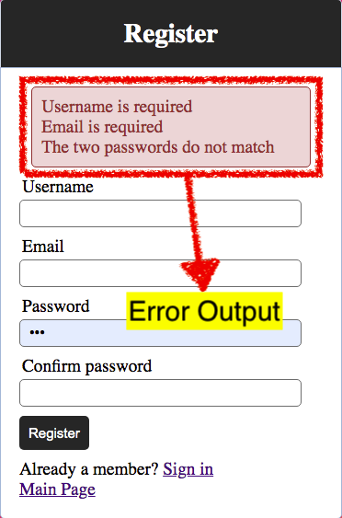

*Figure 28: Output of the errors in the registration form of the website*

Error output of the registration form has the same concept as in the login form. This will check the input lines of the form and display necessary errors. In this form, data is also validated so the user knows his/her password.

### Game login form output

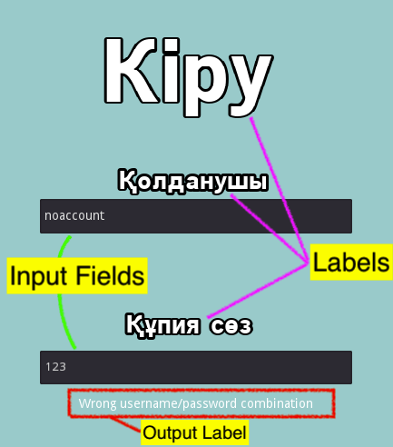

*Figure 29: Output of the errors in the login form of the game*

This form is created for the game for logging into user accounts in order to send scores from the game. This form also has the same concept as in login form as it will show error data after checking the database or after checking input fields.

### Game content output

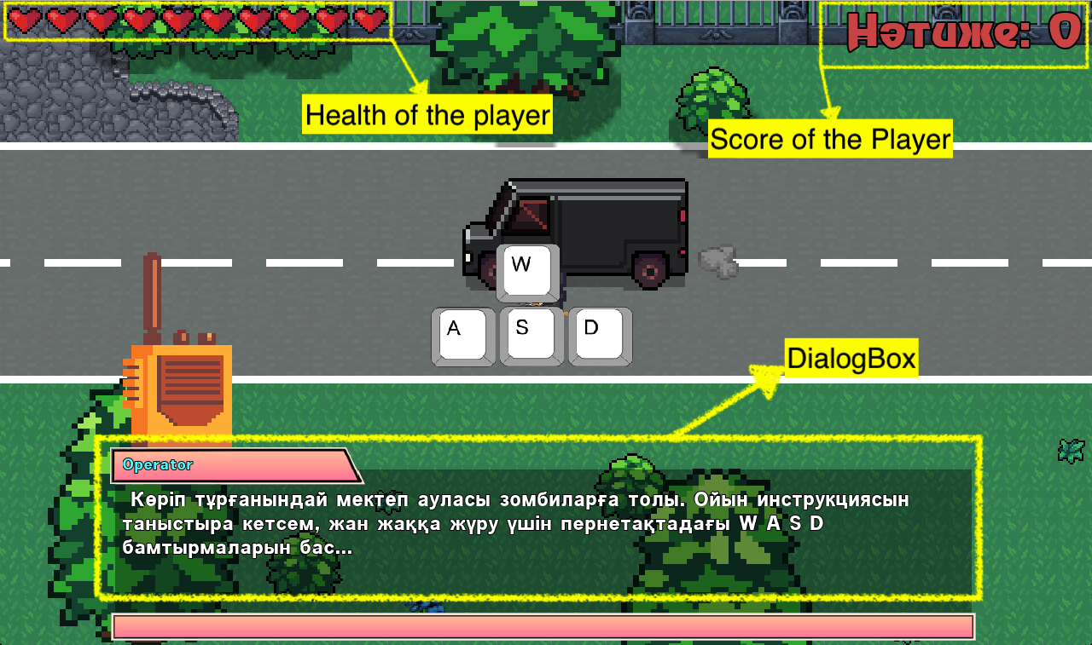

*Figure 30: Interface of the game with data outputs*

This is the main gaming interface of the game and here, several data outputs can be seen. For example, the health of the player is displayed via pictures of the hearts and is changed according to the real health of the player in the game. In other words, it is animation. Score of the player is displayed via label and the number of his label is changed according to the score of the player. Last one is a dialog box which is used for displaying interactive texts or dialogs. This box includes picture background, label text output, and audio of the text in Kazakh language.

## Menu and Module Design

According to the preferences and requirements of the client, I suggest a new system with 4 main modules. Each module has its specific functions. Also, a menu design is needed to lead the user to access to different working modules. The following represents the main modules that will be used in both website and game.

* *Data input module.*
* *Data login and registration module.*
* *Score report module.*
* *Data saving and loading module*

## Data flow diagram of the new system

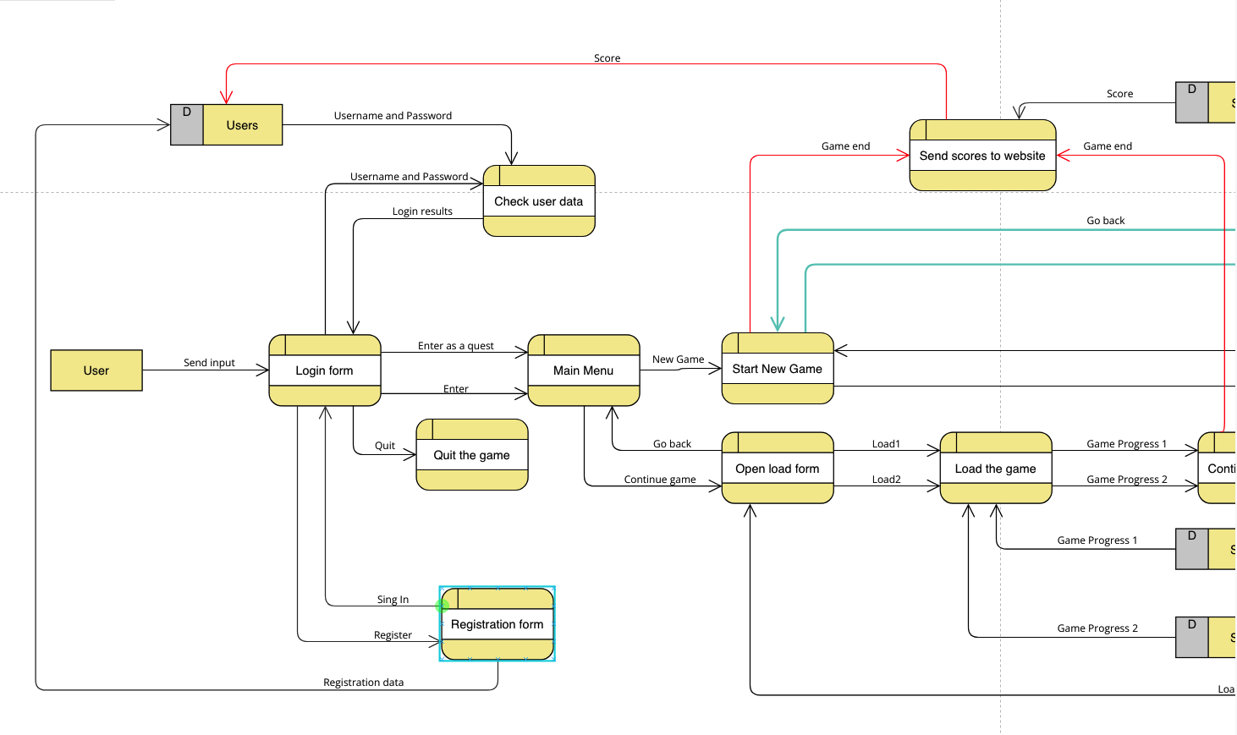

*Figure 31: Data flow diagram of the new system (1-part)*

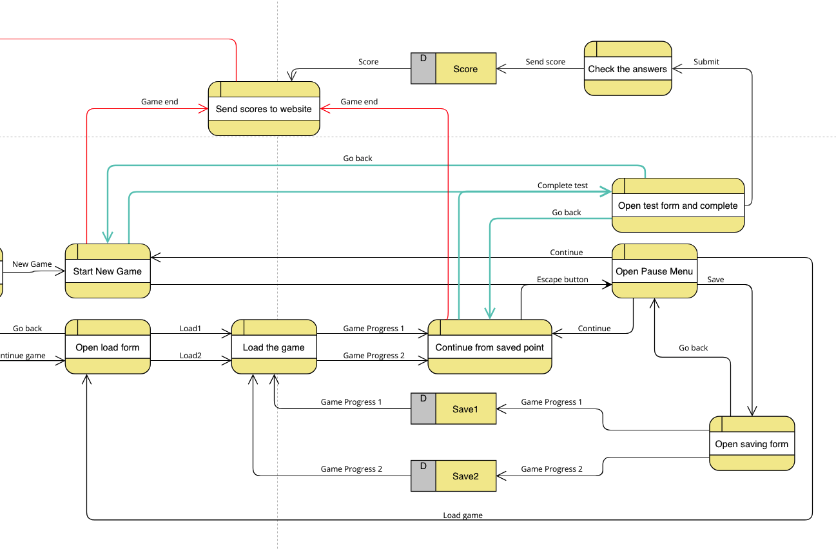

*Figure 32: Data flow diagram of the new system (2-part)*

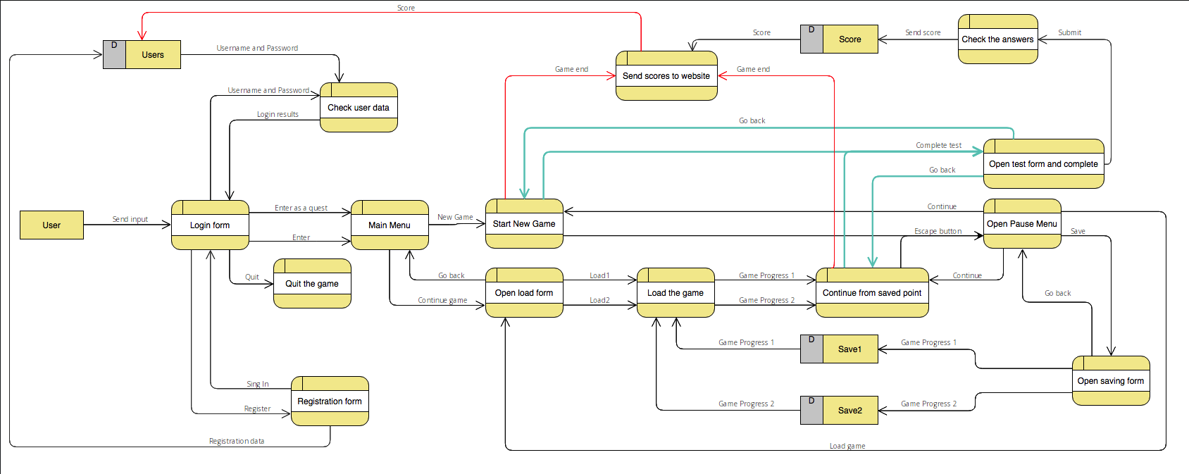

*Figure 33: Whole data flow diagram of the new system*

## Flow chart for the new system (Game)

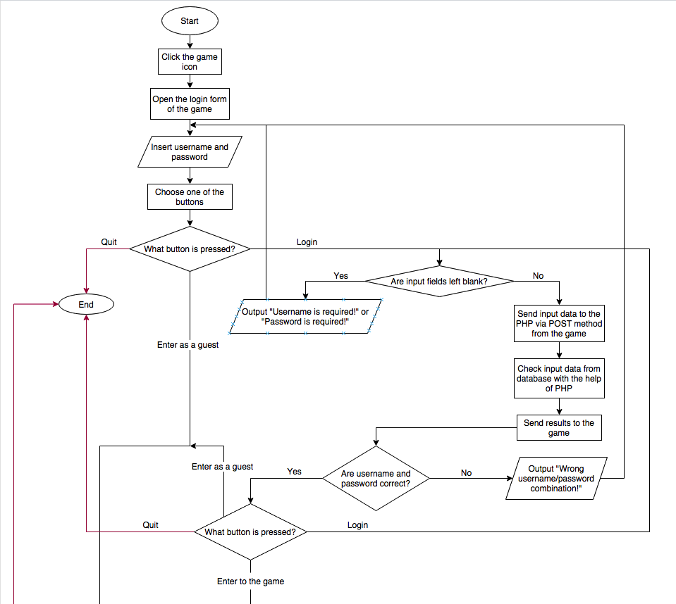

*Figure 34: Flowchart of the new system (1-part)*

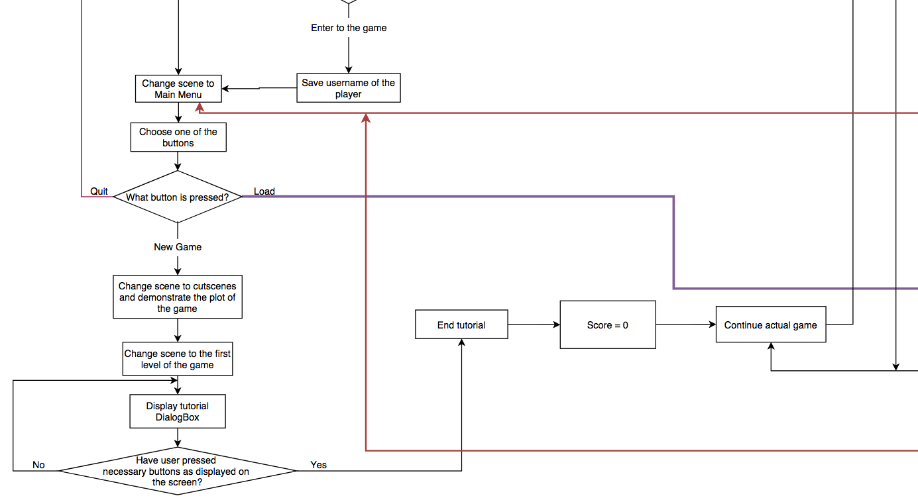

*Figure 35: Flowchart of the new system (2-part)*

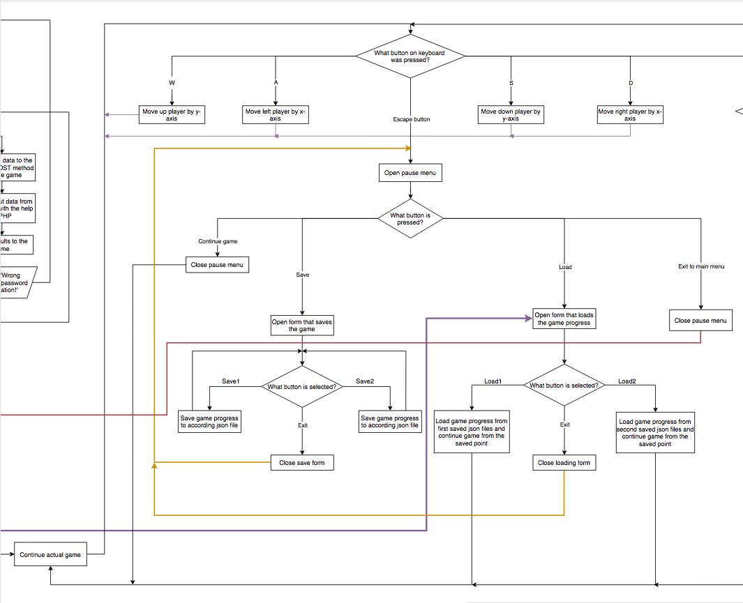

*Figure 36: Flowchart of the new system (3-part)*

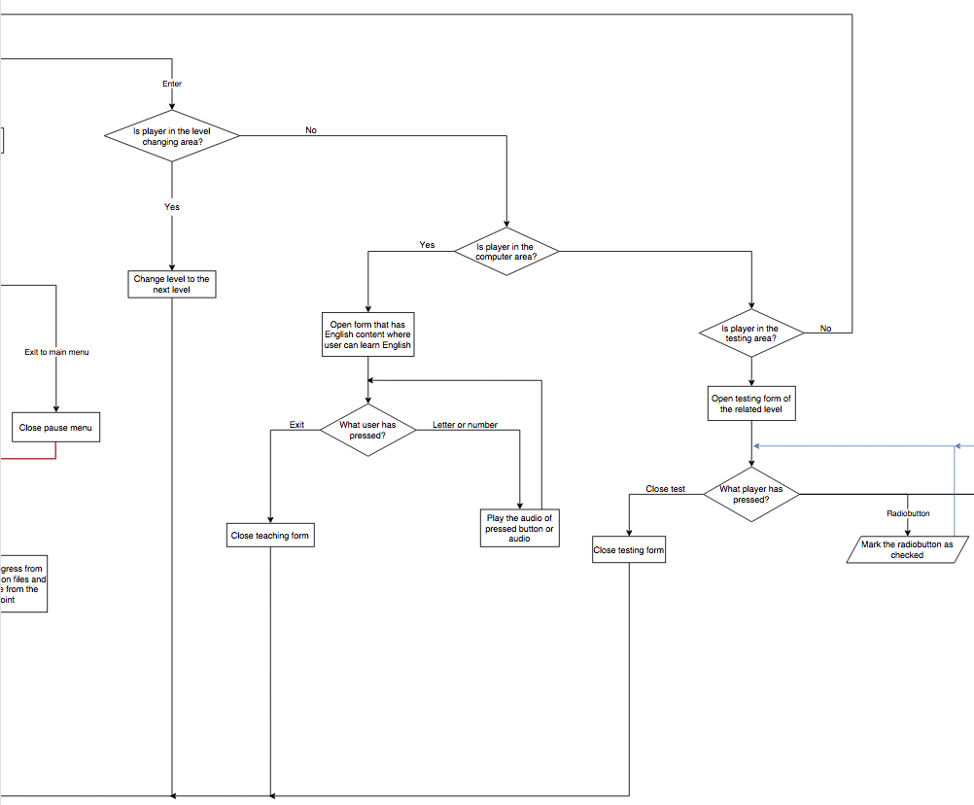

*Figure 37: Flowchart of the new system (4-part)*

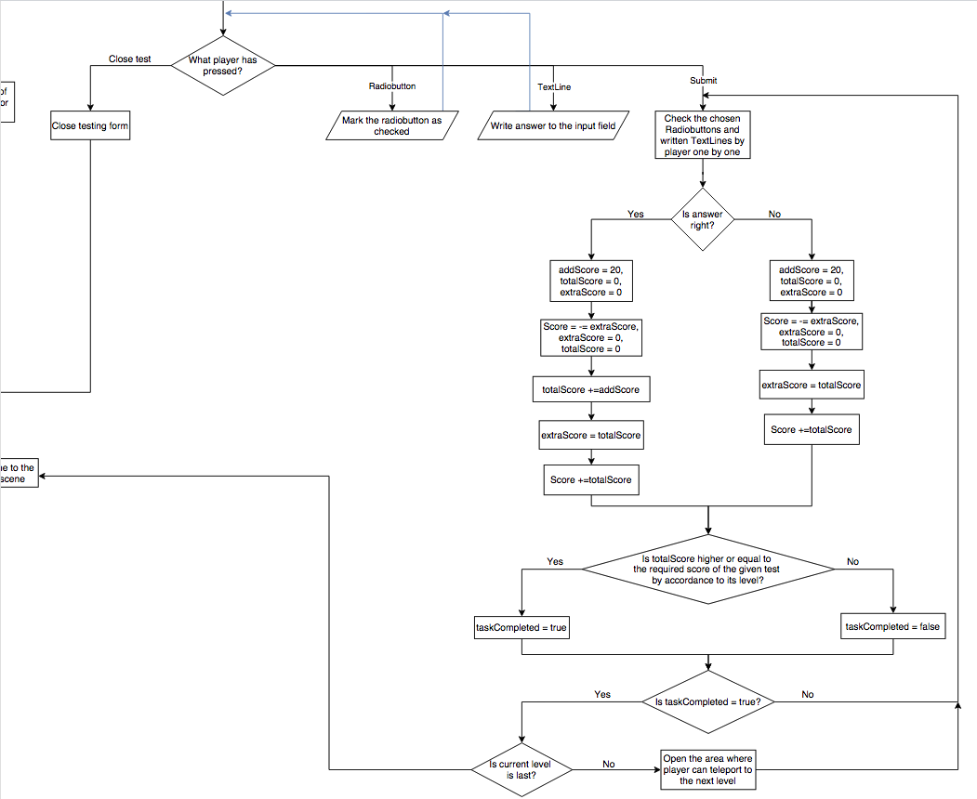

*Figure 38: Flowchart of the new system (5-part)*

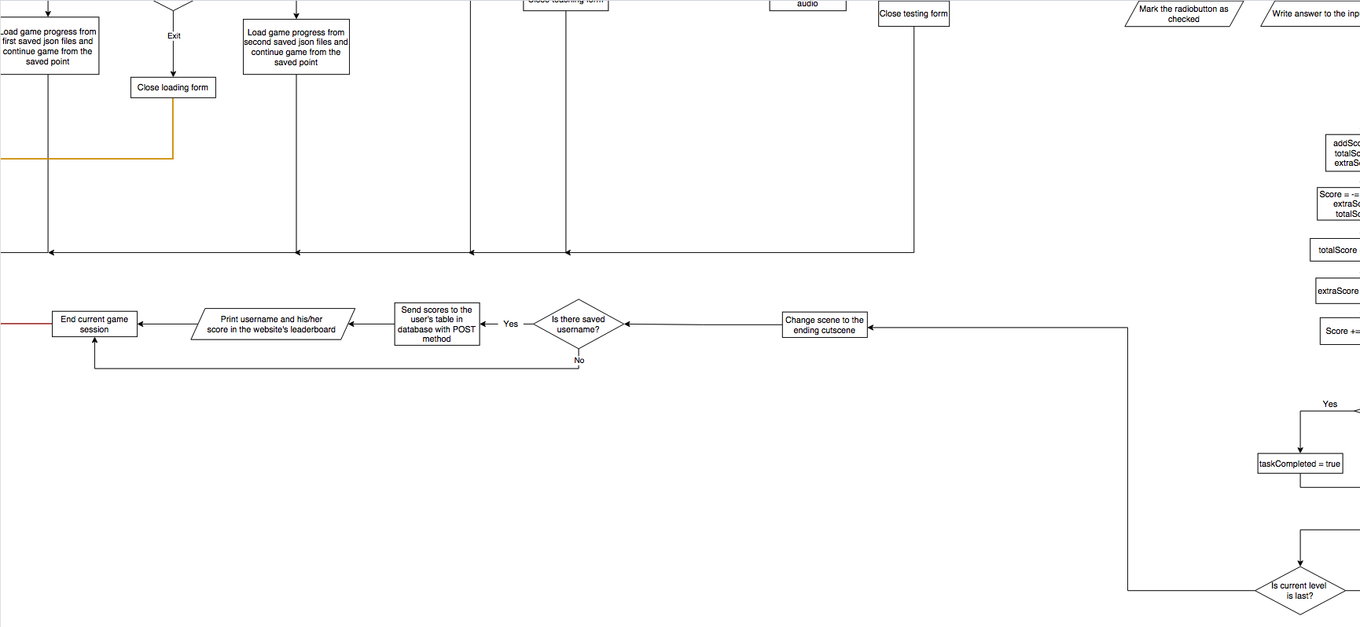

*Figure 39: Flowchart of the new system (6-part)*

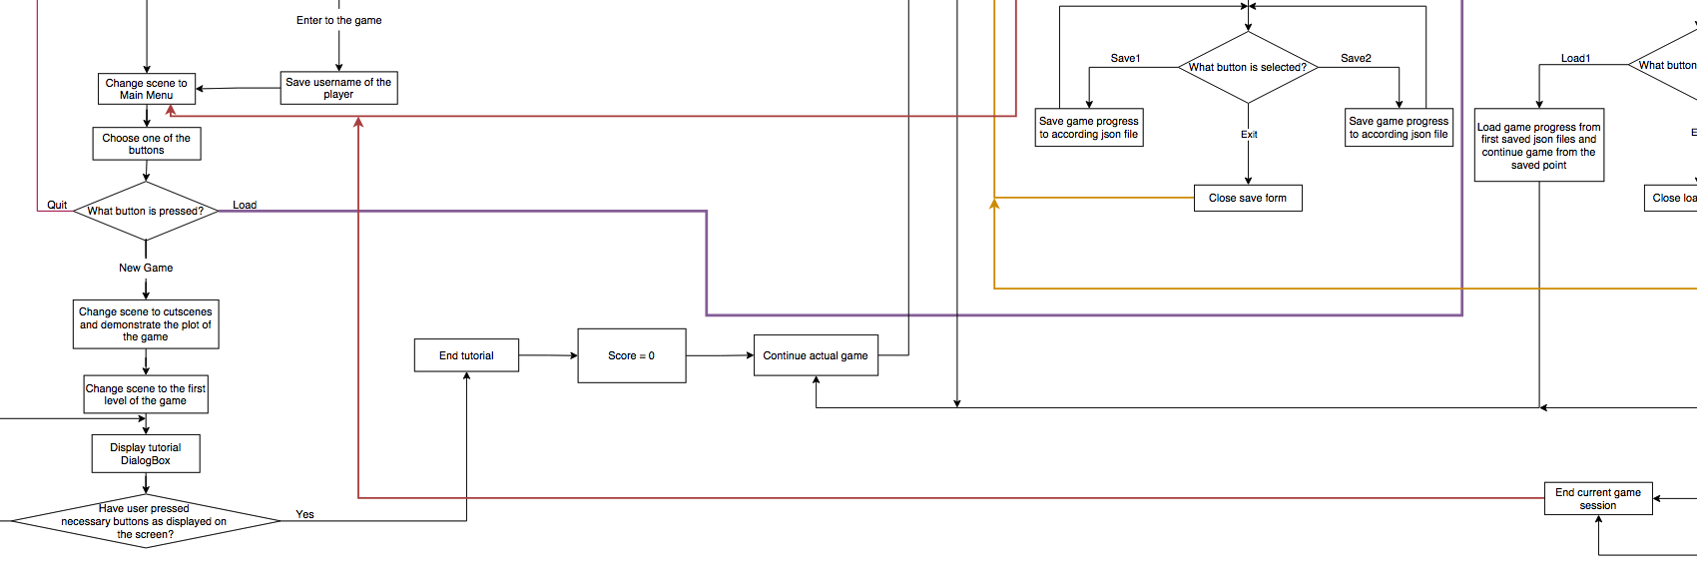

*Figure 40: Flowchart of the new system (7-part)*

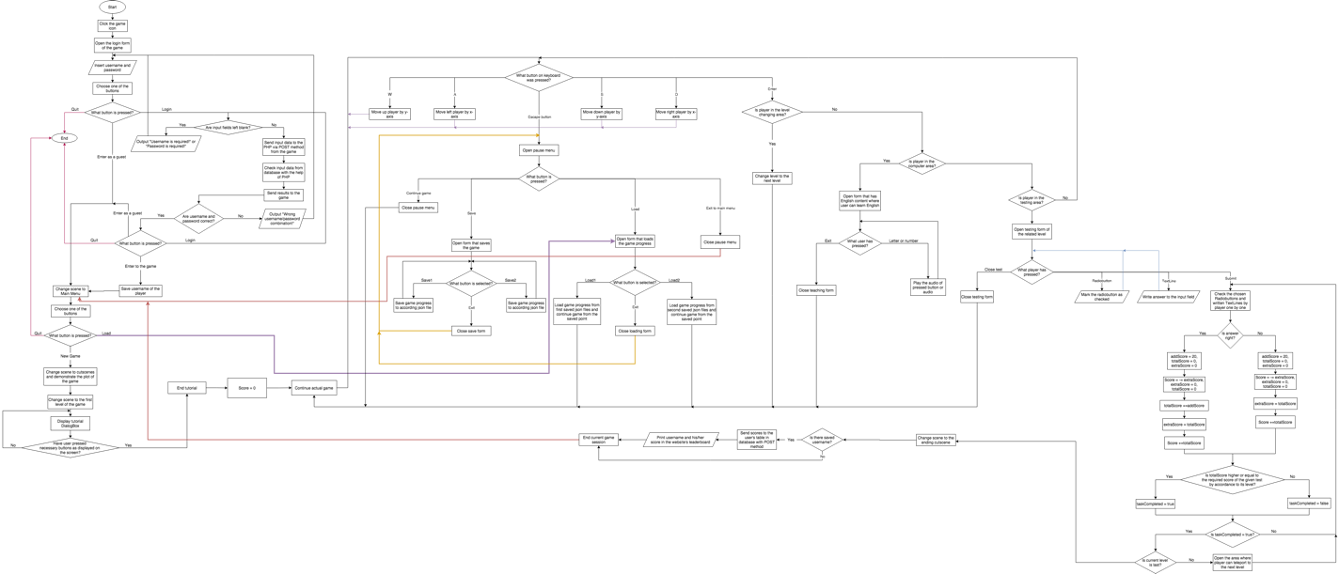

*Figure 41: Whole flowchart of the new system*

## Flow chart for the new system (Website)

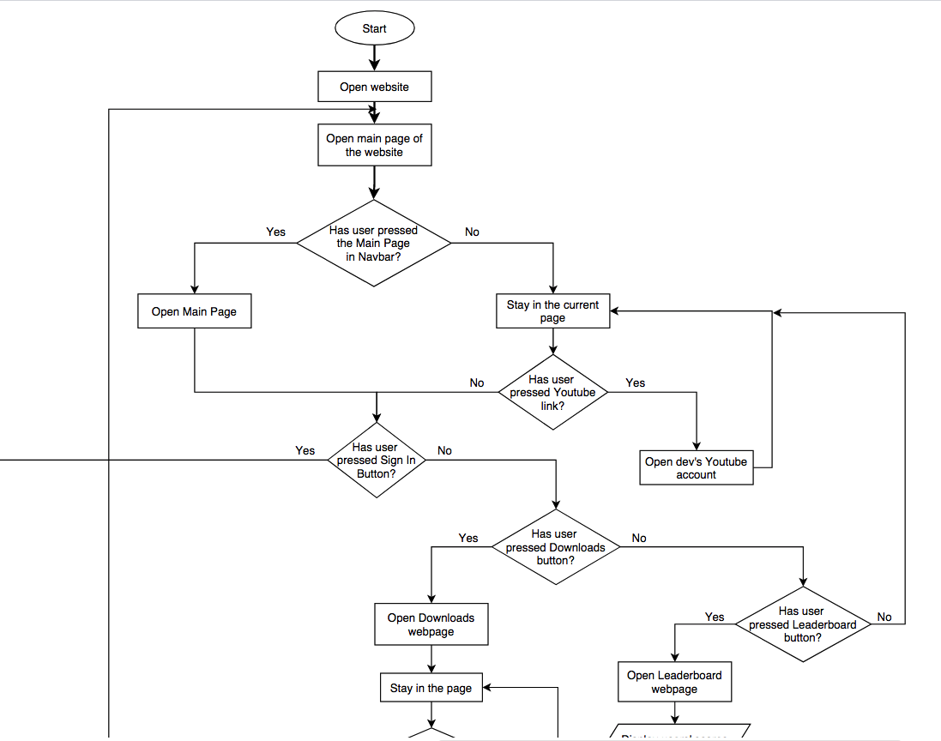

*Figure 42: Flowchart of the new website (1-part)*

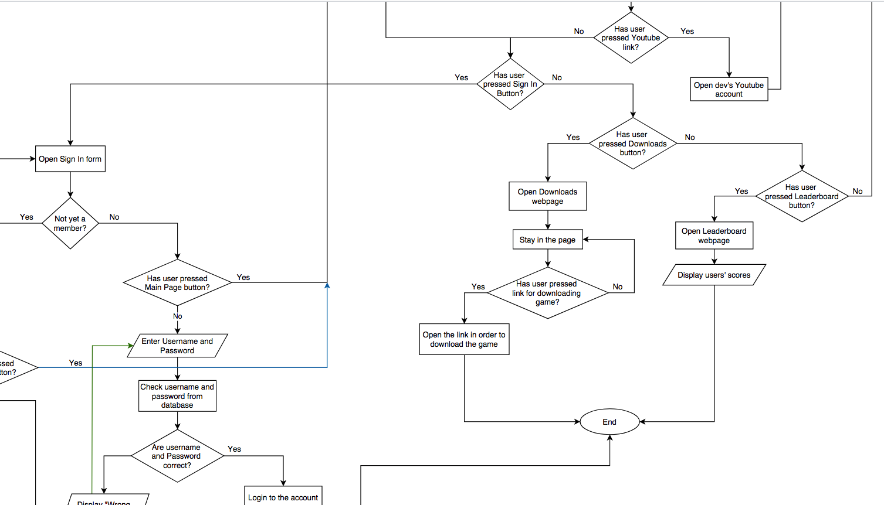

*Figure 43: Flowchart of the new website (2-part)*

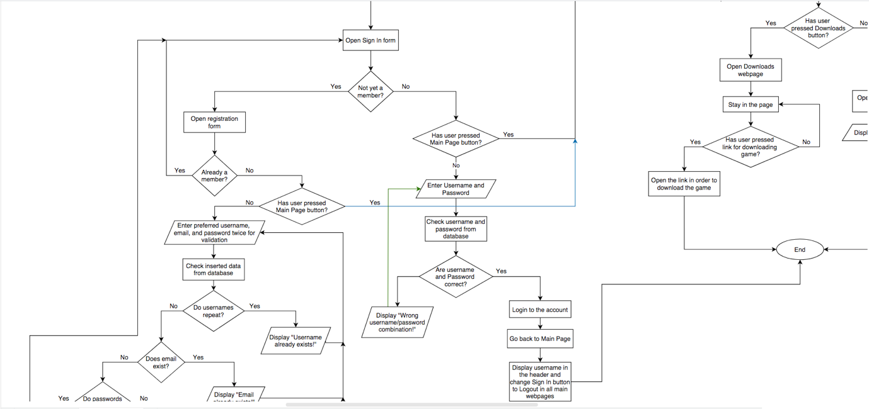

*Figure 44: Flowchart of the new website (3-part)*

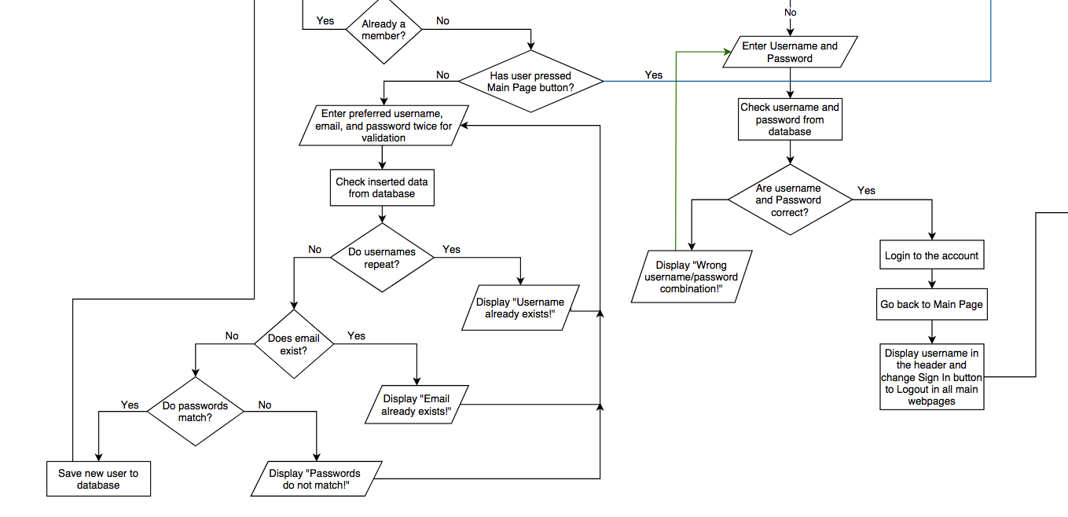

*Figure 45: Flowchart of the new website (4-part)*

## Intended benefits

1. New system is educational, so users can learn beneficial information from the system. This system includes teaching English to Kazakh natives or who want to learn English in Kazakh language. This will give great understanding for people who don’t know other well-known languages. For example, in Kazakhstan, many students learn other languages, mainly Russian. That’s why this game will be helpful for a number of people;
2. New system provides entertaining content for the user. This new system was designed and developed as a game with additional websites. Due to that, players will not get bored while learning English from the game. In game, players will play in 3rd person and it’s designed as a shooter RPG game. Furthermore, the game contains plot. So, players won’t get tired from learning;
3. New system provides flexibility. It is because users can use their user accounts in both website and game, which means both systems are interconnected;
4. Users can increase their memory. Game provides special learning spots where they can learn new words and numbers;
5. Both systems are interactive and user-friendly. In the game, players will meet Kazakh interface and tutorial which will help them in great understanding of the process. Also, players can listen to the Kazakh dialogue of players and they can learn words or numbers by pressing on them and they will play the audio of related words. Moreover, the game contains video content where players can learn new words. On the website, users can download games for free and the registration system provides flexible error output. Whole site is responsive;
6. Games can develop hand-eye coordination in the players as they will have to use both keyboard and mouse.

## Limits of the scope of the solution

Although the new system might solve many problems in the original one, there are still some limits and disadvantages in its usage.

1. Website is not fully optimized. Due to it containing some heavy graphical content, it might lag in the browsers with many opened tabs or highly resource-demanded browsers which use a high amount of RAM;
2. Game might contain some bugs. For example, some of the areas might look strange to the human eye and interaction with some interface might cause the freezing of the game;
3. Due to my system being a game, players might get addicted to it;
4. Some parents of the users might think that this game contains violence due to its shooter and might restrict their children from playing the game;
5. No matter what, this system is newly developed. So, it might contain many underreporting as traditional learning is more developed;
6. Game doesn’t contain translation of all words;
7. Database has a limitation of 5 users.

# Development

### Preparation of necessary software

For the development of the game and website, I need several apps that will help realize my project. Firstly, I need a Game Engine where I can code my game. Secondly, I need a convenient text editor where I can code my website and view other files such as svg, json. Thirdly, I need to have a local server that contains a database for storing user data. As a Game Engine, I chose the “Godot” game engine. This program is user friendly, contains online documentation, tutorials, community forums and its programming language called “GDScript”. This language is really similar to Python and contains many pre-written functions. Also, it’s very light and open-source. As a text editor, I chose Visual Studio Code. It's a really well-developed text editor where users can download only necessary programming languages. Also, it can handle many file formats where I can work with necessary file formats. Thirdly, for the local server I chose XAMPP. It’s free and provides a convenient database with MySQL. Lastly, I needed a browser and have chosen Opera browser as it's just convenient and can open the virtual domain of the XAMPP.



*Figure 46: Logo of the Godot game engine*



*Figure 47: Logo of the XAMPP application*



*Figure 48: Logo of the Visual Studio Code text editor*



*Figure 49: Logo of the Opera browser*

All of these programs are installed and ready for use.

### Building the base of the game

For game development, I started following Godot tutorials and started creating the main character. I used character design from the Internet. Also, audios, videos, and most of the game interior was taken from the Internet. There are 9 main user interface forms where users can have full control over the game.

### Building the base of the website

For the website, I decided to make a website with 5 main forms. For the carcass of the site, I used HTML, for the design I used CSS, and for connecting with the database, I used php (it was also used for some html content).

### Creating local server and database on PHPMyAdmin

In XAMPP I opened virtual domain and this app also provided virtual database. For database, I created “twelvegame” database and In XAMPP I opened virtual domain and this app also provided virtual database. For database, I created “twelvegame” database and one table called “users”.

### Connecting game with database

In order to be able to login and send scores, I had to connect my game to a database with the help of php. In game project’s login form, I send user input data with the help of method POST to the php and in php, user data is checked from.

# Programming

## GDScript Programming language:

### Login form of the game

This form is used in forming the login form of the game. Here, we connect with the website via function called HTTPRequest. It connects with the given URL and the connection type is assigned. When the button pressed, HTTPRequest function sends data from input form and then obtains data from the respective php file.

extends Button #Below is the code of the Login button in login form

var url = "http://192.168.64.2/twelvegame/gamelogin.php" #URL of the site that we will need to send the data

var content = "Content-Type: application/x-www-form-urlencoded" #that means that our data is sent as a form to the site

#Variables

var LOG

var user

var password

var getdata

func _on_Button_pressed(): #function that will process when the Button is pressed

LOG = HTTPRequest.new() #Creating new HTTP connection to the site

user = $'../Label2/LineEdit'.text #getting text that user has inserted to the LineEdit node

password = $'../Label3/LineEdit'.text #getting text that user has inserted to the LineEdit node

var array = [user, password] #array that contain values of user and password

get_tree().get_root().get_node("Login/CanvasLayer/ColorRect/Button").add_child(LOG) #insert new HTTP connection node to this scene

LOG.request(url, [content], false, HTTPClient.METHOD_POST, "Login="+to_json(array)) #Here, http request node sends the data of array (which is converted to json file) as a method POST to the site

LOG.connect("request_completed", self, "connected") #if the request is completed, function named "connected" will process

func connected(_result, _response_code, _headers, body): #function for checking the received data

$'../Label2/UserLabel'.text = "" #Label that will output the details about username completion

$'../Label3/PassLabel'.text = "" #Label that will output the details of other details of connection success or failure

getdata = body.get_string_from_utf8() #getting the received data from our php's "ECHO".

if LOG.is_inside_tree():

LOG.queue_free()

#Printing the received data to labels so user can understanbd what's wrong with the Login in case of wrong data is inserted:

if "Username is required!" in getdata && "Password is required!" in getdata:

$'../Label2/UserLabel'.text = "Username is required!"

$'../Label3/PassLabel'.text = "Password is required!"

$'../Enter'.visible = false

SaveLoadVariables.USERNAME_TRUE = false

elif "Username is required!" in getdata:

$'../Label2/UserLabel'.text = "Username is required!"

$'../Enter'.visible = false

SaveLoadVariables.USERNAME_TRUE = false

elif "Password is required!" in getdata:

$'../Label3/PassLabel'.text = "Password is required!"

$'../Enter'.visible = false

SaveLoadVariables.USERNAME_TRUE = false

elif "Wrong username/password combination" in getdata:

$'../Label3/PassLabel'.text = "Wrong username/password combination"

$'../Enter'.visible = false

SaveLoadVariables.USERNAME_TRUE = false

else: #From here, we will try to set up the scene if all the data is correct:

$'../Label3/PassLabel'.text = "Success!!!"

SaveLoadVariables.USERNAME = user

SaveLoadVariables.USERNAME_TRUE = true

$'../Enter'.visible = true

func _on_Skip_pressed(): #if button skip is pressed, it changes to another scene

ScreenChanger.change_scene("res://MainMenu.tscn", "fade")

func _on_Enter_pressed(): #if button Enter is pressed, it changes to another scene

ScreenChanger.change_scene("res://MainMenu.tscn", "fade")

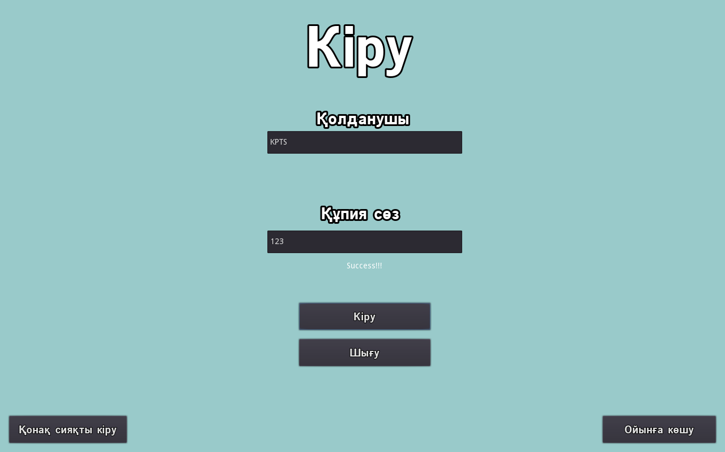

*Figure 50: Login form of the game*

### Main Menu of the game

Main menu contains 3 buttons which has their own functions.

extends MarginContainer #code of the main menu in the game

func _ready(): #when form is loaded, selection is focused on first button

$CanvasLayer/CenterContainer/VBoxContainer/CenterContainer2/VBoxContainer/CenterContainer/StartButton.grab_focus()

func _on_StartButton_pressed(): #while Start button is pressed assign saving variables as false

SaveLoadVariables.toSchoolLevel1 = false

SaveLoadVariables.toSchoolLevel2 = false

SaveLoadVariables.toSchoolLevel3 = false

ScreenChanger.change_scene("res://Cutscene_and_Dialog/InitialCutScene.tscn", "fade") #start new game from cutscene

func _on_ExitButton_pressed(): #while pressed quit from the game

get_tree().quit()

func _on_LoadButton_pressed(): #open loading form if pressed

var save_menu = load("res://Load.tscn").instance() #assign as an instance

add_child(save_menu) #add as a child

get_node("Load").connect("CloseLoadMenu", self, "CloseLoadMenu") #if player pressed CloseLoadMenu then form will get deleted and so, closed

func CloseLoadMenu(): #function for closing Load form

get_node("Load").queue_free()

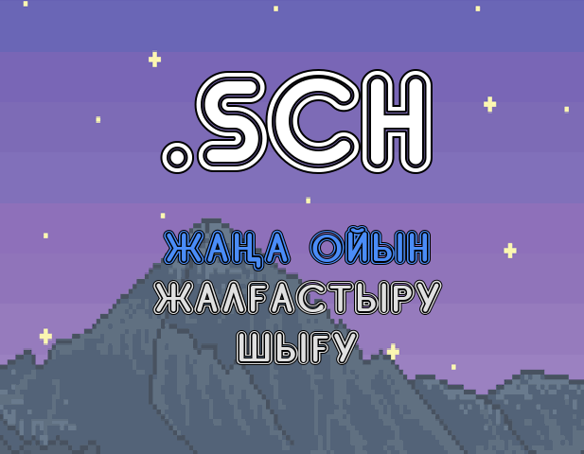

*Figure 51: Main menu of the game*

### Dialog in the First Cutscene of the game

extends Control #Code of the DialogBox of first cutscene

var dialog = [ #lines that will be used in the dialog of the characters that will be shown one by one

" [wave]2081 жыл. Белгісіз бір себеппен, Жер бетінде ядролық соғыс басталды және де ядролық бомбалардың қолданылуы Жер экологиясы мен табиғатының нашарлауына әкеліп соқты...",

" Алайда, жаңа типтегі биоқарудың жасалуы - адамзат тіршілігінің жоғалуына қауіп төңдіре бастады...",

" Себебі бұл қарудың қолданылуы жоспар жүзінде басқа да ядролық бомбалармен бірдей болғанымен, оның ішіндегі вирустың таралу аймағы ескерілмей қалды...",

" Нәтежиесінде, ол вирус Жер бетінің барлық жағына таралып, адамзаттың 99% жойылуына себепші болды...",

" Вирустың бір ерекшелігі - ол тек адамның өмірін алып қою емес, сонымен қатар сол вирустың адам денесіне бейімделуі болып табылады...",

" Қысқасы, адамдар зомбиларға айнала бастады...",

" Ал тірі қалған адамдар олар не вирусқа иммунитеті бар адамдар,",

" не жер астына бункерге тығылған адамдар (Ескерте кетсек вирустың өлшемінен тіпті ол жақта да қорғану мүмкін болмады),",

" не су астында немесе ғарышта жүргендер тірі қалды...",

" Біздің жағдайымызда, біз Каспий теңізінің су асты тіршілігін зерттеп жүрген зерттеушілер болып табыламыз және де болған жағдай туралы біз радиоқабылдағыш арқылы біле алдық...",

" Бақытқа орай, біздің қасымызда жаңа заманауи газтұмылдырықтар болды және де ең бастысы - олар вирусты өткізбеуге қабілетті болды...",

" Жер бетіне шықпастан бұрын, біз өзіміздің сүңгуір қайығымызға арнайы дезинфециялық сектор жасадық. Әйтпесе, біз сол қайық ішіндегі азық-түлігімізден айырылатын едік...",

" Жер бетіне шығып, біз ең бірінші, басқа да тірі адамдарды іздеуге кірістік...",

" Себебі неге болмасқа?",

" Неде болса адамзат болмысының осындай түрде жоғалуы біз үшін нағыз ұят болып табылды...",

" Сондықтан да, біз жер бетіне арнайы штабымызды сайлап, түрлі технологиялық аппараттар арқылы басқа адамдарды іздеуге кірістік...",

" Өкінішке орай, 5 жыл ішінде біз ешқандай да тіршілік көзінен ешқандай хабарлар естімедік...",

" Алайда, бүгін бұл күніміз келді, себебі біз телеграф арқылы көмек жөнінде хабарлама ала алдық..."

]

var character_name = [ #name of the characters that will be seen above their dialog lines

" ???????",

" ???????",

" ???????",

" ???????",

" ???????",

" ???????",

" ???????",

" ???????",

" ???????",

" Оператор",

" Оператор",

" Оператор",

" Оператор",

" Оператор",

" Оператор",

" Оператор",

" Оператор",

" Оператор",

]

#assigning variables

var dialog_index = 0

var finished = false

func load_dialog(): #function for displaying all dialog content

if dialog_index < dialog.size(): #will repeat until dialog is ended

finished = false

$RichTextLabel.bbcode_text = dialog[dialog_index] #text of the Label

$RichTextLabel.percent_visible = 0 #nothing is visible yet

if dialog_index == 0: #if its first dialog

$Tween.interpolate_property( #it will use special function that is used for displaying Dialog on the screen. Words will appear oe by one according to the given time

$RichTextLabel, "percent_visible", 0, 1, 10.29,

Tween.TRANS_LINEAR, Tween.EASE_IN_OUT)

elif dialog_index == 1: #same as above but for next line

$Tween.interpolate_property(

$RichTextLabel, "percent_visible", 0, 1, 5,

Tween.TRANS_LINEAR, Tween.EASE_IN_OUT

)

elif dialog_index == 2:

$Tween.interpolate_property(

$RichTextLabel, "percent_visible", 0, 1, 7.81,

Tween.TRANS_LINEAR, Tween.EASE_IN_OUT

)

elif dialog_index == 3:

$Tween.interpolate_property(

$RichTextLabel, "percent_visible", 0, 1, 6.16,

Tween.TRANS_LINEAR, Tween.EASE_IN_OUT

)

elif dialog_index == 4:

$Tween.interpolate_property(

$RichTextLabel, "percent_visible", 0, 1, 6.73,

Tween.TRANS_LINEAR, Tween.EASE_IN_OUT

)

elif dialog_index == 5:

$Tween.interpolate_property(

$RichTextLabel, "percent_visible", 0, 1, 2.27,

Tween.TRANS_LINEAR, Tween.EASE_IN_OUT

)

elif dialog_index == 6:

$Tween.interpolate_property(

$RichTextLabel, "percent_visible", 0, 1, 3.14,

Tween.TRANS_LINEAR, Tween.EASE_IN_OUT

)

elif dialog_index == 7:

$Tween.interpolate_property(

$RichTextLabel, "percent_visible", 0, 1, 6.28,

Tween.TRANS_LINEAR, Tween.EASE_IN_OUT

)

elif dialog_index == 8:

$Tween.interpolate_property(

$RichTextLabel, "percent_visible", 0, 1, 2.6,

Tween.TRANS_LINEAR, Tween.EASE_IN_OUT

)

elif dialog_index == 9:

$Tween.interpolate_property(

$RichTextLabel, "percent_visible", 0, 1, 10.36,

Tween.TRANS_LINEAR, Tween.EASE_IN_OUT

)

elif dialog_index == 10:

$Tween.interpolate_property(

$RichTextLabel, "percent_visible", 0, 1, 7.81,

Tween.TRANS_LINEAR, Tween.EASE_IN_OUT

)

elif dialog_index == 11:

$Tween.interpolate_property(

$RichTextLabel, "percent_visible", 0, 1, 9.41,

Tween.TRANS_LINEAR, Tween.EASE_IN_OUT

)

elif dialog_index == 12:

$Tween.interpolate_property(

$RichTextLabel, "percent_visible", 0, 1, 4.45,

Tween.TRANS_LINEAR, Tween.EASE_IN_OUT

)

elif dialog_index == 13:

$Tween.interpolate_property(

$RichTextLabel, "percent_visible", 0, 1, 1.35,

Tween.TRANS_LINEAR, Tween.EASE_IN_OUT

)

elif dialog_index == 14:

$Tween.interpolate_property(

$RichTextLabel, "percent_visible", 0, 1, 5.43,

Tween.TRANS_LINEAR, Tween.EASE_IN_OUT

)

elif dialog_index == 15:

$Tween.interpolate_property(

$RichTextLabel, "percent_visible", 0, 1, 7.31,

Tween.TRANS_LINEAR, Tween.EASE_IN_OUT

)

elif dialog_index == 16:

$Tween.interpolate_property(

$RichTextLabel, "percent_visible", 0, 1, 5.88,

Tween.TRANS_LINEAR, Tween.EASE_IN_OUT

)

elif dialog_index == 17:

$Tween.interpolate_property(

$RichTextLabel, "percent_visible", 0, 1, 5.31,

Tween.TRANS_LINEAR, Tween.EASE_IN_OUT

)

$Tween.start()

$Label.text = character_name[dialog_index] #display name of charater order by order

else:

self.hide() #hide after dialogs are finished

dialog_index +=1 #for every text, increase index to get to the next line

func _on_Tween_tween_completed(object, key): #function that finishes the dialog

finished = true

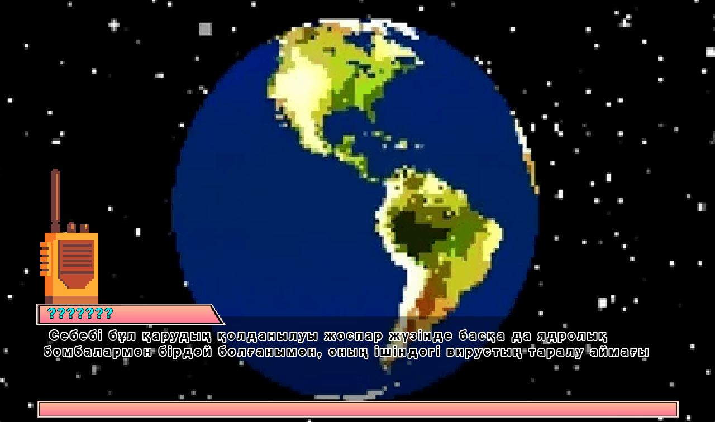

*Figure 52: First cutscene of the game*

### Main form of the First Cutscene of the game

This control node is used to control the animation of the cutscene and handle user inputs.

extends Control #code of the first cutscene

func _process(_delta): #while game is proccesing start from fisrt frame of the cutscene

$AnimationPlayer.play("first_frame")

func _input(_event): #function for accepting user inputs

if Input.is_action_just_pressed("ui_accept"): #if user presses Enter button, skip to the next cuntscene

ScreenChanger.change_scene("res://Cutscene_and_Dialog/SecondCutScene.tscn", "fade")

func _on_AnimationPlayer_animation_finished(_anim_name): #after animation is finished, change scene to the next cutscene

$AnimationPlayer.stop()

ScreenChanger.change_scene("res://Cutscene_and_Dialog/SecondCutScene.tscn", "fade")

### Dialog of the Second Cutscene of the game:

The concept of the second cutscene is same as the first one.

extends Control #dialog of the second cutscene

var dialog = [

" Так, сен не істеу керектігін ұмытпаған шығарысын?",

" Әрине. Айтқанын бойынша, 3-4 адам мектеп астындағы бункерге шоғырланған. Қызық екен...",

" Ия, алайда бұл тапсырманы оңай қабылдама. Себебі сенің жолында зомбилар кездесетін болады. А, айтуды ұмытып кетіппін. Ана адамдардың айтуы бойынша сен жер астына түсу үшін әрбір кірісте тұрған панельдерге барып солардың ішіндегі ағылшын тілі бойынша тапсырмаларын орындауға тиісті боласын...",

" Мәссаған..."

]

var character_name = [

"Operator",

"Мен",

"Operator",

"Мен"

]

var dialog_index = 0

var finished = false

func _process(delta):

pass

$Sprite.visible = finished

$CanvasLayer/NextToolButton.visible = finished

if Input.is_action_just_pressed("ui_accept"):

load_dialog()

func _ready():

load_dialog()

func load_dialog():

if dialog_index < dialog.size():

finished = false

$RichTextLabel.bbcode_text = dialog[dialog_index]

$RichTextLabel.percent_visible = 0

if dialog_index == 0:

$Tween.interpolate_property(

$RichTextLabel, "percent_visible", 0, 1, 3.65,

Tween.TRANS_LINEAR, Tween.EASE_IN_OUT)

$AnimationPlayer.play("first_sentence")

elif dialog_index == 1:

$Tween.interpolate_property(

$RichTextLabel, "percent_visible", 0, 1, 8.17,

Tween.TRANS_LINEAR, Tween.EASE_IN_OUT)

$AnimationPlayer.play("second_sentence")

elif dialog_index == 2:

$Tween.interpolate_property(

$RichTextLabel, "percent_visible", 0, 1, 19.11,

Tween.TRANS_LINEAR, Tween.EASE_IN_OUT)

$AnimationPlayer.play("third_sentence")

elif dialog_index == 3:

$Tween.interpolate_property(

$RichTextLabel, "percent_visible", 0, 1, 1,

Tween.TRANS_LINEAR, Tween.EASE_IN_OUT)

$AnimationPlayer.play("last_one")

$Tween.start()

$RichTextLabel2.text = character_name[dialog_index]

else:

pass

dialog_index +=1

func _on_Tween_tween_completed(object, key):

finished = true

func _on_NextToolButton_pressed(): #if pressed next, start loading dialog

load_dialog()

func _on_AnimationPlayer_animation_finished(anim_name): #after animation is finished, change scene to the first level of the game

ScreenChanger.change_scene("World.tscn", "fade")

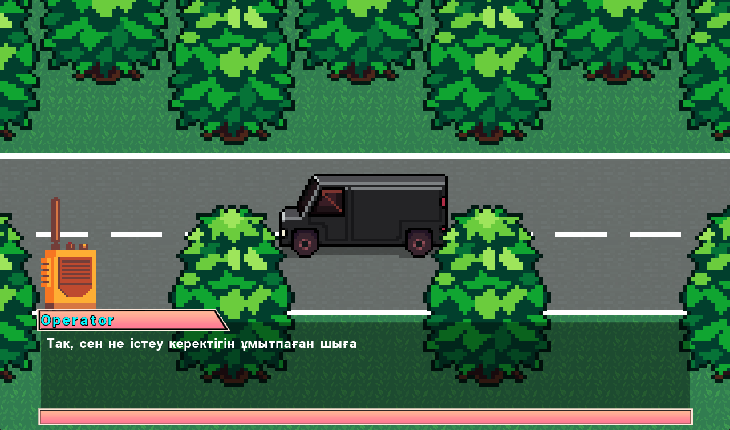

*Figure 53: Second cutscene of the game*

### First level of the game

Code is one of the parts of the first level called “World”.

extends Node2D #main code of the first level

onready var portal = $LevelChangingSpot/CollisionShape2D #assigning area as a variable

var dialogEnd = false

func _ready():

if SaveLoadVariables.loadButton1Pressed == true: #it will load all game progress if user loaded game from main menu

LoadAll.load1() #loading all game progress in first saving json files

SaveLoadVariables.loadButton1Pressed = false #assign the variable as false again

elif SaveLoadVariables.loadButton2Pressed == true:

LoadAll.load2()

SaveLoadVariables.loadButton2Pressed = false

elif SaveLoadVariables.toWorld1 == true: #if player came back from second level, game will load the saved progress of current level while player was teleported to the second level

SaveLoadVariables.loadworld1()

SaveLoadVariables.toWorld1 = false

else: #else game will be started from tutorial point, or new game

$World1/Player.hide()

$CanvasLayer2/DialogBox.show()

$CanvasLayer2/DialogBox/AnimationPlayer.play("van")

Score.points = 0 #setting main score to 0

PlayerStats.health = PlayerStats.max_health #assigning max health to the player

func _on_LevelChangingSpot_screen_changer_area_accepted(): #function that will process if user entered teleporting area and pressed enter

if SaveLoadVariables.firstschool1 == false: #if player was not in next level, it will be assigned as new entering

SaveLoadVariables.toSchoolLevel1 = true

else:

SaveLoadVariables.firstschool1 = true

SaveLoadVariables.saveworld1() #save the progress of first level

ScreenChanger.change_scene("res://School_level1.tscn", "fade") #change scene to the next level

func _show_player(): #function for showing player

$World1/Player.show()

func _on_DialogBox_DialogEnded():

dialogEnd = true

func save(): #function for saving the process of tutorial dialog.

var save_dict = { #it will be saved in dictionary

dialogEnd = dialogEnd

}

return save_dict

func save_world(): #saving name of the level

var save_dict = {

world = get_filename(),

}

return save_dict

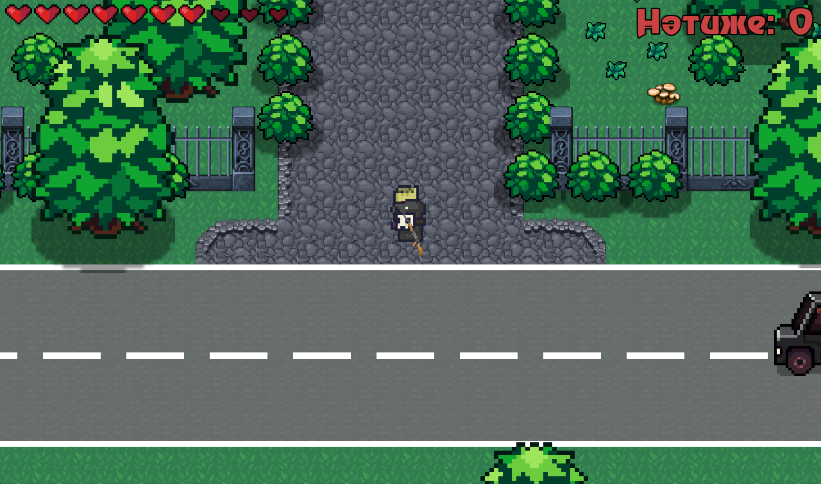

*Figure 54: Main gaming environment/interface of the game*

### Camera limit of the Player

Limit of the camera was assigned for the player to not do outside of the map. For example, TopLeft and BottomRight limits were used.

extends Camera2D --camera of the player

--assgining limits for the camera

onready var topleft = $Limits/TopLeft

onready var bottomRight = $Limits/BottomRight

func _ready(): --choosing position for the camera limit while game is loaded

limit_top = topleft.position.y

limit_left = topleft.position.x

limit_bottom = bottomRight.position.y

limit_right = bottomRight.position.x

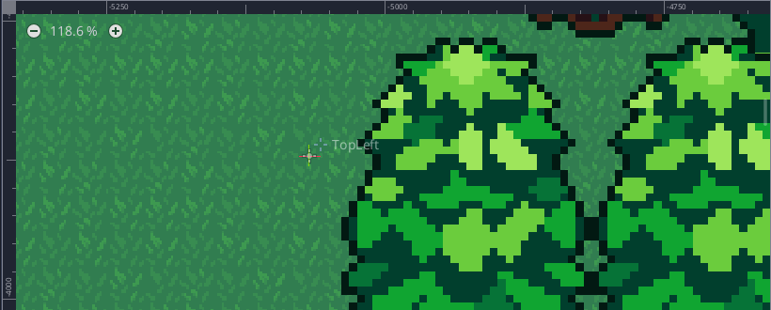

*Figure 55: One of the limits of the camera in the game editor*

### Code of the Player

This is the main code of the player which contain logics, physics and more.

extends KinematicBody2D --the main node of player

var velocity = Vector2.ZERO --setting velocity coordinates to zero

const PLayerHurtSound = preload("res://PlayerHurtSound.tscn")

export var ACCELERATION = 900 --type of speed that is used for gaining velocity

export var MAX_SPEED = 300 --the speed of player

export var FRICTION = 900 --type of speed that is used for stopping smoothly

var stats = PlayerStats

onready var shoot_audio = $shoot

const BulletPath = preload("res://Bullet.tscn") --Loading scene for spawning bullet

onready var animationPlayer = $AnimationPlayer --setting the animations of animation player node to variable

onready var hurtbox = $Hurtbox

onready var blinkAnimation = $BlinkAnimation

--setting timer for gun's bullet

var timer = null

var bullet_delay = 0.2 --delay for shooting

var can_shoot = true

func _ready(): --_ready() is called when the node and its children have all been added to the tree and are ready

stats.connect("no_health", self, "queue_free")

timer = Timer.new() --initializing new timer

timer.set_one_shot(true) --setting fixed framerate for timer

timer.set_wait_time(bullet_delay) --setting waiting time or delay

timer.connect("timeout", self, "on_timeout_complete") --connects when time is out to this code and when its complete

add_child(timer) --adding child function

func on_timeout_complete(): --when time is ended or delay is ended player can shoot

can_shoot = true --true statement for shooting

func _process(_delta): --function for any processes set by delta

if Input.is_action_pressed("shoot") && can_shoot: --checks if shoot key is pressed and can_shoot is true

print("i'm shooting") --checking by printing text

shoot() --calling function for shooting bullet

shoot_audio.play()

can_shoot = false --changing to false due to delay timer

timer.start() --wait 0.2 seconds for next shooting

func _physics_process(delta): --used for completing physical and ingame processes directed to its parent which is Kinematic body

var mouse = get_global_mouse_position() --setting a variable by getting resolution of game screen and mouse's coordinates

var input_vector = Vector2.ZERO --variable for inputting and setting it to (0, 0)

input_vector.x = Input.get_action_strength("ui_right") - Input.get_action_strength("ui_left") --sets for x axis if right or left is pressed by sending 1 or -1

input_vector.y = Input.get_action_strength("ui_down") - Input.get_action_strength("ui_up") --same but for y axis

input_vector = input_vector.normalized() --special function for normilizing so it would be within a circle

if input_vector != Vector2.ZERO: --checks if there was input from the keys

if mouse.x < self.global_position.x: --checks if mouse position is less than 512 px in x axis

animationPlayer.play("RunLeft") --it will play animation that runs left

--------------------------------------------------------------------------------------------------------------------------------------------------------------------

else: --same but for running right

animationPlayer.play("RunRight")

velocity = velocity.move_toward(input_vector*MAX_SPEED, ACCELERATION*delta) --setting final velocity of player so it could run

else: --if no keys are pressed

velocity = velocity.move_toward(Vector2.ZERO, FRICTION * delta) --player will stop smoothly

if mouse.x < self.position.x: --condition for playing standing animation of player

animationPlayer.play("IdleLeft")

else:

animationPlayer.play("IdleRight")

velocity = move_and_slide(velocity) --special function that allows player to move and slide

func shoot(): --function set up for shooting

var bullet = BulletPath.instance() --making a new bullet instance which is another bullet scene

get_parent().add_child(bullet) --it will be set to parent and will add a bullet to it

bullet.rotation = $Sprite/Gun.global_rotation --needed for setting rotation of bullet by using global rotation rate

bullet.position = $Sprite/Gun.global_position--same but with position

bullet.velocity = get_global_mouse_position() - bullet.position --setting the velocity of bullet

func _on_Hurtbox_area_entered(area): --while enemy enters the player's hurtbox

stats.health -= area.damage --downgrade health of the player by accoring damage.

hurtbox.start_invincibility(1)

hurtbox.create_hit_effect() --creating hit effect

var playerhurtSound = PLayerHurtSound.instance()

get_tree().current_scene.add_child(playerhurtSound) --playing hurting sound

func _on_Hurtbox_invincibility_started(): --while Player is hurted, white blinking animation plays on player

blinkAnimation.play("Start")

func _on_Hurtbox_invincibility_ended(): --and stops

blinkAnimation.play("Stop")

func save(): --function for saving player position, score, and health

var save_dict = {

pos = {

x = position.x,

y = position.y

},

score = Score.points,

mainhealth = stats.health

}

return save_dict

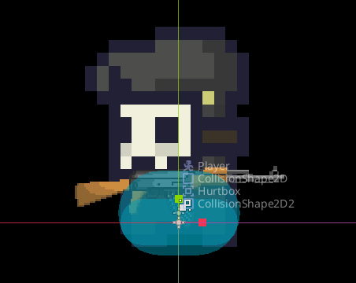

*Figure 56: Contents of the player in the game editor*

### Code of the Player’s gun

Here, mainly rotation of the player’s gun is handled.

extends Sprite #setting gun's sprite

func _physics_process(_delta): #physics process of gun

var mouse = get_local_mouse_position() #setting variable by getting a local position of ,ouse according to screen size

var mousepos = get_global_mouse_position()

if mousepos.x < self.global_position.x: #checks mouse position is less than 512 px in x axis in the current camera position

self.set_flip_v(true)

rotation += mouse.angle() #used for the rotation of sprite according to mouse angle

else:

self.set_flip_v(false)

rotation += mouse.angle() #same as above

### Code of the gun’s bullet

In this code, physics of the bullet, which is mainly the child of player node, is handled.

extends KinematicBody2D #used for bullet scene

const Bullet = preload("res://BulletKnockBack.gd")

onready var BulletHitBox = $BulletKnockBack

var velocity = Vector2(0, 0) #setting velocity to 0

var speed = 800 #setting speed of bullet

func _physics_process(delta):

var collision_info = move_and_collide(velocity.normalized() * delta * speed) #used to set a velocity for bullet so it could move

if collision_info != null: #if no information about collision then delete bullet

queue_free()

BulletHitBox.knockback_vector = velocity.normalized() #normalize the vector of bullet

func _process(_delta):

BulletHitBox.knockback_vector = velocity.normalized()

func _on_body_entered(body):

if "Enemy" in body.name: #if bullet hits enemy, bullet will show hit effect and disappear

var BulletEffect = load("res://HitEffect.tscn")

var bulletEffect = BulletEffect.instance()

var world = get_tree().current_scene

world.add_child(bulletEffect)

bulletEffect.global_position = global_position

queue_free()

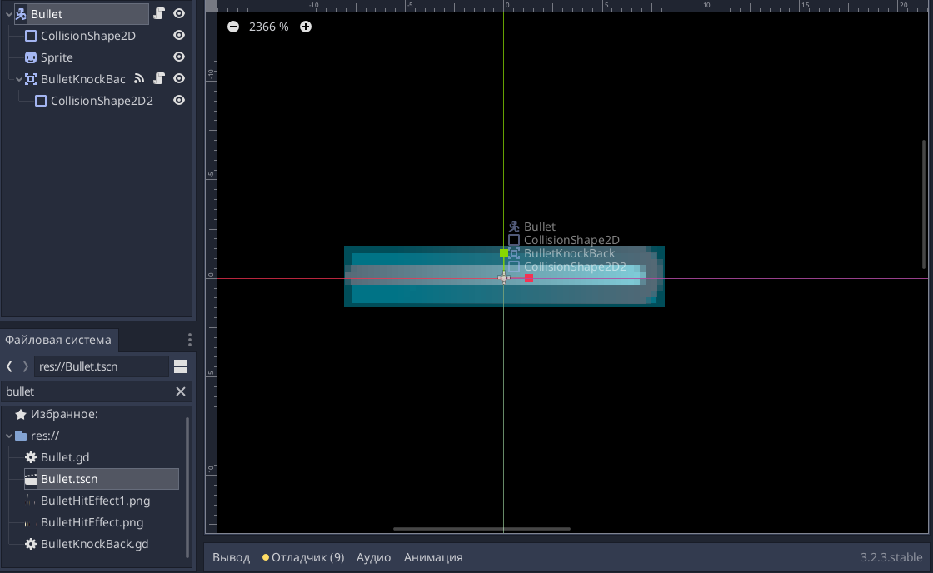

*Figure 57: Contents of the bullet in the game editor*

### Code of the Enemy

Same as the player’s node, enemy’s code handles same physics. However, it has its own simple AI.

extends KinematicBody2D #code of the enemy

#trajectory of enemy's follow

const FORCE = 0.5

const DELTA = 0.2

#states of the enemy

enum{

IDLE,

WANDER,

CHASE

}

var state = IDLE

#velocity of the enemy

export var ACCELERATION = 500

export var SPEED = 150

export var FRICTION = 200

export var WANDER_TARGET_RANGE = 4

#sound of the dying enemy

var EnemyDeathSound = preload("res://EnemyDeathSound.tscn")

#assigning related stats for the Enemy

onready var stats = $Stats

onready var playerDetectionZone = $PlayerDetectionZone

onready var hurtbox = $Hurtbox

#setting vectors for the enemy

var velocity = Vector2()

var behaviour = Vector2()

var knockback = Vector2.ZERO

#setting the animations of animation player node to variable

onready var animationPlayer = $AnimationPlayer

onready var wanderController = $WanderController

onready var blinkAnimationBat = $BlinkBatAnimation

#points that will be given for the player for killed enemy

var Points = 10

func _ready(): #this is used for setting the trajectory of enemy

randomize() #assign random value

var theta = randf()*2*PI #assgning trajectory kength using C=2*PI*randomvalue formula

var ampl = (1+(randf()-0.5)*DELTA)*FORCE #changing amplitude of the enemy by its trajectory

behaviour = Vector2(cos(theta), sin(theta))*ampl #change the vector of enemy by sine and cone value and multiply it by amplitude value. This code will give curved trajectory for the enemy

state = pick_random_state([IDLE, WANDER]) #picking random state for the Enemy, whether staying or just wandering

func _physics_process(delta):

knockback = knockback.move_toward(Vector2.ZERO, FRICTION * delta)

knockback = move_and_slide(knockback) #knockback phyics

match state:

IDLE: #setting IDLE state for enemy where enemy just stands by random time

velocity = velocity.move_toward(Vector2.ZERO, FRICTION * delta)

seek_player()

if wanderController.get_time_left()==0:

update_wander()

if velocity.x < 0:

animationPlayer.play("self_left")

else:

animationPlayer.play("self_right")

WANDER: #setting wandering state for enemy where enemy walks toward player and come back, but don't chase

seek_player()

if wanderController.get_time_left()==0:

update_wander()

var toPlayer = global_position.direction_to(wanderController.target_position)

velocity = velocity.move_toward(toPlayer * SPEED, ACCELERATION * delta)

if global_position.distance_to(wanderController.target_position) <= WANDER_TARGET_RANGE:

update_wander()

if velocity.x < 0:

animationPlayer.play("run_left")

else:

animationPlayer.play("run_right")

CHASE: #state where enemy chases Player

var player = playerDetectionZone.player

if player != null:

var toPlayer = global_position.direction_to(player.global_position)

velocity = (toPlayer+behaviour).normalized()*SPEED

#move_and_collide(velocity*delta)

if velocity.x < 0:

animationPlayer.play("run_left")

else:

animationPlayer.play("run_right")

else:

state=IDLE

move_and_slide(velocity) #assigning velocity of Enemy for last time

func seek_player(): #function if Player in the area of Enemy, so change state for the chase

if playerDetectionZone.can_see_player():

state = CHASE

func pick_random_state(state_list): #picking random state from state list

state_list.shuffle()

return state_list.pop_front()

func update_wander(): #updating random values for wandering of the enemy

state = pick_random_state([IDLE, WANDER])

wanderController.start_wander_timer(rand_range(1, 3))

func kill_enemy(): #function that will delete enemy node

queue_free()

func _on_Hurtbox_area_entered(area): # will functionif something entered enemy hurtbox

stats.health -= area.damage #decrease the health of enemy

knockback = area.knockback_vector * 200 #assigning knockback vector for the enemy if bullet hit the Enemy

hurtbox.create_hit_effect() #create hit efect

hurtbox.start_invincibility(0.4) #start interval for taking damage

func _on_Stats_no_health(): #if enemy do not have health

Score.points += Points #score of the player will be added by points

self.queue_free() #Enemy node will get deleted

var enemydeathSound = EnemyDeathSound.instance()

get_tree().current_scene.add_child(enemydeathSound) #playing deathsound of the enemy

func _on_Hurtbox_invincibility_started():

blinkAnimationBat.play("Start")

func _on_Hurtbox_invincibility_ended():

blinkAnimationBat.play("Stop")

func save(): #saving a position and health of the enemy

var save_dict = {

pos = {

x = position.x,

y = position.y

},

health = stats.health

}

return save_dict

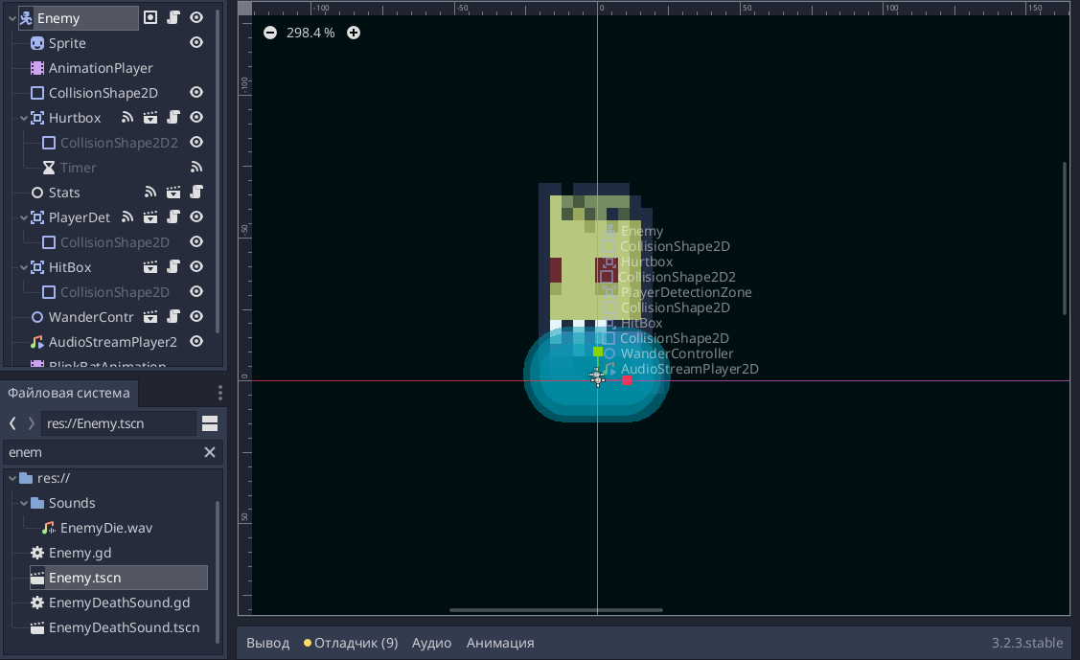

*Figure 58: Contents of the enemy in the game editor*

### Code of the test form

Here, the system of testing form is handled by checking the answers and by assigning scores right.

extends Control #code of the test for level 2

signal TaskCompleted #assigning signal

var taskCompleted1 = false #task of the level one is not completed

func _ready():

pass

var totalScore = 0 #total score from whole session of the test

var addScore = 20 #score for each right answer

var extraScore = 0 #total score from one session of the test

func _on_Area2D_body_entered(_body): #if player entered area, show button for passing the test

if taskCompleted1 == false: #only if task is not completed

$CanvasLayer/CenterContainer/ToolButton.show()

func _on_Area2D_body_exited(_body): #if player left area, hide button for passing the test

if taskCompleted1 == false: #only if task is not completed

$CanvasLayer/CenterContainer/ToolButton.hide()

func _on_ToolButton_pressed(): #if task opening button is pressed, open test form

$CanvasLayer/ColorRect.show()

func _on_TaskExitButton_pressed(): #exit button for exitting the form

$CanvasLayer/ColorRect.hide()

func _on_TaskSubmitButton_pressed(): #while submit button is pressed

Score.points -= extraScore #for every submit, extrascore is withdrawn to prevent repeating score addition

extraScore = 0

totalScore = 0

if $CanvasLayer/ColorRect/ScrollContainer/CenterContainer/VBoxContainer/FirstQuestionVBox/HBoxContainer/C.get_text().to_lower() == 'c': #if answer is right, add score to toal score

totalScore += addScore

if $CanvasLayer/ColorRect/ScrollContainer/CenterContainer/VBoxContainer/FirstQuestionVBox/HBoxContainer/F.get_text().to_lower() == 'f':

totalScore += addScore

if $CanvasLayer/ColorRect/ScrollContainer/CenterContainer/VBoxContainer/FirstQuestionVBox/HBoxContainer/H.get_text().to_lower() == 'h':

totalScore += addScore

if $CanvasLayer/ColorRect/ScrollContainer/CenterContainer/VBoxContainer/FirstQuestionVBox/HBoxContainer2/K.get_text().to_lower() == 'k':

totalScore += addScore

if $CanvasLayer/ColorRect/ScrollContainer/CenterContainer/VBoxContainer/FirstQuestionVBox/HBoxContainer2/O.get_text().to_lower() == 'o':

totalScore += addScore

if $CanvasLayer/ColorRect/ScrollContainer/CenterContainer/VBoxContainer/FirstQuestionVBox/HBoxContainer2/Q.get_text().to_lower() == 'q':

totalScore += addScore

if $CanvasLayer/ColorRect/ScrollContainer/CenterContainer/VBoxContainer/FirstQuestionVBox/HBoxContainer2/S.get_text().to_lower() == 's':

totalScore += addScore

if $CanvasLayer/ColorRect/ScrollContainer/CenterContainer/VBoxContainer/FirstQuestionVBox/HBoxContainer3/V.get_text().to_lower() == 'v':

totalScore += addScore

if $CanvasLayer/ColorRect/ScrollContainer/CenterContainer/VBoxContainer/FirstQuestionVBox/HBoxContainer3/X.get_text().to_lower() == 'x':

totalScore += addScore

if $CanvasLayer/ColorRect/ScrollContainer/CenterContainer/VBoxContainer/SecondQuestionHBox/HBoxContainer2/Label2.get_text().to_lower() == "two":

totalScore += addScore

if $CanvasLayer/ColorRect/ScrollContainer/CenterContainer/VBoxContainer/SecondQuestionHBox/HBoxContainer4/Label4.get_text().to_lower() == "four":

totalScore += addScore

if $CanvasLayer/ColorRect/ScrollContainer/CenterContainer/VBoxContainer/SecondQuestionHBox/HBoxContainer7/Label7.get_text().to_lower() == "seven":

totalScore += addScore

if $CanvasLayer/ColorRect/ScrollContainer/CenterContainer/VBoxContainer/SecondQuestionHBox/HBoxContainer8/Label8.get_text().to_lower() == "eight":

totalScore += addScore

if $CanvasLayer/ColorRect/ScrollContainer/CenterContainer/VBoxContainer/ThirdQuestionHBox/CheckBox2.is_pressed() == true:

totalScore += addScore

if $CanvasLayer/ColorRect/ScrollContainer/CenterContainer/VBoxContainer/FourthQuestion2/CheckBox6.is_pressed() == true:

totalScore += addScore

if $CanvasLayer/ColorRect/ScrollContainer/CenterContainer/VBoxContainer/FifthQuestion2/CheckBox4.is_pressed() == true:

totalScore += addScore

if $CanvasLayer/ColorRect/ScrollContainer/CenterContainer/VBoxContainer/SixthQuestion2/CheckBox2.is_pressed() == true:

totalScore += addScore

if $CanvasLayer/ColorRect/ScrollContainer/CenterContainer/VBoxContainer/SeventhQuestion2/VBoxContainer/CheckBox.is_pressed() == true:

totalScore += addScore

if $CanvasLayer/ColorRect/ScrollContainer/CenterContainer/VBoxContainer/EighthQuestion2/CheckBox.is_pressed() == true:

totalScore += addScore

if $CanvasLayer/ColorRect/ScrollContainer/CenterContainer/VBoxContainer/NinthQuestion2/VBoxContainer2/CheckBox4.is_pressed() == true:

totalScore += addScore

if $CanvasLayer/ColorRect/ScrollContainer/CenterContainer/VBoxContainer/TenthQuestion2/CheckBox2.is_pressed() == true:

totalScore += addScore

if $CanvasLayer/ColorRect/ScrollContainer/CenterContainer/VBoxContainer/EleventhQuestion2/VBoxContainer2/CheckBox3.is_pressed() == true:

totalScore += addScore

if $CanvasLayer/ColorRect/ScrollContainer/CenterContainer/VBoxContainer/TwelfthQuestion2/CheckBox3.is_pressed() == true:

totalScore += addScore

if totalScore >= 400: #if totalScore is higher or equal to needed score then teleport to next level is opened

taskCompleted1 = true

else:

taskCompleted1 = false

if taskCompleted1 == true:

$CanvasLayer/CenterContainer/ToolButton.hide()

emit_signal("TaskCompleted")

extraScore = totalScore

Score.points += totalScore

$CanvasLayer/ColorRect.hide()

func save(): #save data about test

var save_dict = {

extraScore = extraScore,

totalScore = totalScore

}

return save_dict



*Figure 59: One of the testing forms of the game*

### Game progress saving form

This code is used to control over saving form. This form saves game data to related .json files by the button. Also, nested loops are used.

extends Control

signal CloseSaveMenu

const SAVE_PATH1 = "res://Save1.json"

const SAVE_PATH2 = "res://Save2.json"

const SAVE_WORLD1 = "res://saveworld1.json"

const SAVE_WORLD2 = "res://saveworld2.json"

func _input(event):

if event.is_action_pressed("pause"):

self.queue_free()

func save():

var save_dict = {}

var nodes_to_save = get_tree().get_nodes_in_group("save")

for node in nodes_to_save:

save_dict[node.get_path()] = node.save()

var save_file = File.new()

save_file.open(SAVE_PATH1, File.WRITE)

save_file.store_line(to_json(save_dict))

func save2():

var save_dict = {}

var nodes_to_save = get_tree().get_nodes_in_group("save")

for node in nodes_to_save:

save_dict[node.get_path()] = node.save()

var save_file = File.new()

save_file.open(SAVE_PATH2, File.WRITE)

save_file.store_line(to_json(save_dict))

func _on_btn_Save1_pressed():

save()

save_world()

func _on_btn_Save2_pressed():

save2()

save_world2()

func save_world():

var save_dict = {}

var nodes_to_save = get_tree().get_nodes_in_group("world")

for node in nodes_to_save: #example of a nested loop

if node.get_path() == "/root/World1" or node.get_path() == "/root/School_level1" or node.get_path() == "/root/School_level2" or node.get_path() == "/root/School_level3":

save_dict = node.save_world()

var save_file = File.new()

save_file.open(SAVE_WORLD1, File.WRITE)

save_file.store_line(to_json(save_dict))

func save_world2():

var save_dict = {}

var nodes_to_save = get_tree().get_nodes_in_group("world")

for node in nodes_to_save:

if node.get_path() == "/root/World1" or node.get_path() == "/root/School_level1" or node.get_path() == "/root/School_level2" or node.get_path() == "/root/School_level3":

save_dict = node.save_world()

var save_file = File.new()

save_file.open(SAVE_WORLD2, File.WRITE)

save_file.store_line(to_json(save_dict))

func _on_btn_Back_pressed():

emit_signal("CloseSaveMenu")

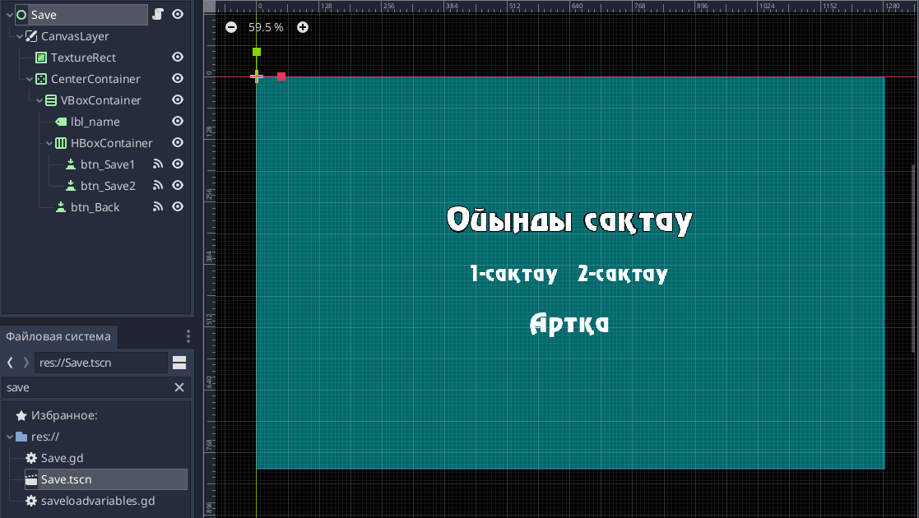

*Figure 60: View of the saving form in the game editor*

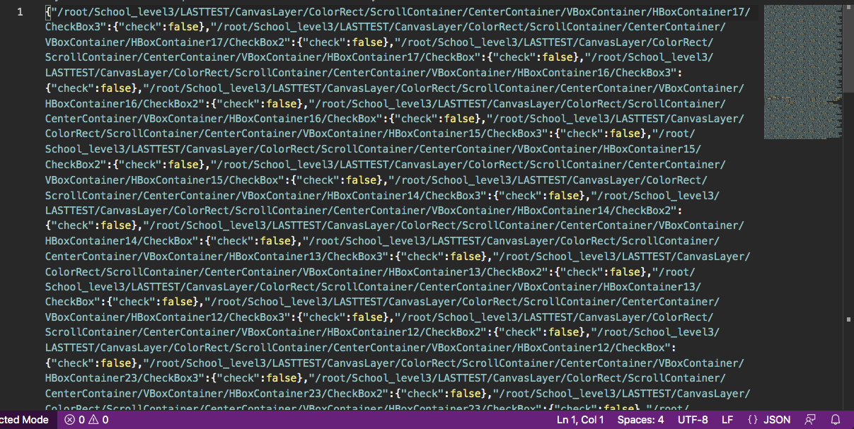

*Figure 61: One of the examples of actual saved data in the json file*

### Game progress loading form

This code is used to control over loading form by getting data from the .json files. Also, nested loops are used.

extends Control

const SAVE1_PATH = "res://Save1.json"

const SAVE2_PATH = "res://Save2.json"

const SAVE_WORLD1 = "res://saveworld1.json"

const SAVE_WORLD2 = "res://saveworld2.json"

signal CloseLoadMenu

func _ready():

pass

func _input(event):

if event.is_action_pressed("pause"):

self.hide()

func _on_ExitButton_pressed():

emit_signal("CloseLoadMenu")

func _on_btn_load1_pressed():

SaveLoadVariables.loadButton1Pressed = true

load_world1()

print(SaveLoadVariables.loadButton1Pressed)

func _on_btn_load2_pressed():

SaveLoadVariables.loadButton2Pressed = true

load_world2()

func load1():

var save_file = File.new()

save_file.open(SAVE1_PATH, File.READ)

var data = {}

var text = save_file.get_as_text()

data = parse_json(text)

var allnodes = get_tree().get_nodes_in_group("qwe")

for node_path in data.keys(): #example of a nested loop

var node = get_node(node_path)

for attribute in data[node_path]:

if attribute == "pos":

node.position = Vector2(data[node_path]['pos']['x'], data[node_path]['pos']['y'])

elif attribute == "score":

Score.points = data[node_path]["score"]

elif attribute == "dialogEnd":

node.set(attribute, data[node_path]["dialogEnd"])

elif attribute == "mainhealth":

PlayerStats.health = data[node_path]["mainhealth"]

elif attribute == "health":

node.set(attribute, data[node_path]["health"])

elif attribute == "line":

node.text = data[node_path]["line"]

elif attribute == "check":

node.pressed = data[node_path]["check"]

else:

node.set(attribute, data[node_path][attribute])

for i in range(allnodes.size()):

var dead = data.keys()

if allnodes[i].get_path() in dead:

var a = get_node(allnodes[i].get_path())

print(a)

else:

var a = get_node(allnodes[i].get_path())

a.queue_free()

func load2():

var save_file = File.new()

save_file.open(SAVE2_PATH, File.READ)

var data = {}

var text = save_file.get_as_text()

data = parse_json(text)

var allnodes = get_tree().get_nodes_in_group("qwe")

for node_path in data.keys():

var node = get_node(node_path)

for attribute in data[node_path]:

if attribute == "pos":

node.position = Vector2(data[node_path]['pos']['x'], data[node_path]['pos']['y'])

elif attribute == "score":

Score.points = data[node_path]["score"]

elif attribute == "dialogEnd":

node.set(attribute, data[node_path]["dialogEnd"])

elif attribute == "mainhealth":

PlayerStats.health = data[node_path]["mainhealth"]

elif attribute == "health":

node.set(attribute, data[node_path]["health"])

else:

node.set(attribute, data[node_path][attribute])

for i in range(allnodes.size()):

var dead = data.keys()

if allnodes[i].get_path() in dead:

var a = get_node(allnodes[i].get_path())

print(a)

else:

var a = get_node(allnodes[i].get_path())

a.queue_free()

func load_world1():

var save_file = File.new()

save_file.open(SAVE_WORLD1, File.READ)

var data = {}

var text = save_file.get_as_text()

data = parse_json(text)

for node_path in data.keys():

if node_path == "world":

ScreenChanger.change_scene(data[node_path], "fade")

func load_world2():

var save_file = File.new()

save_file.open(SAVE_WORLD2, File.READ)

var data = {}

var text = save_file.get_as_text()

data = parse_json(text)

for node_path in data.keys():

if node_path == "world":

ScreenChanger.change_scene(data[node_path], "fade")

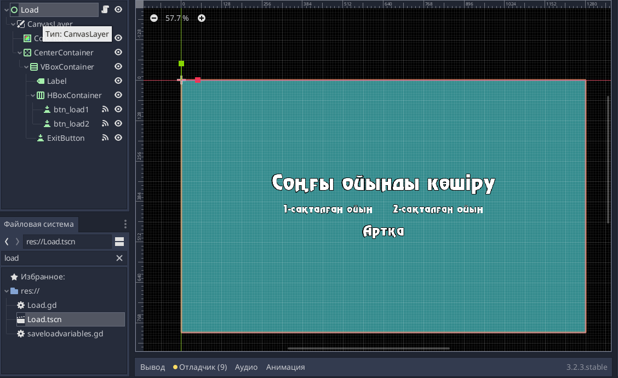

*Figure 62: View of the loading form in the game editor*

### Sending game score to the php file via POST method:

This code is used to send the scores after finishing the game. Data is sent by HTTPRequest method in one array.

func _on_Dialog_dialogEnd():

$CanvasLayer2.queue_free()

dialogEnd = true

ScreenChanger.change_scene("res://Cutscene_and_Dialog/TotalEnd.tscn", "fade")

if SaveLoadVariables.USERNAME_TRUE == true:

SENDSCORE = HTTPRequest.new() #Creating new HTTP connection to the site

user_score = [SaveLoadVariables.USERNAME, Score.points]

get_tree().get_root().get_node("School_level3").add_child(SENDSCORE) #insert new HTTP connection node to this scene

SENDSCORE.request(url, [content], false, HTTPClient.METHOD_POST, "Score="+to_json(user_score)) #Here, http request node sends the score as a method POST to the site

SENDSCORE.connect("request_completed", self, "connected") #if request completed, function conected will work

print(to_json(user_score))

func connected(_result, _response_code, _headers, body):

print(body.get_string_from_utf8()) #printing data

## PHP with HTML, CSS, and JavaScript

### Main Page of the website

For the main page on the website, I used internal CSS, HTML tags, and internal JavaScript by using <style>, <body>, and <script> tags.

CSS tags are used to make glowing effect on the text, to add card backgrounds for the pictures, to make animated or color-changing background for the website, to customize the Navigation bar by adding hover effects on buttons, and to control over the gallery which automatically changes pictures.

HTML is used to construct the main carcass of the website.

In terms of JavaScript, by the help of for loops, a gallery with automatic changing pictures is made. Also, this code uses a recursive function as the gallery’s pictures are changing infinitely.

<php> tag is used to show the name of user if the user was logged in.

All the other pages as Download, and Leaderboard has similar CSS effects and PHP.

<?php

//connecting with server.php file

include("server.php");

?>

<!DOCTYPE html>

<html>

<head>

<style>

* {

box-sizing: border-box;

}

body {

font-family: arial;

padding: 19px;

background: linear-gradient(-45deg, #efdd53, #e6397e, #20a1d4, #20d4ad);

background-size: 399% 399%;

animation: gradient 14.9s ease infinite;

}

.header h1 {

font-size: 49.9px;

}

/* The header of the website */

.header {

padding: 0px 0px 19px;

border-radius: 9.9px;

text-align: center;

background: #FFFFFF;

}

/* Style of the top navigation bar */

.navi{

border-radius: 9.99px;

width: 99.99999%;

overflow: hidden;

background-color: #343232;

}

/* Change color while hovering on the links */

.navi a:hover {

background-color: #dedede;

color: #000000;

}

/* Style the navigation bar links */

.navi a {

float: left;

display: block;

color: #f0efef;

text-align: center;

padding: 13.999px 19.99px;

text-decoration: none;

}

/* Create two unequal columns that floats next to each other */

/* Left side column */

.sol {

border-radius: 9.99px 9.99px 9.99px 0px;

float: left;

width: 74.99999%;

}

/* Right side column */

.on {

border-radius: 9.999px 9.999px 9.999px 9.99px;

float: right;

width: 25%;

background-color: #A020F0;

padding-left: 9.999px;

margin-top: 19.999px;

padding-top: -19.999px;

padding-right: 9.99px;

padding-bottom: 9.99px;

}

.suret {

background-color: #808080;

padding: 9.99px;

}

/* Add a background for articles */

.tort {

border-radius: 9.99px 9.99px 9.99px 9.999px;

background-color: #FFFFFF;

padding: 19.99px;

margin-top: 19.99px;

}

/* Clear floats after the columns */

.oryn:after {

content: "";

display: table;

clear: both;

}

/* Responsive layout that stacks the content of the website order by order */

@media screen and (max-width: 799.999px) {

.sol, .sol {

width: 100%;

padding: 0;

}

}

/* Responsive layout that stacks the content of the website order by order*/

@media screen and (max-width: 399.99px) {

.navi a {

float: none;

width: 99.9999%;

}

}

* {box-sizing:border-box}

/* Slideshow of the images */

.gallerychanger {

margin: auto;

background-attachment: fixed;

background-size: cover;

}

/* Hide the images by default */

.GalleryImages {

display: none;

}

/* On hover, add a black background color with a little bit see-through */

.prev:hover, .next:hover {

background-color: rgba(0,0,0,0.8);

}

/* Caption text */

.text {

color: #f0f0ef;

font-size: 14.999px;

padding: 7.99px 11.99px;

position: absolute;

bottom: 7.999px;

width: 99.999%;

text-align: center;

}

/* the keyframes below are used for background which can change the color*/

@-webkit-keyframes fade {

from {opacity: 3.99}

to {opacity: 2}

}

@keyframes fade {

from {opacity: 3.99}

to {opacity: 2}

}

@keyframes gradient {

0% {

background-position: 0.0001% 49.999%;

}

50% {

background-position: 99.999% 49.999%;

}

100% {

background-position: 0.0001% 49.99%;

}

}

.bastyzat {

border-radius: 9.999px;

font-size: 79.99px;

color: #fff;

text-align: center;

-webkit-animation: glow 1s ease-in-out infinite alternate;

-moz-animation: glow 1s ease-in-out infinite alternate;

animation: glow 1s ease-in-out infinite alternate;

}

@-webkit-keyframes glow{ /* Used to make glow effect on the particular text */

from {

text-shadow: 0 0 10px #fff, 0 0 20px #fff, 0 0 30px #e60073, 0 0 40px #e60073, 0 0 50px #e60073, 0 0 60px #e60073, 0 0 70px #e60073;

}

to {

text-shadow: 0 0 20px #fff, 0 0 30px #ff4da6, 0 0 40px #ff4da6, 0 0 50px #ff4da6, 0 0 60px #ff4da6, 0 0 70px #ff4da6, 0 0 80px #ff4da6;

}

}

</style>

</head>

<body>

<div class="header">

<div class="navi">

<a href="project.php">Main Page</a>

<a href="Downloads.php">Downloads</a>

<a href="Leaderboard.php">Leaderboard</a>

<?php

if (isset($_SESSION['username'])){

echo '<a href="logout.php" style="float:right"> Logout </a>';

}

else {

echo '<a href="login.php" style="float:right"> Sing in </a>';

}

?>

</div>

<div class="bastyzat">

<h1>.SCH</h1>

</div>

<h3>2D RPG Pixel game that is supposed to teach English</h3>

<h3>

<?php /* Used to show user name if user was logged, else do not show anything*/

if (isset($_SESSION['username'])){

echo '<p> Hey, ', $_SESSION['username'], '!</p>';

}

else {

echo "<p></p>";

}

?>

</h3>

</div>

<div class="oryn">

<div class="sol">

<div class="tort">

<h2>ABOUT GAME</h2>

<div class="suret">

<div class="gallerychanger">

<!-- Full-width images with number and caption text -->

<div class="GalleryImages fade">

<img src="photos/gallery1.png" style="width:100%; max-height: 400px; position: 100%;">

</div>

<div class="GalleryImages fade">

<img src="photos/gallery2.png" style="width:100%; max-height: 400px; position: 100%;">

</div>

<div class="GalleryImages fade">

<img src="photos/gallery3.png" style="width:100%; max-height: 400px; position: 100%;">

</div>

</div>

</div>

<p>This project's started creating since the summer of 2020. The main purpose of the project is to help Kazakh schoolchildren by improving their English. However, just learning materials is not funny, so I decided to add a game with plot. As you can see from photo, this game has its own environment based on 2D world. Also, due to this game is Role-play gaming, player has to control character. Aside of plot and enemies, this game has special interface that teaches English, and in order to pass to the next level, you have pass special tests in order to evaluate your level of English that you had obtained from the game. Also, this game is being created on the dame engine called "Godot". </p>

</div>

<div class="tort">

<h2>HOW TO PLAY</h2>

<div class="suret">

<img src="photos/instruction.png" style="width:100%;">

</div>

<p>In order to control the charater, you have to press W(to go up) A(to go left) S(to go down) D(to go right).</p>

<p>In order to shot, you can just press the mouse's left click.</p>

</div>

</div>

<div class="on">

<div class="tort">

<h2>About Me</h2>

<div class="suret">

<img src="photos/player.jpg" style="width:100%;">

</div>

<p>I'm 12th grade student of NIS in Aktau. I'm 17 years old and like sitting in front of computer</p>

</div>

<div class="tort">

<h3>Follow Me</h3>

<a href="https://www.youtube.com/channel/UCoYuacxXCBi6-5Z6cQV8-zQ/featured">YouTube Channel</a>

</div>

</div>

</div>

<script>

var betid = 0;

betkorset();

function betkorset() { /* Function which uses recursion to change the photos infinitely every 2 seconds*/

var i;

var better = document.getElementsByClassName("GalleryImages");

for (i = 0; i < better.length; i++) {

better[i].style.display = "none";

}

betid++;

if (betid > better.length) {betid = 1}

better[betid-1].style.display = "block";

setTimeout(betkorset, 2000); // Change image every 2 seconds

}

</script>

</body>

</html>

### Download Page of the website

Here, the <a> tag was used to control leave a link for the game so user can download it.

<div class="content">

<h1>Downloads</h1>

</div>

<h3>

<?php

if (isset($_SESSION['username'])){

echo '<p> Hey, ', $_SESSION['username'], '!</p>';

}

else {

echo "<p></p>";

}

?>

</h3>

</div>

<div class="row">

<div class="rightcolumn">

<a href="https://drive.google.com/drive/folders/1tRDrNkU1P0STPq4whtjsNrcrUPR5Kbo0?usp=sharing">Download game for Windows</a>

<br>

<a href="https://drive.google.com/file/d/1uu4p_7QA-0JbMC_qxwdTL87mRDf86Wz7/view?usp=sharing">Download game for MacOS</a>

</div>

### Leaderboard Page of the website

This page is used to show the leaderboard, so table with the help of <table>, <tr>, and <td> tags was made. Also, the scores are taken from the database by PHP mysqli_query method.

<div class="content">

<h1>Leaderboard</h1>

</div>

<h3>

<?php

if (isset($_SESSION['username'])){

echo '<p> Hey, ', $_SESSION['username'], '!</p>';

}

else {

echo "<p></p>";

}

?>

</h3>

</div>

<div class="rightcolumn">

<p>Highest scores from the game:</p>

<table>

<tr style="color: blue; background-color: lightgrey; font-size: 150%;">

<td>Ranking</td>

<td>User</td>

<td>Score</td>

</tr>

<?php

$score = mysqli_connect("localhost", "root", "", "lasttwelve");

$result = mysqli_query($score, "SELECT username, score FROM users ORDER BY score DESC");

$ranking = 1;

if (mysqli_num_rows($result)) {

while ($row = mysqli_fetch_array($result)) {

echo "<tr>

<td>{$ranking}</td>

<td>{$row['username']}</td>

<td>{$row['score']}</td>

</tr>";

$ranking++;

}

}

?>

</table>

</div>

### Login form of the website

In the login form, external CSS is used and the data is sent by the form which has a method of post and has input fields which is used to send data.

<?php include('server.php') ?>

<!DOCTYPE html>

<html>

<head>

<title>Sign In</title>

<link rel="stylesheet" href="style.css?v=<?php echo time(); ?>">

</head>

<body>

<div class="header">

<h2>Login</h2>

</div>

<form method="post" action="login.php">

<?php include('errors.php'); ?>

<div class="input-group">

<label>Username</label>

<input type="text" name="username" >

</div>

<div class="input-group">

<label>Password</label>

<input type="password" name="password">

</div>

<div class="input-group">

<button type="submit" class="btn" name="login_user">Login</button>

</div>

<p>

Not yet a member? <a href="register.php">Sign up</a>

</p>

<a href="project.php">Main Page</a>

</form>

</body>

</html>

### Registration form of the website

Registration form has same CSS linking. However, data is sent by the echo method.

<?php include('server.php') ?>

<!DOCTYPE html>

<html>

<head>

<title>Sign Up</title>

<link rel="stylesheet" href="style.css?v=<?php echo time(); ?>">

</head>

<body>

<div class="header">

<h2>Register</h2>

</div>

<form method="post" action="register.php">

<?php include('errors.php'); ?>

<div class="input-group">

<label>Username</label>

<input type="text" name="username" value="<?php echo $username; ?>">

</div>

<div class="input-group">

<label>Email</label>

<input type="email" name="email" value="<?php echo $email; ?>">

</div>

<div class="input-group">

<label>Password</label>

<input type="password" name="password_1">

</div>

<div class="input-group">

<label>Confirm password</label>

<input type="password" name="password_2">

</div>

<div class="input-group">

<button type="submit" class="btn" name="reg_user">Register</button>

</div>

<p>

Already a member? <a href="login.php">Sign in</a>

</p>

<a href="project.php">Main Page</a>

</form>

</body>

</html>

### PHP for login and registration handling of the website:

Main code that is used to handle data from registration and login form.

<?php

session_start();

// initializing variables

$username = "";

$email = "";

$errors = array();

$score = 0;

// connect to the database

$db = mysqli_connect('localhost', 'root', '', 'lasttwelve');

// REGISTER USER

if (isset($_POST['reg_user'])) {

// receive all input values from the form

$username = mysqli_real_escape_string($db, $_POST['username']);

$email = mysqli_real_escape_string($db, $_POST['email']);

$password_1 = mysqli_real_escape_string($db, $_POST['password_1']);

$password_2 = mysqli_real_escape_string($db, $_POST['password_2']);

// form validation: ensure that the form is correctly filled ...

// by adding (array_push()) corresponding error unto $errors array

if (empty($username)) { array_push($errors, "Username is required"); }

if (empty($email)) { array_push($errors, "Email is required"); }

if (empty($password_1)) { array_push($errors, "Password is required"); }

if ($password_1 != $password_2) {

array_push($errors, "The two passwords do not match");

}

// first check the database to make sure

// a user does not already exist with the same username and/or email

$user_check_query = "SELECT * FROM users WHERE username='$username' OR email='$email' LIMIT 1";

$result = mysqli_query($db, $user_check_query);

$user = mysqli_fetch_assoc($result);

if ($user) { // if user exists

if ($user['username'] === $username) {

array_push($errors, "Username already exists");

}

if ($user['email'] === $email) {

array_push($errors, "email already exists");

}

}

// Finally, register user if there are no errors in the form

if (count($errors) == 0) {

$password = md5($password_1);//encrypt the password before saving in the database

$query = "INSERT INTO users (username, email, password, score)

VALUES('$username', '$email', '$password', '$score')";

mysqli_query($db, $query);

$_SESSION['username'] = $username;

$_SESSION['success'] = "You are now logged in";

header('location: project.php');

}

}

// LOGIN USER

if (isset($_POST['login_user'])) {

$username = mysqli_real_escape_string($db, $_POST['username']);

$password = mysqli_real_escape_string($db, $_POST['password']);

if (empty($username)) {

array_push($errors, "Username is required");

}

if (empty($password)) {

array_push($errors, "Password is required");

}

if (count($errors) == 0) {

$password = md5($password);

$query = "SELECT * FROM users WHERE username='$username' AND password='$password'";

$results = mysqli_query($db, $query);

if (mysqli_num_rows($results) == 1) {

$_SESSION['username'] = $username;

$_SESSION['success'] = "You are now logged in";

header('location: project.php');

}else {

array_push($errors, "Wrong username/password combination");

}

}

}

?>

### Logout from session in the website

If the logout button was pressed, user will log out from the session.

<?php

session_start();

// Destroy session

if(session_destroy()) {

// Redirecting To Home Page

header("Location: login.php");

}

?>

### Logging in to the game

Here, data is received by isset($_POST) method and saved as a massive $data. Then the data is checked and will send results to the game by echo method.

<?php

session_start();

// initializing variables

$username = "";

$password = "";

$errors = array();

// connect to the database

$db = mysqli_connect('localhost', 'root', '', 'lasttwelve');

if (isset($_POST['Login'])) {

$data = json_decode($_POST['Login']);

$username = mysqli_real_escape_string($db, $data[0]);

$password = mysqli_real_escape_string($db, $data[1]);

if (empty($password)) {

array_push($errors, "Password is required!");

echo "Password is required!";

}

if (empty($username)) {

array_push($errors, "Username is required!");

echo "Username is required!";

}

}

if (count($errors) == 0) {

$password = md5($password);

$query = "SELECT * FROM users WHERE username='$username' AND password='$password'";

$results = mysqli_query($db, $query);

if (mysqli_num_rows($results) == 1) {

echo "Success!";

}

else {

echo "Wrong username/password combination";

}

}

?>

### Receiving score from the game

With PHP, I get the scores from the game with the help of $_POST method and decode it by saving it to the array called $data. After connecting to the database with mysqli_connect function, code sends data by the help of mysqli_query method.

<?php

session_start();

$db = mysqli_connect('localhost', 'root', '', 'lasttwelve');

if (isset($_POST['Score'])) {

$data = json_decode($_POST['Score']);

$username = mysqli_real_escape_string($db, $data[0]);

$score = mysqli_real_escape_string($db, $data[1]);

$query = "UPDATE users SET score='$score' WHERE username='$username'";

echo $query;

mysqli_query($db, $query);

}

?>

# Testing

## Test strategy

My new system contains both game and website projects. Due to that, there might be some problems with connection between the game and the website. Also, both website and game contain their own structures that should be checked again with unique user input according to the language of the system. Also, graphical contents should be checked too.

## Test plan

| **Test No.** | **Test objective** | **Test method** | **Test Data used** | **Expected Outcome** | **Actual outcome** | **Evidence on page No.** |
| --- | --- | --- | --- | --- | --- | --- |
| 1 | Testing automatic slideshow on the Main Page | Open the Main Page and see the results | N/A | The slideshow class will show photos automatically | Successful | 109p |
| 2 | Check if the Navigation Bar works correctly | Try to open all pages in Navigation Bar | N/A | Pressed page will open in accordance with its page | Successful | 110p |
| 3 | Testing of login form | Try to input right and wrong user data | N/A | If the user exists in the database and the password is correct, then log in to the website, otherwise show error. | Successful | 111p |
| 4 | Check if the username is displayed correctly in the main pages | Login to the website | N/A | After logging in, username should be displayed in the website pages by adding a greeting for the user and the Sign In button should change to Logout. | Successful | 112p |
| 5 | Check if the user can log out from the website | Log out from the website | N/A | After logging out, the text where the username is displayed should turn back to Sign In and text with username should disappear | Successful | 113p |
| 6 | Testing of the registration form | Try to input data to registration form’s fields | N/A | Registration form should check if username exists, email is written correctly, and if passwords match and then register. If something is wrong, display related error | Successful | 114, 115p |
| 7 | Check if database contain information from registration form | Open and check the database in phpmyadmin | N/A | All the fields should be filled, and score should be set to 0 | Successful | 116p |
| 8 | Check the game’s login form | Try to login to user account by inserting necessary data | N/A | As in website’s login form, game’s login form should display respective errors or enter to the system | Successful | 117, 118p |
| 9 | Check the score system of the game | Try to play the game and do tests | N/A | Scores should be calculated right in order to avoid bugs | Successful | 119, 120p |
| 10 | Check if the scores can be sent to the website | Play and complete the game | N/A | In the last cutscene, scores that player got, should be sent to the database to its according user | Successful | 121, 122p |

### Test 1

Images are shown step by step automatically.

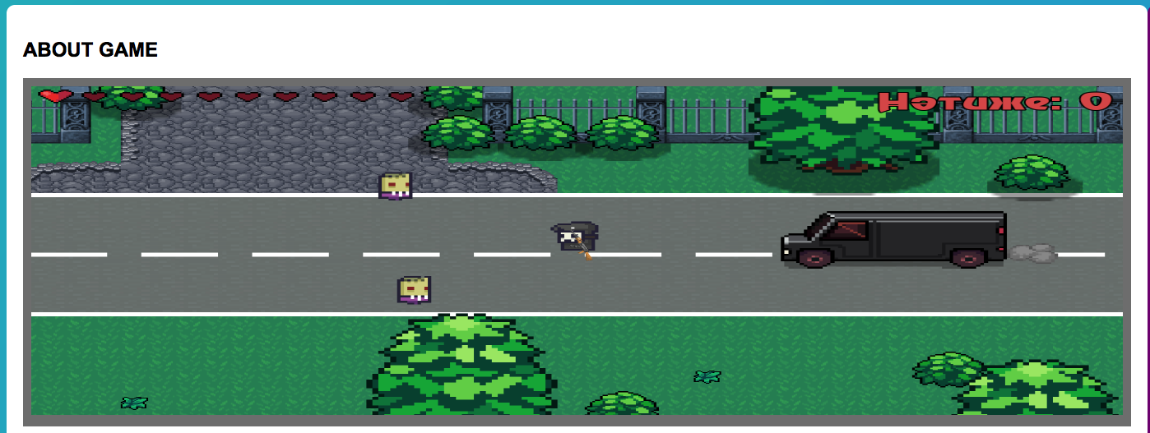

*Figure 63: 1-image of the gallery*

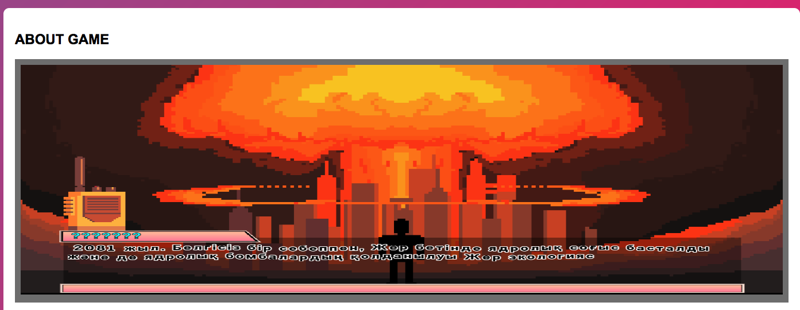

*Figure 64: 2-image of the gallery*

### Test 2

All the pages can be opened by the Navigation Bar buttons and buttons are hovered while the mouse is inside the area of the button.

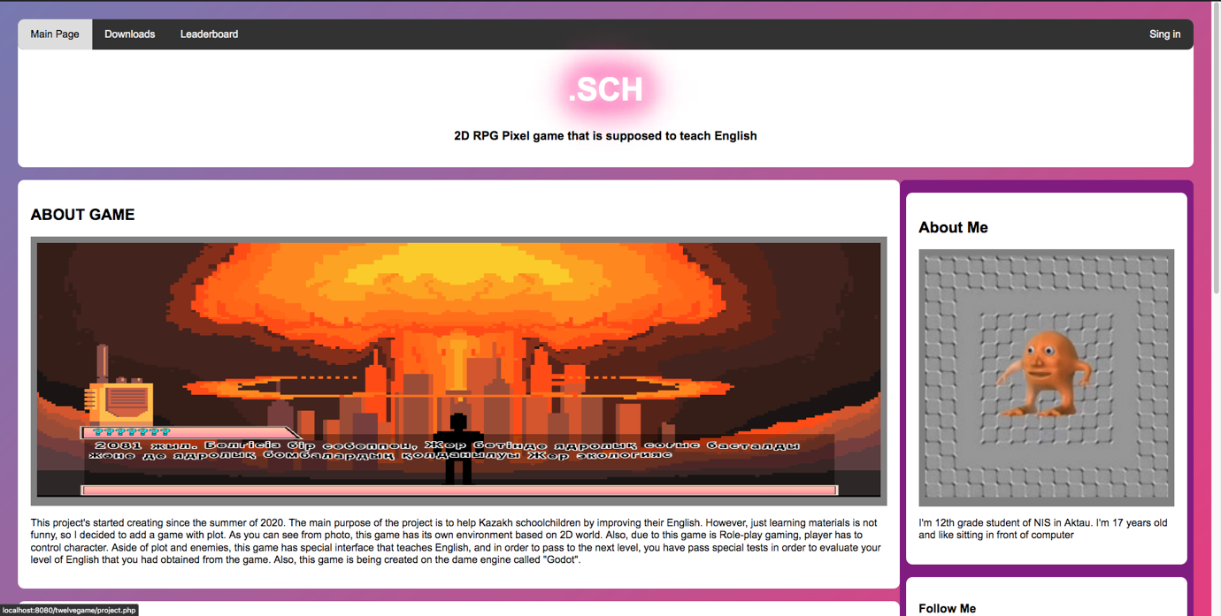

*Figure 65: Hovering over the Main Page button*

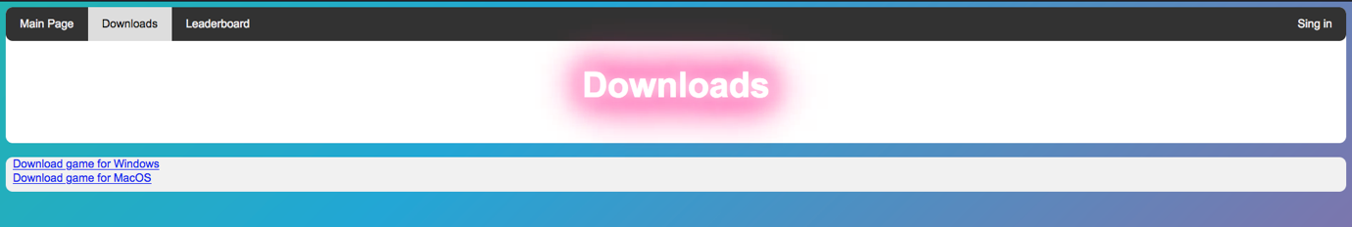

*Figure 66: Hovering over the Downloads page's button*

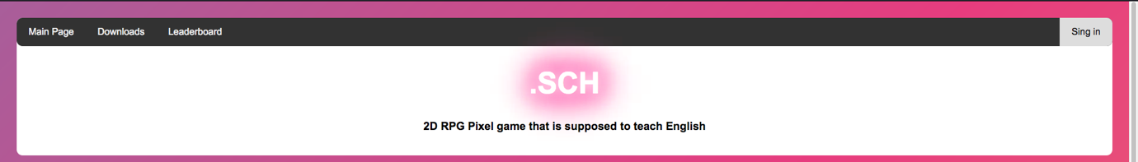

*Figure 67: Hovering over the Sign in button*

### Test 3

If the inserted user data is correct, the website's page automatically switches to the main page and shows the username. Otherwise, the login form will show an error.

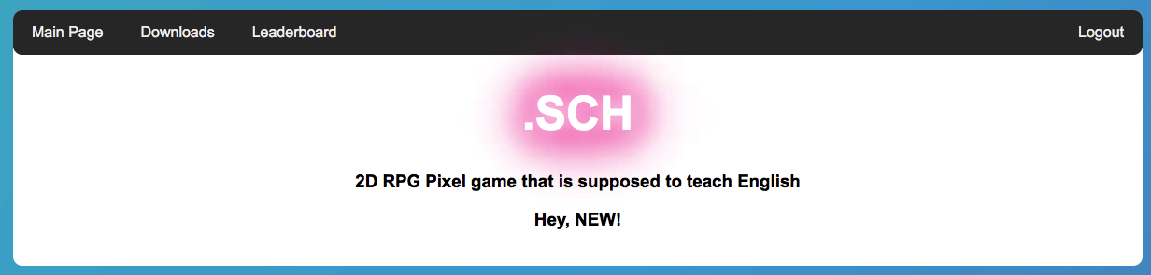

*Figure 68: Displaying user's username in all pages*

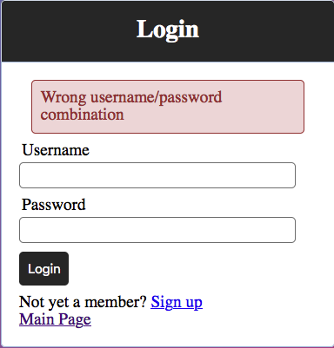

*Figure 69: Displaying errors in the case of error*

### Test 4

After the user is headed to the main page, new text fields greet the user and previous Sign In button changes to Logout.

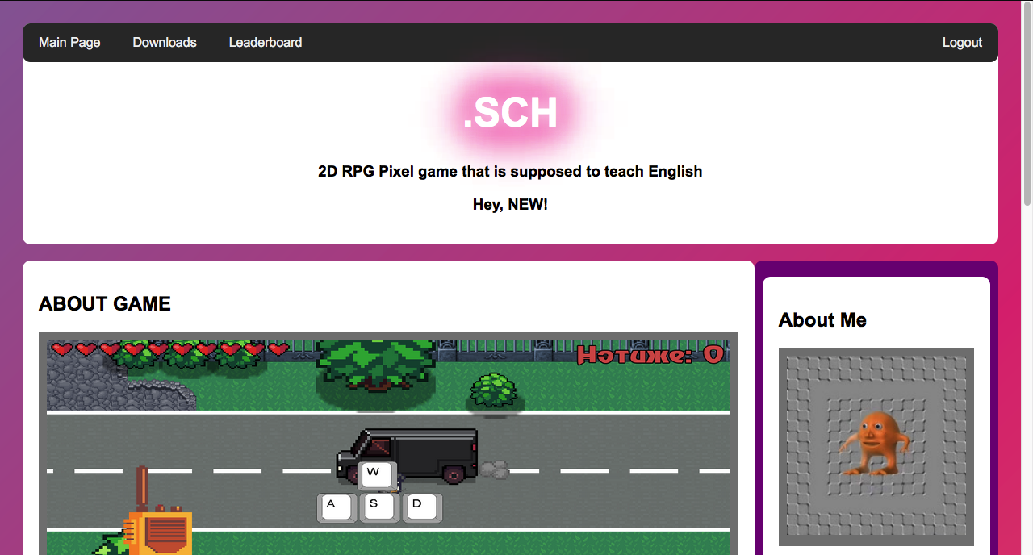

*Figure 70: Change of the texts and button's name to Logout*

### Test 5

After the user logged out from the website, the website's main page came back to normal. Greeting text has disappeared and the button's name has changed to Sign In by indicating that the user can sign in if he wants.

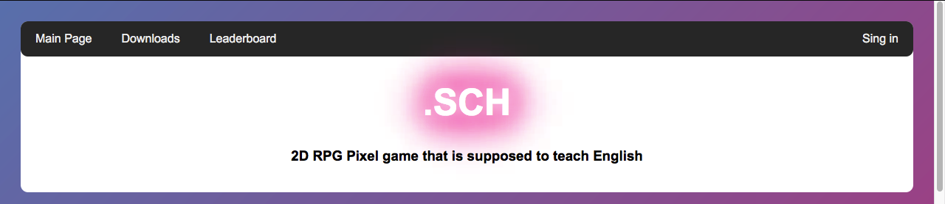

*Figure 71: Changing back to initial state of the website's pages*

### Test 6

Registration system shows all the correlated errors with each input field and if the registration is successful, the user is headed to the main page which is similar to Test 4.

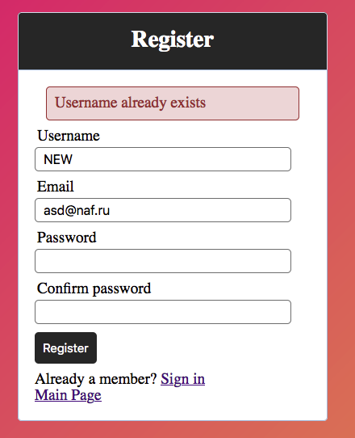

*Figure 72: Type of displayed error when username already exists*

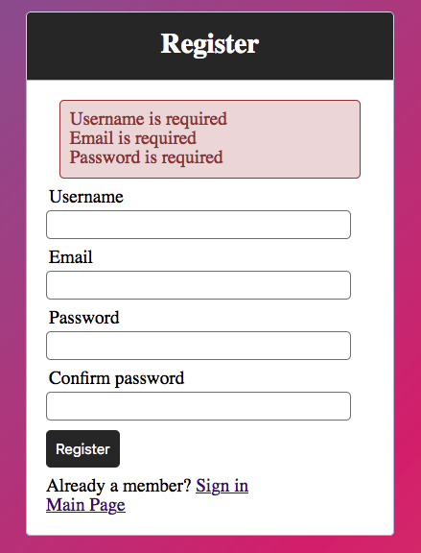

*Figure 73: Errors shown when all the fields are left blank*

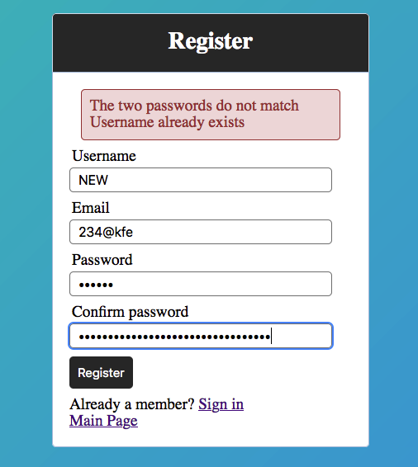

*Figure 74: Errors shown when the passwords do not match*

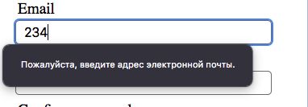

*Figure 75: Error shown when the email doesn't have normalized type*

### Test 7

All the data that was correctly entered to the registration form has appeared in phpMyadmin database.

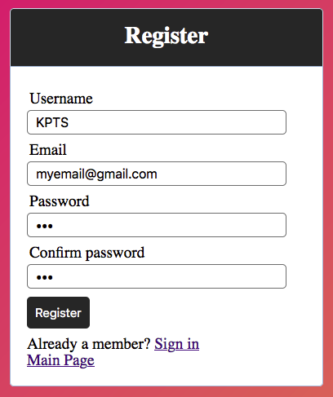

*Figure 76: Registering new user*

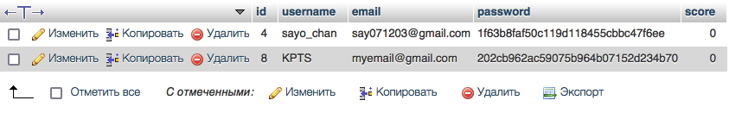

*Figure 77: Changes in the database's table after registering new user*

### Test 8

Login form of the game displays similar outputs as in Test 3.

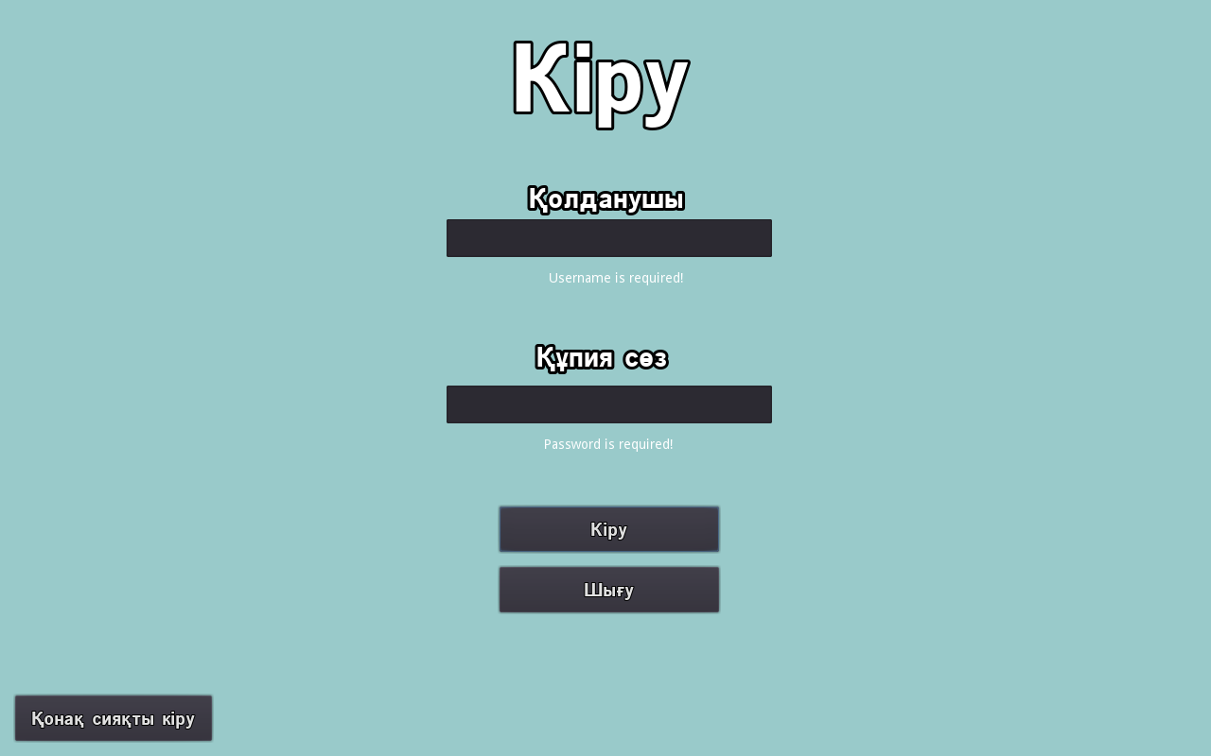

*Figure 78: Errors shown when all the fields are left empty*

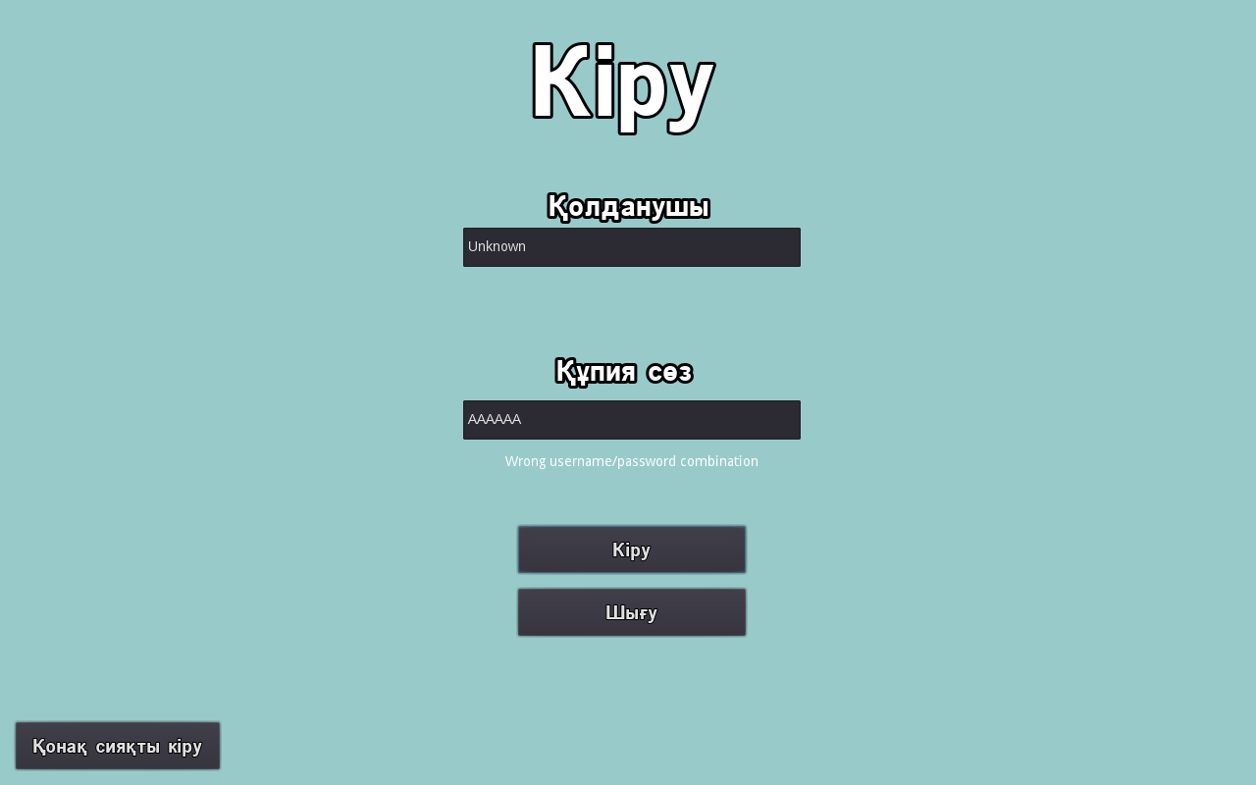

*Figure 79: Errors shown when inserted data don't match with the data from database*



*Figure 80: Successful login*

### Test 9

When the enemy is eliminated or user has inserted right answer to the test form, score is added by 10 points.

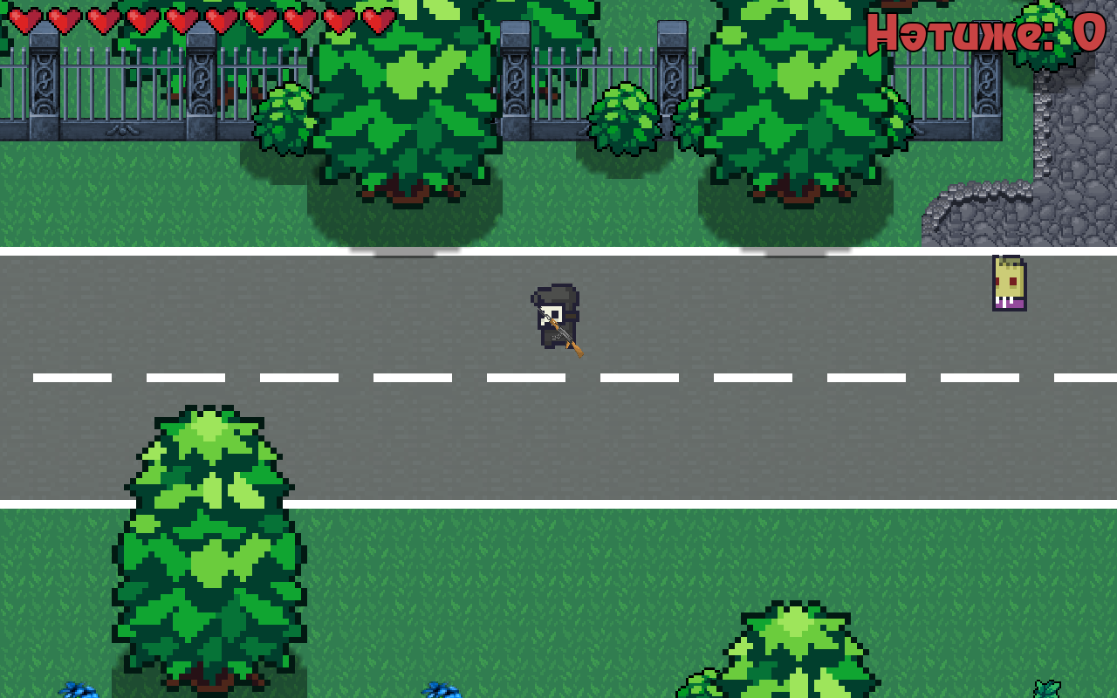

*Figure 81: Results before eliminating the enemy*

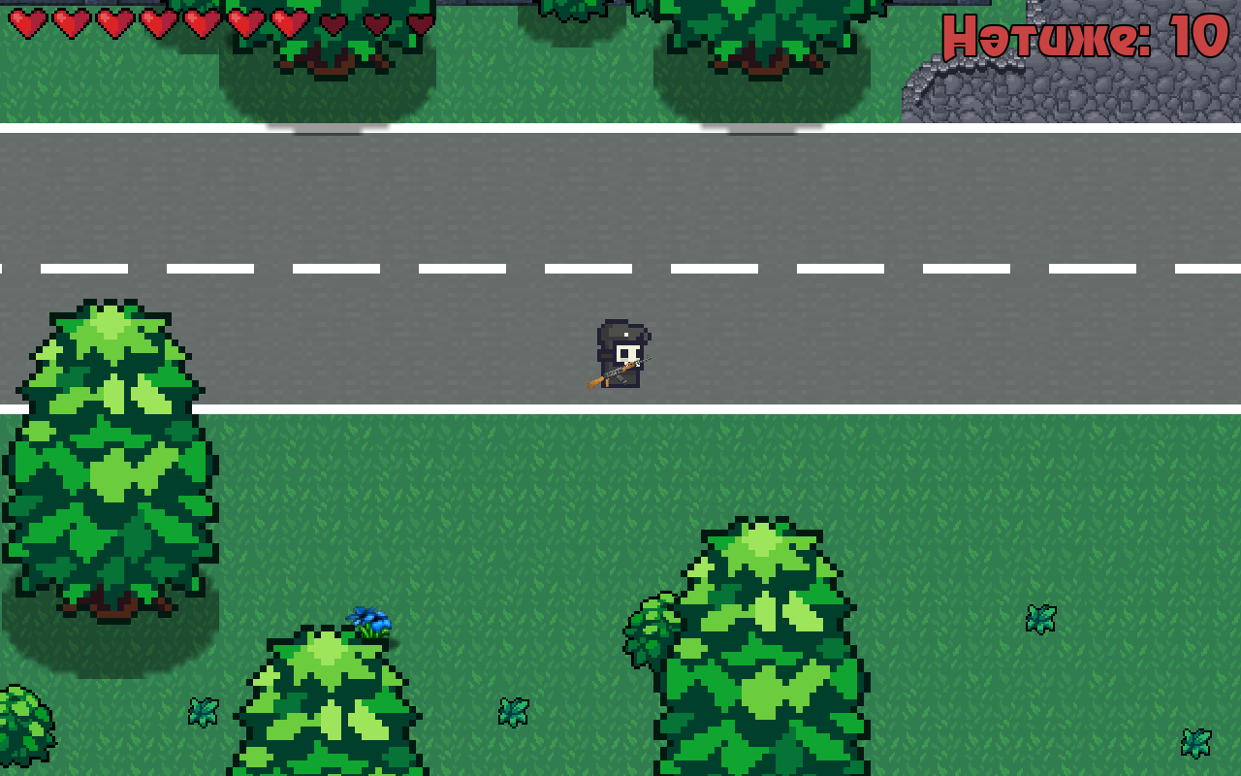

*Figure 82: Health is withdrawn after contacting with the enemy and 10 point were added after eliminating it*

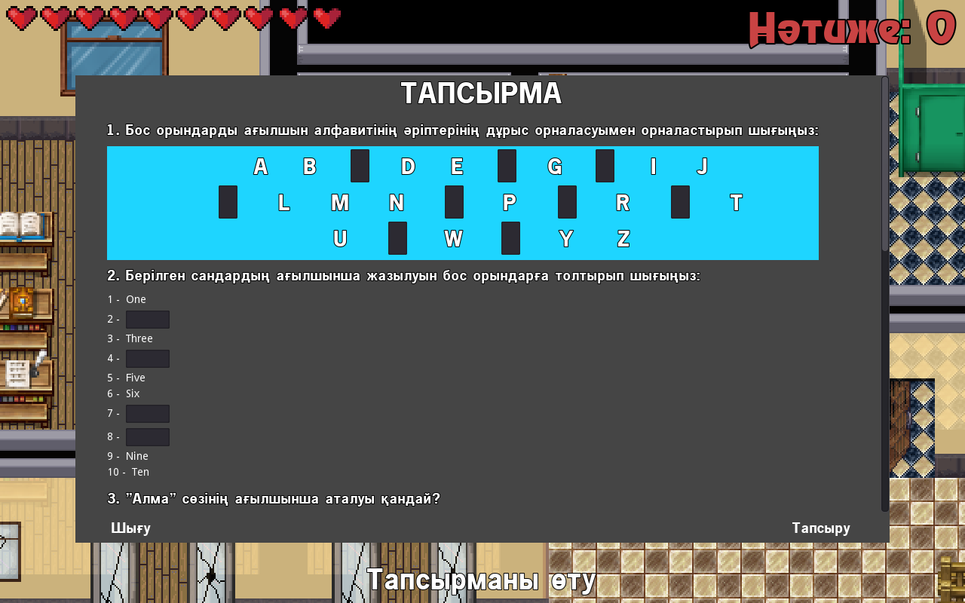

*Figure 83: Testing form without any change*

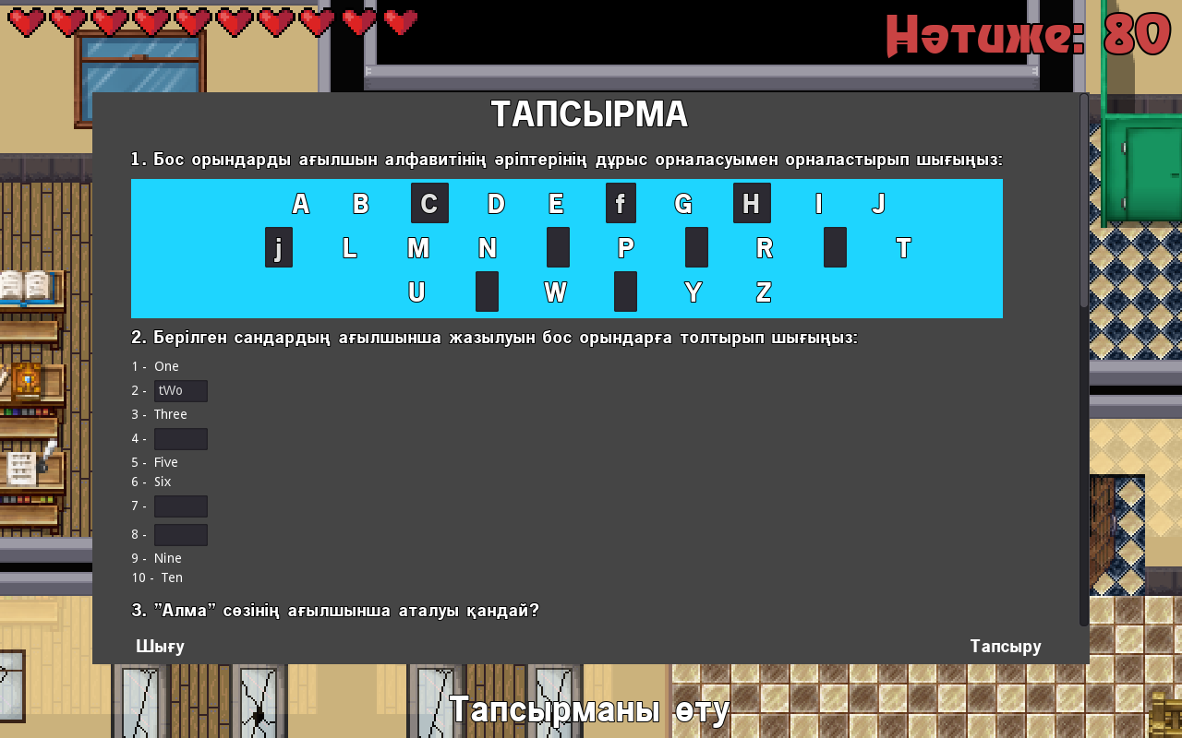

*Figure 84: Scores are changed after inserting correct answers and clicking "Тапсыру" button*

### Test 10

Scores are sent to the database successfully and are displayed in the website in accordance to the player or user.

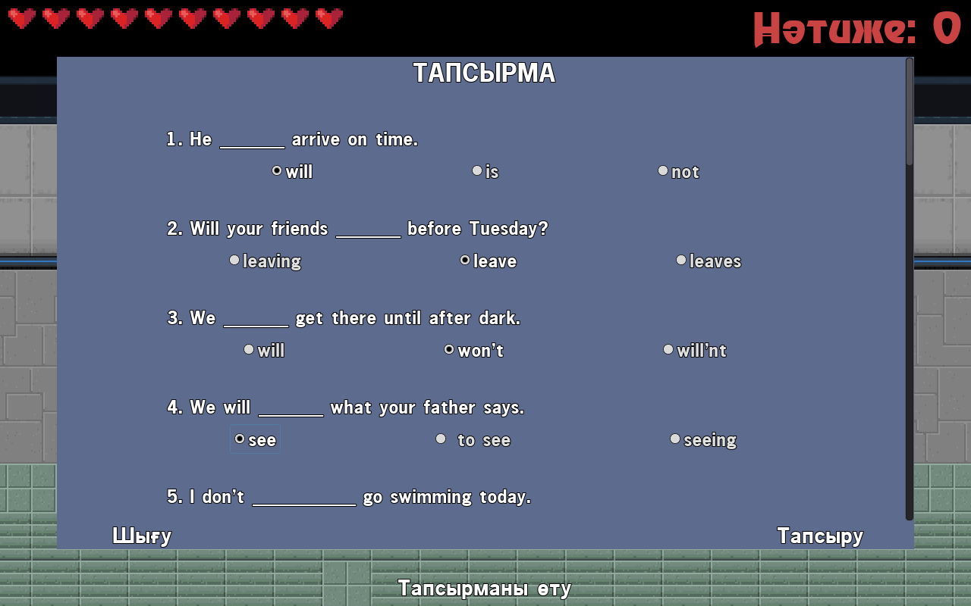

*Figure 85: Last testing form*

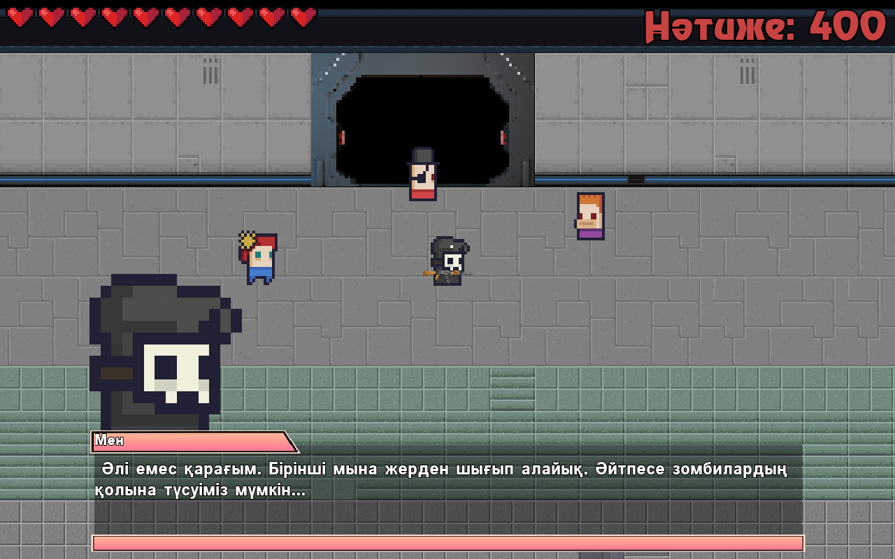

*Figure 86: Last dialog where the scores are sent to the database*

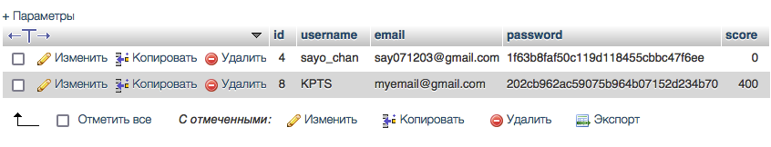

*Figure 87: Scores are shown in the databse*

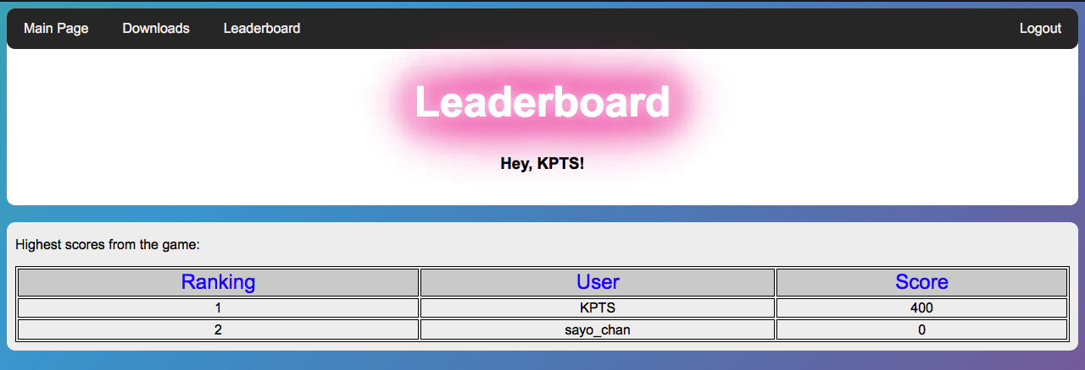

*Figure 88: Scores are shown in the Leaderboard page of the website*

# Installation

## Installation plan

Installation plan was talked over and approved by the client during the processes of testing and development.

The system must be checked and tested by the client and client should suggest changes over the system

* Educate the client about the basics of computer, the Internet, website, and game;
* Give a client an opportunity to test the new system;
* Train a client to use the website and game correctly;
* Consider the feedback of the user to make further improvements on the system;
* Instruct the user how to use system’s forms, functions, how to download the game, and how to play the game thoroughly;
* Start utilizing the system by confirmed system implementation plan;
* To get a confirmation from the user that the systems is functionable, manageable, and user-friendly;
* The support of the developer will be provided until client or user fully understands how to use the system (website and game application).

## Staff training plan

Suggested training date: 20th of December 2021 – 10th of January 2022

Reason: Such training date was chosen due to the client being an elementary school student who hasn't had much experience with using computers. So, it will take a certain time for clients to learn the basics of using computers, websites, and games.

Suggested training method: Individual method of training.

Reason: The system was exclusively made for the client. So, client will be instructed by me who is fully aware of the system

## System implementation plan

Suggested implementation type: Parallel implementation type will be used to use both old and new system

Reason: It is because both old and new systems can be used to teach the client the basics of the English language. Where the old system is mostly based on teaching clients new English words, the new system is based on teaching the client basic English grammar.

Suggested implementation date: 15th of January 2022 – 20th of January 2022

Reason: It will be a wise decision to implement the system after training. Also, a client will have an opportunity to rest between training and implementation processes as the training plan can take the client’s mental and physical energy.

## Evidence of user’s testing

The purpose of the meeting with the client was to give her an opportunity to test the system as a user. With this, the client got an opportunity to view the system according to her criteria. Client was provided with the staff training and system implementation plans as the client would be fully aware of what's going to be next. Client was asked to write a confirmation letter where client indicated that she participated in the testing and that implementation and training plan was acquainted to her. Also, the client filled the questionnaire that I prepared according to her criteria.

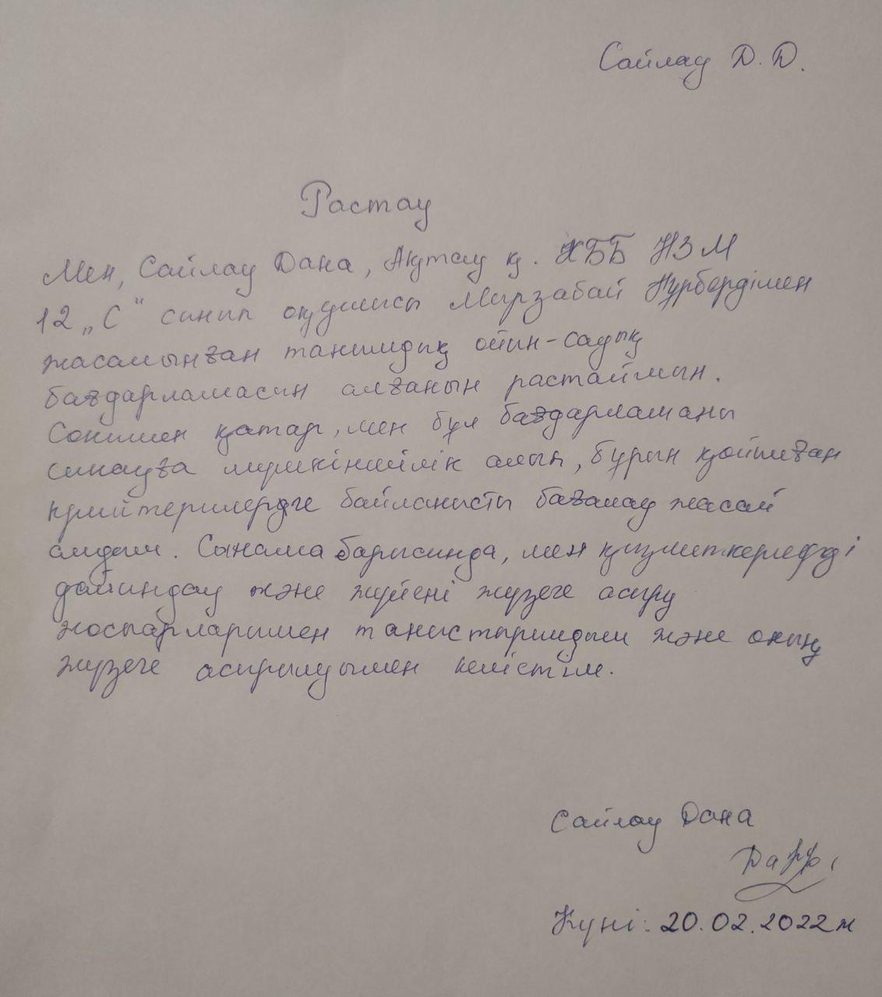

*Figure 89: Confirmation letter written by the client*

The questionnaire below was provided for the client in order to receive an evaluation about the system according to the client’s criteria. By this, I could know if the system had any troubles that should be fixed.

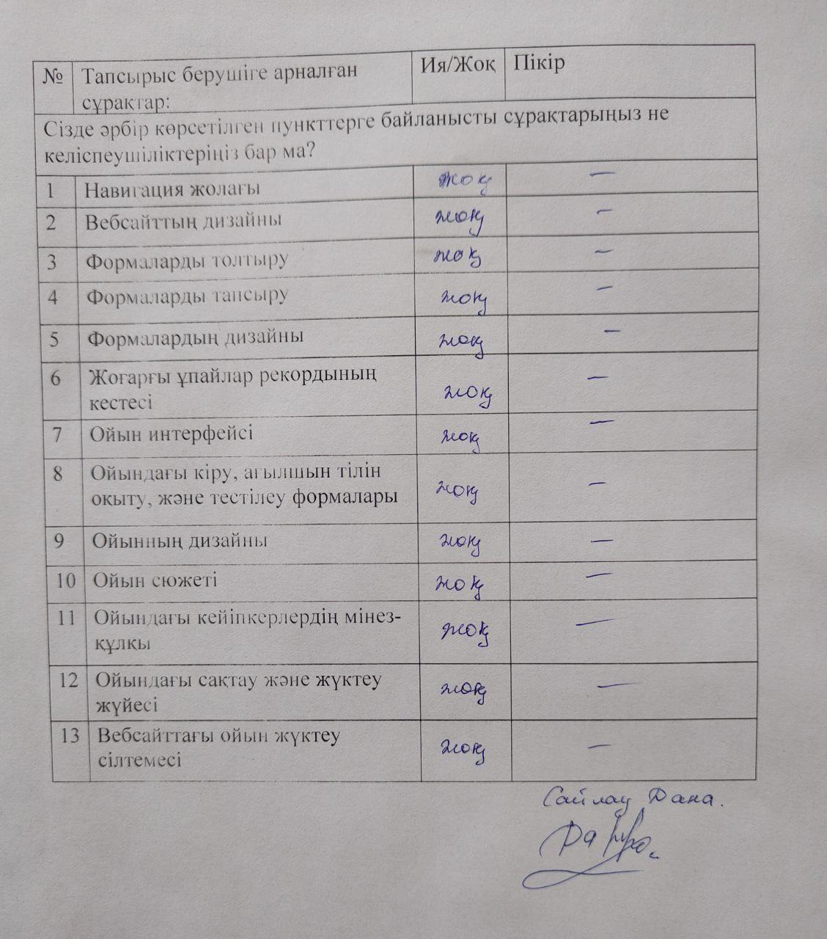

*Figure 90: Questionnaire that was taken from the user*

# Documentation

## Data dictionary of the Website

| **Form name** | **Use** |
| --- | --- |
| Login (Sign In) form | This form will be used for logging into the website by previously registered users. |
| Registration (Sign Up) form | New users can fill the registration form and their data will be saved on the phpMyAdmin database. Also, registered users’ accounts can be used to receive a scores and store them in the database |

### Login (Sign In) form

| **Object name** | **Type** | **Use** |
| --- | --- | --- |
| Login | Label | Used to display the name of the form |
| Errors | Label | Used to display errors with logging in. Normally, it’s not visible |
| Username | Input field | Enter the user’s username |
| Password | Input field | Enter the user’s password |
| Login | Button | Used to submit the form |
| Not a member yet? | Label | To display an instruction for the new users |
| Sign up | Link | Heads user to the registration (sign up) form |
| Main page | Link | Heads user to the Main Page |

### Registration (Sign Up) form

| **Object name** | **Type** | **Use** |
| --- | --- | --- |
| Register | Label | Used to display the name of the form |
| Errors | Label | Used to display errors with logging in. Normally, it’s not visible |
| Username | Input field | Enter the new username |
| Email | Input field | Enter the user’s email |
| Password | Input field | Enter the user’s new password |
| Confirm password | Input field | Confirm that the inserted passwords match with each other |
| Register | Button | Used to submit the form |
| Already a member? | Label | To display an instruction for the users who has an account |
| Sign in | Link | Heads user to the login (sign in) form |
| Main page | Link | Heads user to the Main Page |

## Data dictionary of the Game

| **Form name** | **Use** |
| --- | --- |
| Login (Sign In) form | Registered users of the website can log in with their username and passwords similarly to the login form on the website. After that, username is saved as a variable in order to enable connection between database and game via GDScript and PHP languages |
| Main Menu form | Main menu is used to determine whether to start, continue, or exit from the game. In other word, navigation for the user |
| DialogBox forms | Dialog box forms are used in the game for various purposes such as displaying plot texts, dialog texts, and other instructions which can be helpful for the user. |
| Teaching computer forms | These are the forms that contain educational content where the user can educate himself/herself. It contains interactive interfaces such as audios and videos. Every level has its own computers depending on the level’s size |
| Test forms | Test forms are used to test the user’s knowledge that was obtained from the teaching computer forms. Every level has its own test form. If the user has successfully completed the test, he/she can get an access to the next level |
| Pause form | Pause form is used to pause the game and get access to other functions and forms such as exiting to the main page, continue the game or get an access to the save and load forms. This form can be achieved by pressing the Escape button as in other games. |
| Save form | Save form can be accessed via Pause menu and is primarily used to save the game’s progress to .json files. |
| Load form | Load form not only can be accessed from the Pause menu, but also from the main menu. This form is used to retrieve the saved game progress from .json files and continue from the last point where the user has saved the game. |

### Login (Sign In) form

| **Object name** | **Type** | **Use** |
| --- | --- | --- |
| Кіру | Label | Label that is used to indicate the name of the form. |
| Errors | Label | Used to display errors with logging in. Normally, it’s not visible |
| Қолданушы | LineEdit | Used to enter user’s username |
| Құпия сөз | LineEdit | Used to enter user’s password |
| Кіру | Button | Used to submit the form and check if the inserted data are correct |
| Шығу | Button | Button to exit from the game |
| Қонақ сияқты кіру | Button | Button to enter the game as a guest. This means scores won’t be sent to the database. |
| Ойынға кіру | Button | Used to enter the game if the user could login to his/her account. This button is hidden and only appears if the inserted data is correct. |

### Main Menu form

| **Object name** | **Type** | **Use** |
| --- | --- | --- |
| .SCH | Label | To indicate the game’s name |
| Жаңа ойын | Button | Used to start a new game |
| Жалғастыру | Button | Opens a load form |
| Шығу | Button | Exits from the game |

### DialogBox forms

| **Object name** | **Type** | **Use** |
| --- | --- | --- |
| Image of character | TextureRect | Used to show the narrator’s or characters image or appearance |
| Character name | RichTextLabel | Used to indicate the narrator’s or character’s name |
| RichTextLabel | RichTextLabel | Used to display texts that are related with game’s plot, dialog, and other instructions |
| NextPhraze | Button | After pressing, loads the next phrase immediately |
| CharacterAudio | AudioStreamPlayer | Used to load audios which contain the speech of characters |
| AnimationPlayer | AnimationPlayer | Multi-functional mode which can be used for many things such as controlling function and other nodes’ properties by setting them to time. |

### Teaching computer forms

| **Object name** | **Type** | **Use** |
| --- | --- | --- |
| Educational texts | Label | All the computer forms have labels where the educational information about English language is written. |
| Educational audio buttons | Button and AudioStreamPlayer | Almost all of the educational forms contain buttons where the user or player can listen to educational information such as how to pronounce letters and numbers after pressing the button. |
| Educational video player | VideoPlayer | Video player is used to include videos with educational context where users can learn new words. However, the type of the node which is VideoPlayer is not fully functionable. |
| Видеоны қосу | Button | Required button for the previous VideoPlayer in order to turn on the video by the user. |
| Тоқтату/Ойнату | Button | Also required a button for the VideoPlayer. By this user can either stop or continue watching the video. |

**Test forms**

| **Object name** | **Type** | **Use** |
| --- | --- | --- |
| Quiestion texts | Label | These labels are used to display the questions and additional information. |
| Questions’ text inputs | LineEdit | It is used by the player to answer the questions by writing text answers. LineEdit is an input field. |
| Multiple choice questions | CheckBox | These checkboxes can be used as radiobuttons and as a checkbox where users can choose multiple answers if the property of CheckBox’s node was correctly changed. |
| Шығу | Button | Button that is used to close the form. However, all the form’s data is saved. |
| Тапсыру | Button | Button that is used to submit the form and calculate the scores of the test. |

### Pause form

| **Object name** | **Type** | **Use** |
| --- | --- | --- |
| Жалғастыру | Button | By this, user can continue playing the game at a point where he/she pressed to pause button |
| Ойынды сақтау | Button | Opens the Save form |
| Ойынды жүктеу | Button | Opens the Load form |
| Шығу | Button | Exits to Main Menu |

### Save form

| **Object name** | **Type** | **Use** |
| --- | --- | --- |
| Ойынды сақтау | Label | Indicates that user has opened the Save form |
| 1-сақтау | Button | Saves the game progress to .json files that was created exclusively for the first saving button |
| 2-сақтау | Button | Saves the game progress to .json files that was created exclusively for the second saving button |
| Артқа | Button | Goes back to the Pause menu |

### Load form

| **Object name** | **Type** | **Use** |
| --- | --- | --- |
| Соңғы ойынды көшіру | Label | Indicates that user has opened the Load form |
| 1-сақталған ойын | Button | Loads the game progress from .json file that was saved by the Save form’s first button |
| 2-сақталған ойын | Button | Loads the game progress from .json file that was saved by the Save form’s second button |
| Артқа | Button | Goes back to the Pause menu |

## Section References

Most of the sections required for the system maintenance documentation already occur previously in this document.

| **Section** | **Page reference** |
| --- | --- |
| Interview | 7-9p |
| Current Flowchart | 11-12p |
| Current DFD | 13p |
| User requirements | 17, 18p |
| Hardware and Software requirements | 19p |
| New Flowchart | 42-49p |
| New DFD | 40, 41p |
| Prototype | 25-29p |
| Programming | 55-105p |

## Possible Adaptive Maintenance

In order to contribute further development of the system, future updates and additional work on the new system can include:

* Website’s interface improvement. Due to the XAMPP server only supporting English, the website's webpages are written in English and Kazakh symbols cannot be displayed;
* Including interactive forms to the website. For example, live chat, review and comments area, user’s account page and more;
* Including registration system from the game;
* Presence of music background. Whether its game or website, both of them need to have background with interesting music;
* The AI of the game’s enemies. For now, enemies can’t detect the walls and obstacles. This should be improved;
* Deleting junk files and codes;
* Make an optimization for the game and website;
* Saving game’s progress to the database;
* Make a website online.

# User documentation

## User guide

Here, I’ll explain how to use the new system as a client and system administrator.

### Hosting local website

In order to use the website, a local server should be hosted. To do so, an XAMPP app is used. It can create a local website and with phpMyAdmin, administrators can control the website’s database. As a user, we are interested in using XAMPP only. All the guides are made in the MacOS High Sierra. However, it can be used in the Windows OS also:

1. Client should open XAMPP;
2. In the General tab, user should press “Start” button and the red light should turn to green after some time;

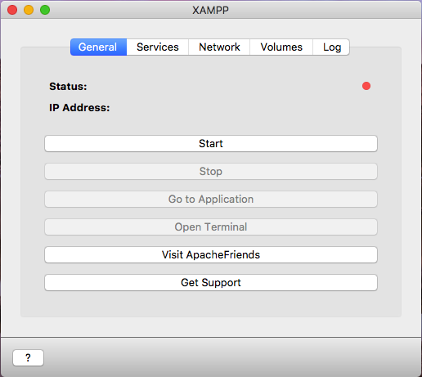

*Figure 91: General tab of the XAMPP*

1. After starting, the user should go to the Services tab and click the “Start All” button. Three stack services should turn green.

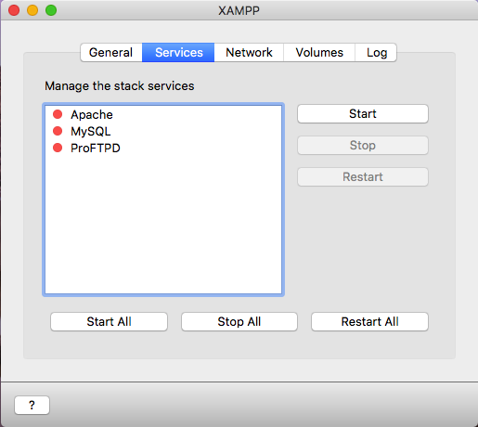

*Figure 92: Services tab of the XAMPP*

Then user can head to the Network tab;

1. Here, user should press the port called “localhost:8080 -> 80 (Over SSH)” and then click to “Enable” button.

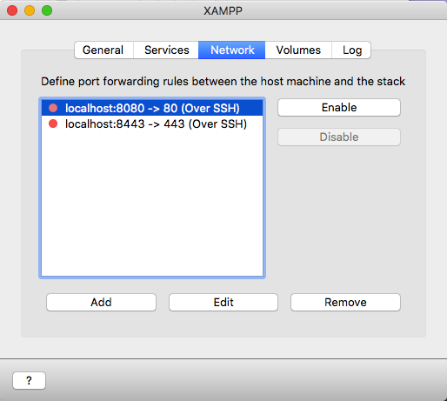

*Figure 93: Network tab of the XAMPP*

Then, user needs to open the Volumes tab;

1. In Volumes tab, user should press “Mount” button.

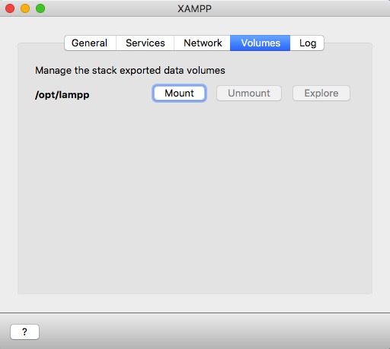

*Figure 94: Volumes tab of the XAMPP*

Now, local host is created, and user can open the site.

1. **Opening and switching between tabs on the website**

From this point, users can start using the website. This section will explain how to open and switch between the tabs on the website:

1. In order to open the website, the user should write the website's address line to any browser’s searching area. The address line is <http://localhost:8080/twelvegame/project.php>



*Figure 95: URL of the website*

After that, user will be directed to the website’s Main Page;

1. On the website, users can open other pages with the help of Navigation bar. In order to use the Navigation bar, the user just has to press the preferred button. In the Navigation bar, users can open “Main Page”, “Downloads” page, “Leaderboard”, and “Sign in” form.

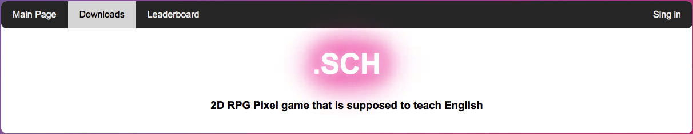

*Figure 96: Downloads page of the website*

1. **Logging in (Signing in) to the website**
2. In Navigation bar, click to the Sign in button;
3. In the Login form, write your Username and Password to the corresponding input fields;
4. Click “Login” button.

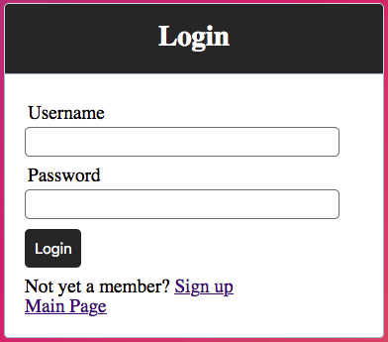

*Figure 97: Login form of the website*

Then user will be directed to the Main Page.

### Registering to the website

This section is related to the new users who don’t have account:

1. In Navigation bar, click to the “Sign in” button;
2. Click to the Sign up link. User will be directed to the Registration form;

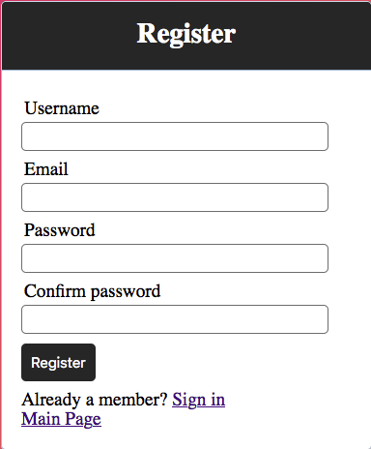

*Figure 98: Registration form of the website*

1. In Registration form, write down a unique and new username, your email, and strong password. Also, user should confirm his/her password by writing down it again to the corresponding field;
2. Press the “Register” button. After that, user should be directed to the Main Page.

### Downloading the game from website

User can download the game from the website. This section will explain how to download the game:

1. User should click the “Downloads” tab in Navigation bar (see 2.2 in User guide);
2. If the user uses Windows OS, user should press “Download game for Windows” text link, and if user uses MacOS, user should press “Download game for MacOS” text label.

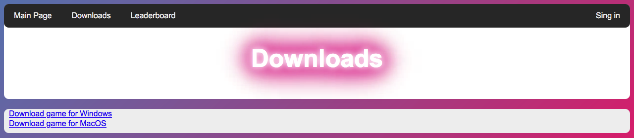

*Figure 99: Downloads page of the website*

After that, Google Drive with the game file will open;

1. In the Google Drive, user should press one of the marked buttons.

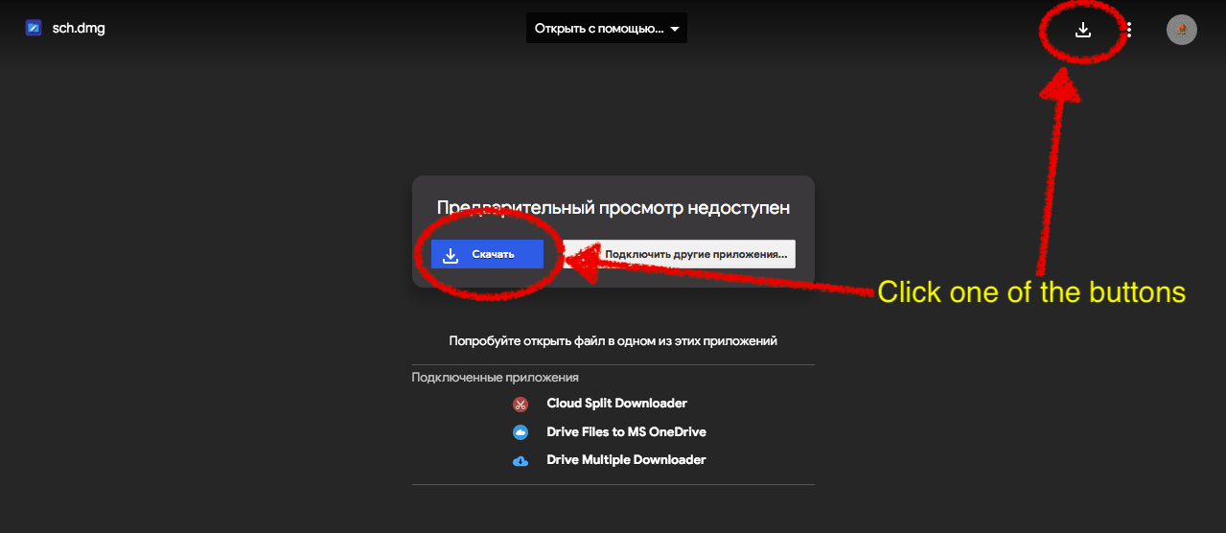

*Figure 100: Google disc where the game is located*

If there is a warning about size and the link’s safety, just press the blue button called “Все равно скачать”. You can choose your own directory to download and just press the game icon to launch the game.;

### Logging in to the game

Login form of the game is slightly different from the website’s form.

1. Open the game by clicking to game’s app icon;

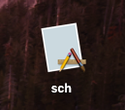

*Figure 101: Icon of the game*

1. Insert your username and password and then click “Кіру”. If the inserted data is right, new button called “Ойынға кіру” should appear;

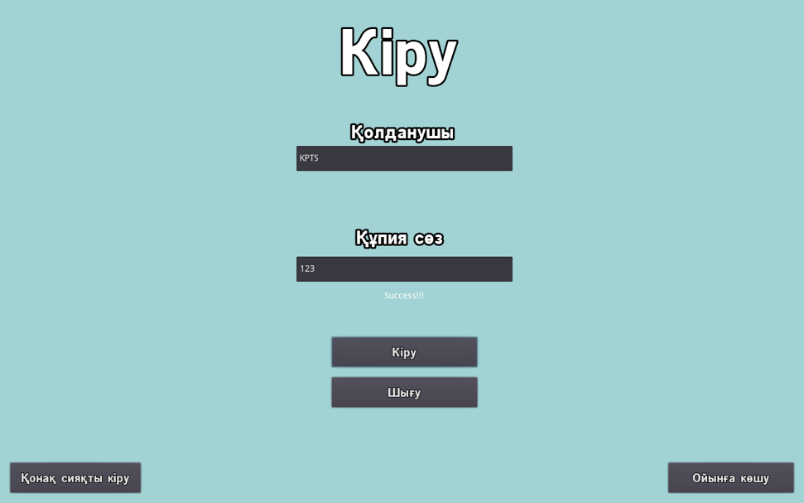

*Figure 102: Login form of the game*

1. Click the new button and you’re logged to the game by your account.

### Starting new game

1. After logging in, user can start new game by pressing “Жаңа ойын” button and game will start.
2. **Game control**
3. In order to walk, user should use W (walking up), A (walking left), S (walking down), and D (walking right) buttons;
4. To shoot, user should press LMB (left mouse button);
5. To open pause menu, user should click esc (Escape) button;
6. In order to open the teaching computer and testing forms, an user should press the appeared button or press enter button. This also can be applied to teleporting to the next level;
7. In teaching computer form, user can listen to the letters and words by pressing LMB (left mouse button) on them. Also, in testing form user can select answers with this method;
8. In the testing form, user have to use an English language keyboard to write down the answers to the input fields.

### phpMyAdmin guide

This step is for the system administrator in order to control the database

1. Refer to the 1st point of the user guide;
2. Click to the database called “lasttwelve” and click the table called “users”;

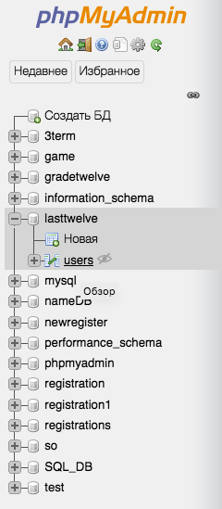

*Figure 103: List of databases*

1. Here, system administrators can change, copy, and delete the table components. Also, the admin can implement other functions such as creating table and etc.

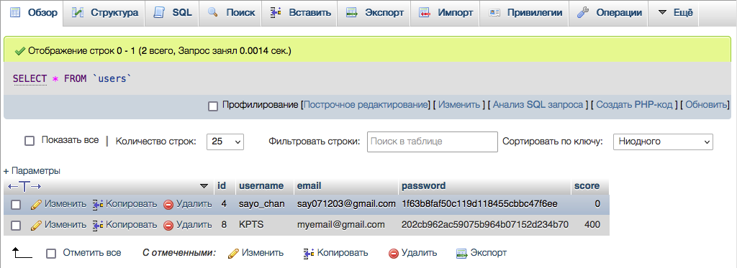

*Figure 104: Contents of the table that is located in database*

### Back-up routine

It’s not necessary for the user to have a storage media. However, if the user wants to save all the saved data from the game, then a flash drive with capacity of 200MB is enough to copy the game inside.

### Glossary

| **Title** | **Description** |
| --- | --- |
| Form | It is a graphical interface object that can be controlled by the user for the sole-purpose or multi-purpose uses |
| Input field | It is a graphical object where user can insert symbols |
| Button | Graphical object that can be pressed by the user to perform specific assigned functions |
| Database | Database is the form that is used to save information related to the game |
| Table | One of the methods of displaying data as a set of cells or for storing necessary data |
| Website | It is a collection of web pages in one domain name that is distributed by someone |
| Godot | Game engine that is used for game development |
| GDScript | It is a programming language that is used in the Godot Engine in order to prepare the set of instructions for an any project |
| Node | Nodes are the blocks that can contain specific functional purposes. For example, there is a node called “Button” which is a common button |
| Scene | Scenes are the tree or set of the nodes. |
| XAMPP | It is an application that is used to open local web server and control it |
| MySQL | It is a variation of database that is mostly controlled by the SQL programming language |
| phpMyAdmin | It is a web page of the XAMPP that is designed for system administrators to control the MySQL database |
| PHP | It is a programming language that is used for web development |
| SQL | It is a declarative programming language that is used to control the relational database tables |
| HTML | HyperText Markup language that is used to build the websites’ carcass or skeleton. |
| CSS | Cascading Style Sheets is used with a HTML to modify the website’s appearance |

## Index

| Hosting local website | 133-135p |
| --- | --- |
| Opening and switching between tabs on the website | 136p |
| Logging in (Signing in) to the website | 136p |
| Registering to the website | 137p |
| Downloading the game from website | 138p |
| Logging in to the game | 139p |
| Starting new game | 140p |
| Game control | 140p |
| phpMyAdmin guide | 141p |
| Back-up routine | 142p |
| Glossary | 142p |

# Evaluation

## Evaluation of success

### Discussion of Degree of Success

After the client’s testing and system implementation, the client has started her evaluation. All the requirements that were set to the system by the user have been completed. Also, I demonstrated how to use the system as a user and administrator and provided a user guide.

List of the user objectives are the same as the objectives in the Design section.

### Objectives of the system

1. System must be created as an entertaining educational application;
2. System must contain testing system so client can check her progress;
3. System must have user control over the contents of the game;
4. System must count the scoring of the user that was obtained in the game;
5. Interface must be understandable and entertaining for user;
6. System must be able to save all the necessary data;
7. System must include website development in order to keep the track of scores and give an access to the downloading link of the game;
8. Website must have a registration system for all users.

## Evaluation of objectives

| № | **Evaluation** | **Evidence** |
| --- | --- | --- |
| 1 | In general, the system has been made as an entertainment and educational system with an interesting and amusing visual. System’s main purpose is to teach the user the grammar and basics of the English language. Game’s design was made as a top-down 2D RPG game which contains pixel art. This system can be used by anyone who has a basic knowledge about computer utilization and for Kazakh people who want to learn the English language or want to play the game. | 10, 20, 28, 29, 33, 38, 50, 58, 62, 65, 67, 82, 119-121p |
| 2 | For the system, it is important to have content which is written in Kazakh language. | 18, 32, 33, 37, 38, 50, 56, 58, 62, 65, 67, 82, 84, 88, 117, 118, 120p |
| 3 | Website’s login and registrations forms, and game’s login form handles input validation in order to avoid errors, mistyping, and falsehood about real information. | 26, 27, 32, 35, 36, 37, 56, 111, 114-118, 139p |
| 4 | Game contains entities with a simple AI which can follow the player. Also, educational content and testing systems are provided. | 9, 17-18, 28, 29, 33, 50, 75-78, 79-82, 119-121p |
| 5 | All the data in the game can be saved and loaded. | 17, 18, 20-24, 40, 41, 44, 47, 50, 83-89p |
| 6 | System can handle connections between the game and website to send the game’s scores to the website’s database. | 17-20, 34, 42-47, 50, 55, 56, 89, 104, 105, 121, 122, 141p |
| 7 | Website must have a leaderboard table which displays the scores from the game and their respective owners. | 34, 198, 122p |
| 8 | Website should contain information about the developer and link to the game where users can download it. | 17, 25, 94, 97, 138p |

### My client’s response

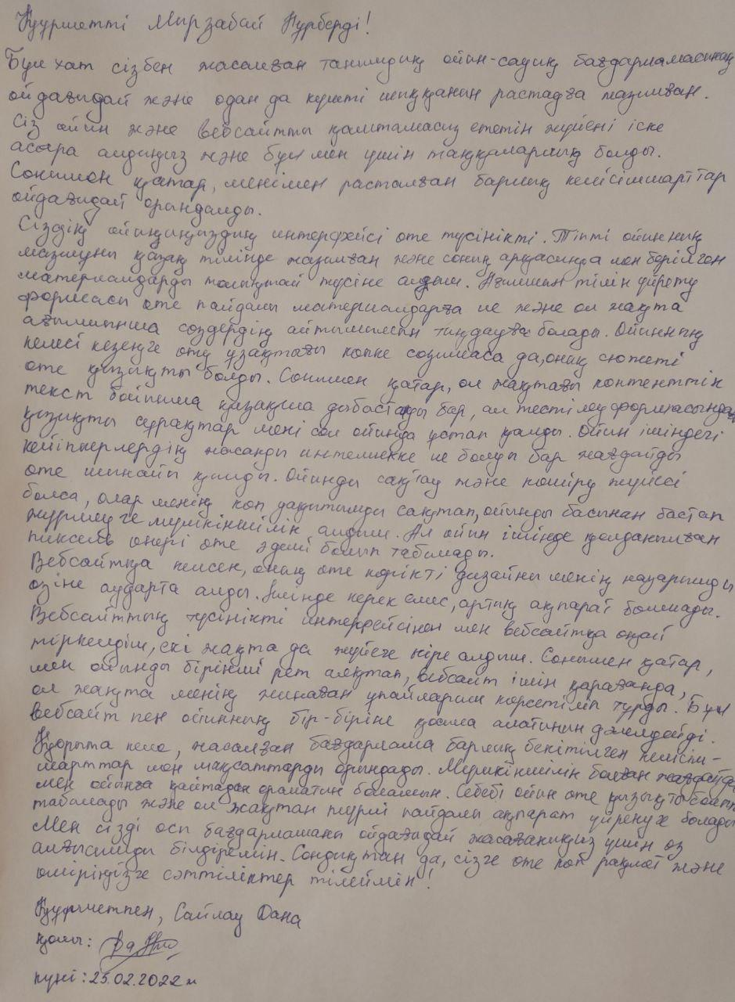

*Figure 105: My client's response*

### Analysis of the client’s response

After the training of the client, we had started implementation of the system. During this time, she was able to get known about the whole system better and started to use it for her own purpose. After testing and implementation, the client has left the letter with her thoughts about the system and her gratitude towards the developer. In the letter, the client has also mentioned the points which my client and I concluded in the user requirement and objectives section. All of the criteria have been successfully completed and the client remained satisfied with the result.

* Client mentions that the developed system is what she wanted to see by saying “сізбен жасалған танымдық ойын-сауық бағдарламасының ойдағыдай және одан да күшті шыққанын растауға жазылған”;
* Client says that the interface of the game went out really understandable by using relative language of her speech in the game’s content “Сіздің ойыныныздың интерфейсі өте түсінікті болып табылады. Тіпті ойынның мазмұны қазақ тілінде жазылған және соның арқасында мен берілген материалдарды толықтай түсіне алдым”. This also applies to the website’s design as she said that the website's design is attractive to her and doesn't have unnecessary information “Вебсайтқа келсек, оның өте көрікті дизайны менің назарымды өзіне аударта алды. Вебсайт ішінде керек емес артық ақпарат болмады”;
* Client mentions that game contain educational content with testing system “Ағылшын тілін үйрету формасы өте пайдалы материалдарға ие және ол жақта ағылшынша сөздердің айтылымын тыңдауға болады. Ойынның өті ұзақтығы ұзаққа созылмаса да, оның сюжеті өте қызықты болды. Сонымен қатар, ол жақтағы контенттің текст бойынша қазақша дыбысталуы бар, ал тестілеу формасындағы қызықты сұрақтар мені сол ойында ұстап қалды”;
* Client confirms about the AI that was used in the game and that game can be both saved and loaded and says that it saved a lot of her time “Ойын ішіндегі кейіпкерлердің жасанды интеллекте ие болуы бар жағдайды өте шынайы қылды. Ойынды сақтау және көшіру жүйесі болса, олар менің көп уақытымды сақтап, ойынды басынан бастап жүрмеуге мүмкіншілік алдым”;
* She mentions that it is easy to register and login to the website and login to the game “Вебсайттың түсінікті интерфесінен мен вебсайтқа оңайлықпен тіркеліп, екі жақтада жүйеге кіре алдым”;
* She confirms that the website and game can connect with each other and send necessary data such as game’s scores to the website and display it there “Сонымен қатар, мен ойынды бірінші рет аяқтап, вебсайт ішін қарағанда, ол жақта менің жинаған ұпайларым көрсетіліп тұрды. Бұл вебсайт пен ойынның бір-біріне қосыла алатынын дәлелдейді”.

## Degree of success

From the provided response and evaluation of the user, I can confirm that the system’s implementation went out to be really satisfying and helpful for the user. So, the system’s development was successful and the client can use the system for her own purposes to learn English and have fun while playing the game.

# Sources of information

1. Godot Action RPG series <https://youtube.com/playlist?list=PL9FzW-m48fn2SlrW0KoLT4n5egNdX-W9a>
2. Bullet system for the game <https://youtu.be/Ud1VKPH6ZTI>
3. Source of sprites for the environment of the game <https://opengameart.org/>
4. Source of the game’s character sprites https://0x72.itch.io/pixeldudesmaker
5. Basics of Godot <https://docs.godotengine.org/en/stable/index.html>
6. Background sounds for the game <https://freesound.org/>
7. Source of the Kazakh text’s speech <https://issai.nu.edu.kz/tts-eng/>
8. Basics of the web development https://www.w3schools.com/